Hand Counting Successes
A white paper drafted from our experience implementing hand counting at the Maricopa County Republican Committee annual meeting.

By:
James Knox, Shelby Busch, and Mark Cook

Table of Contents
Introduction 4
Purpose 4
Election Make-Up 4
Voter 4
Ballot 5
Chain of Custody 5
Storage 5
Counting 6
Tabulation Tables 6
Adjudication 6
Security 7
Hand Count Process 7
Ballot Process Flow 7
Ballot Collection 8
Ballot Intake 8
Runners 9
Tabulation Tables 9
Our Tabulation Tables Makeup 9
Tabulation Team 9
Clearing the Table 10
Aggregation Table 10
Our Aggregation Table Makeup 10
Storage or Transport Teams 10
Floor Managers 11
Observers 11
Process Discrepancies 11
Sharpy Pens 11
Regular Pens 11
Counting Issues 11
Write-in Candidates 12
Templates and Supplies 12
Batch Talley Sheet 12
Technology Needs 13
Sources of items ordered 14
Vote Process Basic Check Sheet 15
Ballot Distribution 15
Chain of Custody 15
Batch Team 16
Transport Manager 17
Tally Manager 17
Aggregation Manager 18
COC Officer 18
Canvass Marshall 19
Team Coordinator 19
Appendix 19

Introduction
On January 13th, 2023, the Maricopa County Republican Committee (MCRC) hosted its annual meeting. The MCRC Executive Committee has been committed to influencing the State of Arizona that hand counting is cost-effective, fast, easy, efficient, and secure. Shelby Busch of We The People AZ Alliance, Mark Cook of Hand Count Roadshow, and James Knox, State Lead for Arizona Cause of America, came together and organized the process documented in this whitepaper. The three came together with slightly different approaches and together produced a process easily replicated and should result when implemented correctly, and election without scrutiny.
I think it would not be right to proceed without a special thanks to several people who have been instrumental in this team to get to this point. Linda Rantz of Cause of America whose hand count method was perhaps the first implemented in this resurgence for transparency in elections. President Trump, through his stolen election in 2020, drove so many American Patriots to do something about the decline of our country and our elections. Last, the thousands of volunteers that have gotten involved in our organizations and the many others are all working to restore America to its constitutionally based glory.

Purpose
So why hand count? I could list probably a hundred or more reasons but let me take this approach. Whenever critical processes enter a system or environment where that process is no longer able to be 100% controlled and documented in a consistent and reliable manner, then that process can be questioned, and the loss of confidence in it exists. Yes, I am speaking of the machines used in our elections, but even in non-machine-managed elections, there can be flaws, gaps, and coercion. The three of us entered this venture as volunteers committed to eliminating any opportunity to question the results. Each of us had our own ideas, many sourced from Linda Rantz of Cause of America, but we each realized at the time we initiated our planning there was not a single method that addressed some of our concerns.
Following this method will ensure your election will not only consistently produce accurate results but also be transparent, trackable, auditable, and open. The digital interfaces we used were not to count but to record the event and the batches of ballots and ensure every aspect of the election occurred under the oversight of the public and was able to be reviewed by them. Each process in our paper has been designed to ensure a complete chain of custody (CoC) which ensures the election has not a single point of doubt.

Election Make-Up
Regardless of the election purpose, the process is the same. Verified voters are provided a secure ballot, with an easy method to record their choice. The recording process must validate the authenticity of the submitted ballot and a transparent method for recording the voter's intent.

Voter
Each voter must be identified and validated as having the right to vote. Whether it be the MCRC credentialling Precinct Committeemen to your county verifying the person is a citizen who registered to vote. This paper will not address this specifically, but we recognize the necessity for this identification process to be secure and reliable. In our election we relied upon the MCRC Credentialling team, this would be comparable to your County Registrar or Elections office.

Ballot
The design of the ballot is different when performing a hand count. Some of the changes are very subtle, but they allow for the Tabulation Team to clearly identify each candidate or choice as it was intended to be by the voter. Simply stated, each choice on the ballot is aligned to a number. In an election, in the first race, say president, each candidate would have a number, and the last number would be for a write-in candidate. In the next race, perhaps the Senate, each candidate would have a number continuing the numbers from the first race on the ballot, followed by a write-in candidate number.
This process is continued for each race on the ballot. The races or for measures, bonds, propositions, or retention of Judges; the options of for or against also would have a number. In Maricopa County, Arizona, the 2022 election in many precincts had ~80 races. By numbering each choice, you could potentially have hundreds of choices.
To a county like Maricopa, with perhaps 2 million voters, it may seem daunting to consider a hand-count. We will address this later in the paper, but I like to always consider this. You don’t each an elephant in a single bite….
The ballot should be designed with one or two clear columns so that each number may be faintly but clearly the first character outside the text body for that column's race candidate/selection. This would be followed by the traditional oval to be selected and then the candidate’s name. Though each race is identified by a title format, it is aligned to the inside tab of the choice number and selection oval.
This can be repeated for no more than two columns on each ballot page. Though we identified the use of the traditional oval, it does not need to be filled in as it would be a machine. In fact, the process of hand counting allows the Tabulation Tables to adjudicate the voters' intent right there at the Tabulation Tables. This not only reduces costs; it ensures the voter intent, which is law in most states, is adhered to.

Chain of Custody
In the more recent elections, CoC was highly suspicious at best here in Maricopa County. You may have heard this in your county, too. In our process, we took CoC seriously and attempted to set up a system that could not be questioned. From the initial ballot being handed to the voter, we marked the credential card that had received the ballots. This process repeated for each vote being turned in, and from the ballot box to each counting station, the CoC was documented.
Though this election was not a public election, it should not be any different. The voter signs in, acknowledging they received their ballot. After completing the ballot, they turn it in, and a receipt of some sort documenting it was received is provided. At each point, the ballots are moved, handled, counted, and stored; each stage must have clear documentation to complete the CoC.

Storage
Ultimately the chain of custody is trackable to the final storage of the ballots. If there was a need to recreate the election or a segment of it. The CoC would allow any audit or questions to be clarified and resolved quickly.

Counting
Why did I not state hand counting? Well, really, it is the method used to count, but the actual election process is counting. Our process consists of three primary stages: Batching, Counting and Totaling. We will break this down a little later, but the batching process is the reduction of the ballots into manageable sets for counting. Counting is the recording of the voter's selection. Totaling is the process of totaling the counts from the Tabulation Tables as they complete each batch.

Tabulation Tables
This diagram shows the layout of a single Tabulation Tables:
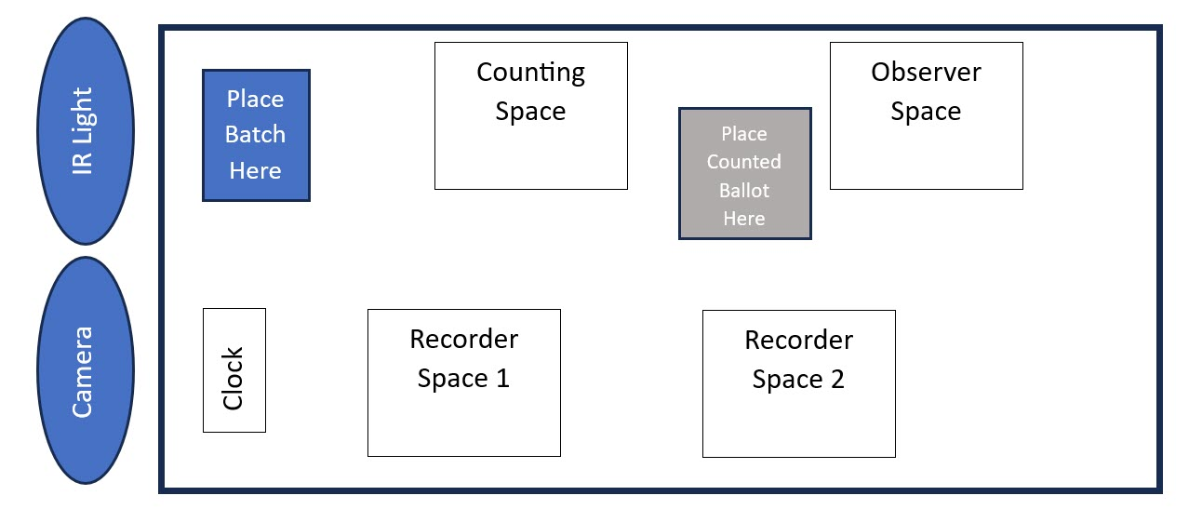
Though this is a diagram of a single Tabulation Tables. We had to share longer tables, so the diagram represents one half with the light and cameras being in the center of the table and the opposing side of the table be the flipped and mirrored.
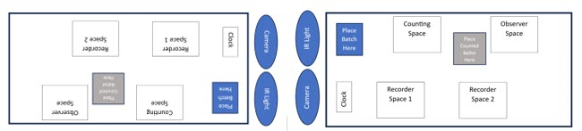
In this rough diagram the ballots would be placed in the center batch start area and move towards the end of the table as counted. By opposing the callers to each other the recorders are able to hear their call clearly.

Adjudication
In traditional machine-managed elections, adjudication not only tends to be a questionable process, but it is also left to those who perform this in isolation. This process also increases the cost of running an election, and the resources to manage the election and, in many cases, highlights the flaws of the digital election process.
If not in every state, at least in most states, it is the voter’s intent that is to be applied by the counting systems. Machine systems can read ovals when filled properly, but what if they are not? Well, then that ballot goes to the adjudication team to decide what the voter intended.
In our process, the Tabulation Team collectively makes that decision right there while counting. If by chance they had any questions, a floor manager can be called to advise on the process, but ultimately, it is that Tabulation Team that makes the decision right there and then.

Security
Depending upon who you ask, different people think different levels of security need to be applied. It is our opinion that security should not be taken lightly. We used cameras at every stage of the handling of ballots, from the initial delivery, handing out, ballot boxes, transportation, and in the counting room. However, the recording of the security checks on the ballots should not be done by any systems that could be connected to a network or remotely accessed. We used older cameras that could feed only to the hard drives connected to them, and the feeds had no means to be viewed live the table counts. The room and other areas of the process did.
Security paper and lights are used to verify the ballot's originality as well as other security measures. The use of seals that are tied into the CoC process is also deployed.

Hand Count Process
The remainder of this whitepaper will focus on the counting process itself. The process ideally should be performed at the precinct level, but we recognize with so many mail-in ballots or voting centers, this process can be adapted to those models. Cause of America has a detailed cost calculator for staffing a hand count, but we will not address that in this paper.
The general process consists of ballot intake, ballot batching, ballot counting/tabulation, aggregation or totaling, and ballot sealing. Each stage includes multiple CoC steps, which provide a method for recreating the election in part of totality.

Ballot Process Flow
The following diagram models the general ballot flow and should be considered to be adapted to your hand count flow/process.
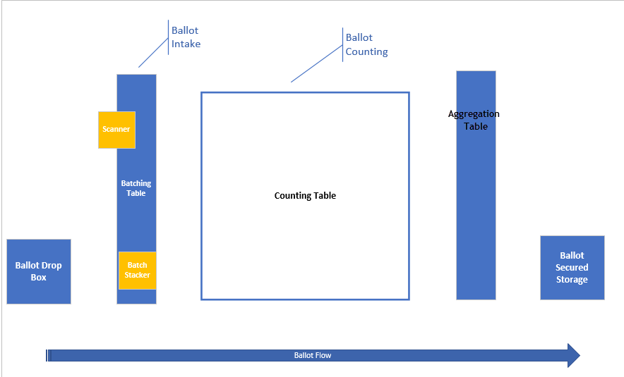

Ballot Collection
Whether at the precinct or from a drop box to the counting floor (as we did in our MCRC election) the ballots submission should not only be recorded, but all collection boxes should also be double sealed and the corresponding CoC paperwork should identify the seal numbers and handlers with time and date for each move. Cameras should also be used to record all ballots being put into the box, and the transportation of the box to the counting area.

Ballot Intake
At the ballot intake area, the CoC paperwork is completed, and the ballots are tracked within this process. The ballots are counted into batch segments. For our election, we did not have to batch be precincts or ballot types, but this should be considered if not counting at a precinct level.
We chose to put our ballots in quantities of 25. Having observed larger batches as being problematic as batch tally sheets used later are small and difficult to read or record. Also, if there are any issues during the counting process, it is far easier to recount 25 as opposed to 50 or 100.
Each batch is then scanned and recorded as to what count paths it will be assigned to. For our election, we needed to count the ballots fast and use paths identified by color. Depending upon the size of your count and time to complete, you may not need to have these identical paths.
Once the ballots have been scanned, they are placed into a batch distribution space, in a bundle and the CoC is completed.

Runners
Runners are used to manage the flow of ballots from the intake to the Tabulation Tables and then from the Tabulation Tables to the totaling table. We initially thought to assign one runner per table but quickly learned it was better to have them focus on a counting path that consists of several tables.
Each time to pick up from the intake area a batch, they need to document right there the pickup, and again when they drop off at a table. Likewise, when they pick up from the table and take to the totaling table.

Tabulation Tables
The most important part of hand counting is this part. Each Tabulation Tables must be configured and operated identically. Any fluctuation allows for a potential question of the count. We used 6-foot tables, with each half dedicated to a count team. If you can use separate tables or longer tables, it would improve the flow. Our count room was not ideal for the number of volunteers we had, but it was what we had to work with.
If you are sharing tables, it is recommended that each team oppose the configuration of the neighboring team.

Our Tabulation Tables Makeup
Tables - 6' x 2.5'
2 counters on one long side
2 UV check/caller/flipper/recorders other long side
1 Atomic clock showing in each camera view: Amazon.com: La Crosse Technology 617-1270 Atomic LCD Alarm Clock : Home & Kitchen
24 teams of 4
96 people total.

Tabulation Team
Each team consists of four members. In a public election, roles should be filled by opposing parties. Each team will complete the CoC paperwork upon receipt of the batch and again upon completion of the batch.

Caller/Observer
This role will be viewing the ballot and verbally calling the voter's choice(s). One will be calling the other will be observing to ensure the caller is accurately performing the call. Each party should be represented in this role in a partisan election. They can rotate if desired, each batch or after several batches.
The caller will set the batch face up in the area identified under the security light. From this position, the table camera can easily view and record each ballot's authenticity. Any question of an artificial ballot in the batch can be addressed by the table and floor manager following the process.
From the stack, the caller will take the top ballot and place it before them where the partnering observer can view the ballot. The caller will begin calling out the number of each voter selection in numerical order. During this the votes are recorded by the recording team.

Recording Team
The recording team should consist of one representative for each party when in a patrician race. Each recorder member will record the vote called by the caller on the batch tally sheet. If there are more races, they can fit upon one sheet. They will tabulate each ballot form from left to right and then turn to the next page. Once the total ballot has been called, they will turn back to the first page and repeat the process.
After the batch has been called each recorder member will tally the total in each column and mark it in the totals row. They will then confirm the totals by each column by one calling the total and the other confirming.
The vote is dabbed using a sharpie. We will cover some of the recommended security aspects of using sharpies and colors later on in the batch tally sheet section. Tallied numbers should be written in pen for clarity.

Clearing the Table
After the batch is counted and tallied, the totals are confirmed, the team documents the totals on the batch form and completes the CoC. A runner will be called to the table, sign the CoC, place the ballots into a security bag, and seal it. The top page is visible through the bag will be the batch total sheet.
The runner will transport the batch to the aggregation table, and another runner will bring a new batch to the table.
At this point in time, roles may swap if desired.

Aggregation Table
The aggregation table receives all the batches after counting and records the totals for each batch. The batch is then placed into a storage bin, and the bin documentation is completed, recording what batches are contained in it. This team may also scan the completed batch sheets and CoC before putting them into the bin.
Once the bin is full, the aggregation team with a storage/transport team will sign the bin account sheet confirming what batches are in it with the sheet atop the bundled batches and seal the bin. They will also affix a duplicate of the bin accounting sheet to the top of the bin.
A runner or storage team member will ensure the CoC is completed and then take the bin to the appropriate storage area.

Our Aggregation Table Makeup
4 aggregators
4 people scanners using 4 scanners.
Following aggregation scanning, finalizing documents will all be scanned (make Final preset and destination)

Storage or Transport Teams
Depending upon the election type and facilities you may have this process repeated multiple times. It may take a local storage room and then transport it to a long-term storage room. Regardless, each time a bin is touched, moved, or transported, it should be documented on the CoC form atop the bin, and each participant should turn in a corresponding CoC form.

Floor Managers
This role is very important and can be thought of as a judge. The role is responsible for ensuring the floor process is not violated, maintaining noise, answering participants' questions, and addressing and documenting any irregularities. You can have floating managers or managers assigned to a set of tables.

Observers
We built this system to provide complete transparency, so the key to this is the ability to have observers in the process. If in a partisan race, please follow your state's laws when it comes to observers. We experienced some challenges with observers, due to the limited space we had to count in.
It is important to give consideration when setting up your counting space to how and where you will allow observation to take place. Ideally is to walk around uninfringed, but the reality is you may need to limit the observation space to the side or surrounding spaces. They should be welcomed so long as they do not impede the flow of the workers, the runner's paths, etc. Also, they need to respect the process and not talk to anyone, as noise can interfere with hearing the caller at a table.
All observers should not be allowed to make calls, text, or communicate while in the room and also from outside the room until polls are closed.

Process Discrepancies
We observed a few problems and had a documented process to resolve them. It is advised to consider and document these prior to the election and include them in your training.

Sharpy Pens
Sharpies are used to dab the batch tally sheet. You can use different colors for different shifts, precincts etc. However, only one color of Sharpie should be used on a batch tally sheet. Documenting the color used and when to use a color is another security measure.

Regular Pens
Regular pens of a set color should be used for tallying and signing of CoC forms. Sharpies should never be used for this as they are not as clear or clean when recording numbers and signatures.

Counting Issues
The following are several of the counting issues we observed and how we addressed them, but generally, the process is consistent. Someone will say stop, all will comply. The error is pointed out, the resolution is implemented.
Miscalled vote: If the caller or Observer catches a miscalled vote, stating the wrong number, one of them will say stop. All at the table will stop what they are doing. The error will be explained, and each recording person will use an error-determined color to cross out the only recorded number and then initial the error. The correct dab will be made, and when all are ready, the process will continue.
Mis-recorded call: If a recorder person dabs the wrong spot, the person recognizing the error will call stop, and the resolution will be implemented.
Wrong line or skipped line: When this happens, it follows the same process as previously mentioned. However, often this is not recognized until the count tally begins after the call or the recording person realizes they have an extra line in the batch rows. Not completed. Following the same process, the deviation is identified. If there was a line skipped, compare the two batch tally sheets to find out what ballot in the 25 batch was the skipped or missed one.
From the skipped line drab a line to the open bottom line, the callers will count back to that ballot and repeat the call. The person missing the count will dab, and the other will confirm it matches their ballot line. The error marked should be signed.
Tallied columns not matching: When a count is not the same by both recorders, they will need to identify the variation. This can be done by comparing the sheets to identify the potential variation. Most likely, one column of one will be plus one while the other is minus one. Comparing the sheets, one can see as they move down what ballot the call was recorded incorrectly. Then the caller can count back to the correct ballot and recall checking the votes. All errors are managed in the same resolution process.
Dropped batches: If a batch is dropped at any point, it is important to immediately stop all movement in the immediate area and collect all the ballots. Those involved and a floor manager may assist should recount the ballots, making sure all 25 are there.

Write-in Candidates
Write in Candidates also are counted, but there are a few different methods that could be deployed. First, depending upon the law, or in our case rules, could there be a write-in candidate? For our election it was not allowed. Therefore, each time someone had a write-in, it was counted as an under-vote. For those who do not know, and under-vote is the recording of less than the maximum selections by the voter was made.
In races where write-ins are allowed, they are recorded as the number assigned for the write-in, in each race. There are two methods to address the counting of write-in candidates. The first is the write-in is simply tallied, without noting the name. At the aggregation table if a write-in was showing a large number of votes, then those batches would be re-examined to identify the write-ins name. It very well could be multiple names had been entered and neither holds a meaningful volume of votes.
The other method would be for the recorders to have a method to record the write-in name(s) when tabulating the table count. A supplemental sheet would be good so each name and race slot(number) could be identified and the number of votes.
Very rare is it a write-in candidate has much of an influence on an election outcome, yet a method of accurately accounting for this type of candidate must be considered.

Templates and Supplies
Here are some of the materials we designed for this election. They can be used as a starting point for your election.

Batch Talley Sheet
Here is a screen shot of the batch tally sheer we designed.
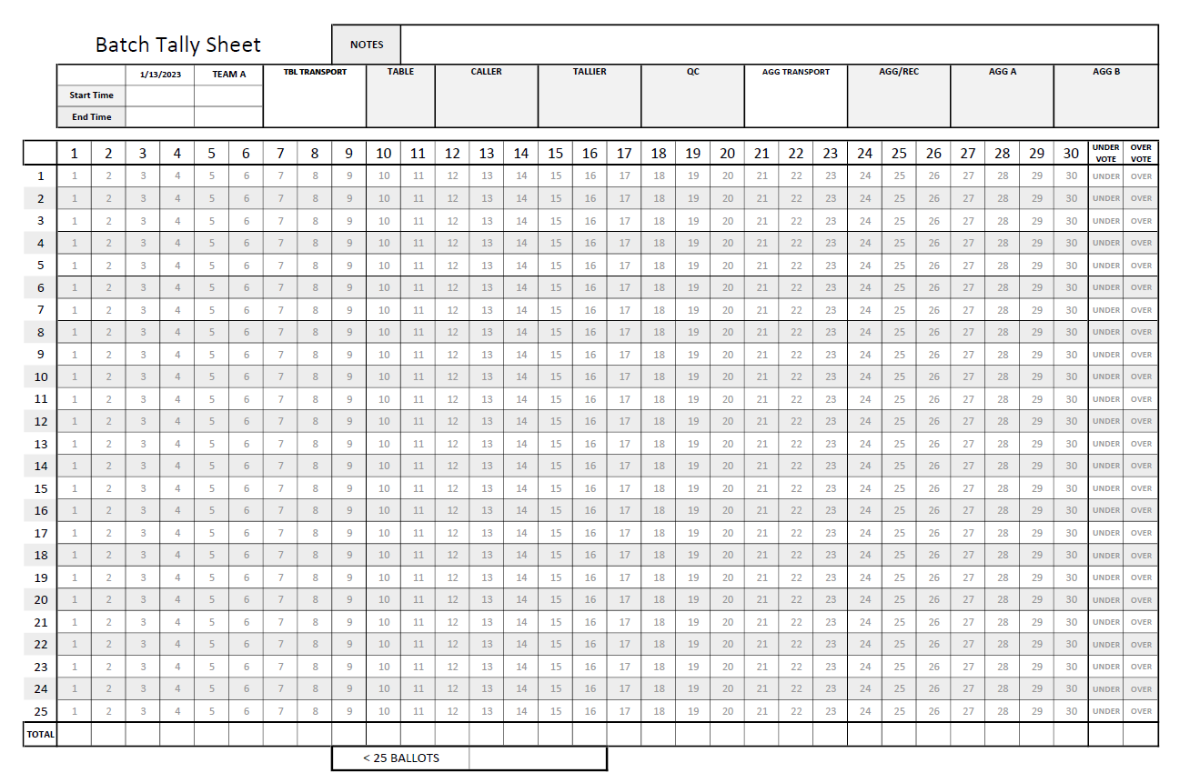
We printed this on colored paper, a different color for each tabulation lane. If you had a need for more races then the displayed 30, we would recommend the following:
Add to the top an A, B,C etc., for each batch tally sheet needed. This should be large and in the upper left corner.
Next to the letter should be a blank where the batch number would be entered. This would allow for batch tally sheet sets to be matched.
Each sheet should be a different color, so all A is one color and B is another color.
When counting the recorder would dab from left to right on the line then switch to the next sheet and continue. You may need a blot protector sheet between each sheet.
The offset shading allows the eyes to follow across the line easier, but we do recommend not using bright colors for your paper and also testing the sharpie color on the paper.

Technology Needs
The following is a list of supplies we used for this election:
20 standalone cameras (~$80ea) $1600 – 20 total
20 battery banks (10,000 mAh) one for each camera
4 TB Network Attached Storage (NAS, RAID-1) for scanned images.
1 Wireless AP
300 UPS
High speed microSD reader
4 Epson ES-580W
3 IP cams for side-stage live display (~10s dwell between cams) used for:
Batching/Scanning
Tabulation
Aggregation/Scanning
Network POE switch.
Laptop for video dwell switching.
PVC for camera and UV light mounts.
Gaffing tape
Extension cords
Security Paper
Security Bags
Ballot Boxes
Ballot Box seals

Sources of items ordered.
256 GB microSD 190 MB/s (https://www.amazon.com/SanDisk-Extreme-microSDXC-Memory-Adapter/dp/B09X7CRKRZ/ref=sr_1_5?keywords=256gb+microsd&sr=8-5)
10k mAh Power Bank set https://www.amazon.com/gp/product/B0BWMNCNZM/ref=ppx_yo_dt_b_asin_title_o00_s02?ie=UTF8&psc=1
4k Camera https://www.amazon.com/gp/product/B076DD5JNS/ref=ppx_yo_dt_b_search_asin_title?ie=UTF8&psc=1
Epson E5-580W Scanner - Refurb - https://www.amazon.com/Epson-Workforce-ES-580W-100-sheet-Touchscreen/dp/B09L45YPZK/ref=sr_1_4?keywords=es-580w&sr=8-4
- New - https://www.amazon.com/Epson-Workforce-ES-580W-100-sheet-Touchscreen/dp/B08P3ZT5WH/ref=sr_1_3?keywords=es-580w&sr=8-3
Atomic LED Clock https://www.amazon.com/Crosse-Technology-617-1270-Atomic-Digital/dp/B00ZVTMS82/ref=sr_1_53?keywords=atomic%2Bclock&sr=8-53
Security Printing Paper: There are a variety of sources.
Amazon.com : DocuGard Premier Medical Security Paper for Printing Prescriptions and Preventing Fraud, CMS Approved, 10 Security Features, Laser and Inkjet Safe, Blue, 8.5 x 11, 24 lb., 500 Sheets (04543) : Printer And Copier Paper : Office Products
Seals:
https://www.amazon.com/Transfer-Evident-Security-Warranty-Numbers/dp/B07GPGGQ5Y/ref=sr_1_2_sspa?crid=N8MYYYVNNQ6J&keywords=security+paper+void&qid=1707322587&sprefix=secrity+paper%2Caps%2C327&sr=8-2-spons&sp_csd=d2lkZ2V0TmFtZT1zcF9hdGY&psc=1
Amazon.com: Leadseals(R) 100 Plastic Tamper Seals, Zip Ties for Fire Extinguishers Pull Tite Security Tags Numbered Disposable Self-Locking Tie 250mm Length (Red) : Industrial & Scientific
Tamper proof document bags.
Amazon.com: BankSupplies Cash Transmittal Bags | 10W x 14H | Pack of 50 | Transit Contaminated Currency | Tamper Evident Seal | Write-on Panel | Barcode | Clear Cash Bags : Everything Else
Amazon.com : MMF Industries Cash Transmittal Bags | 9W x 12H | Pack of 100 | Unique Alphanumeric Numbering | Self-Sealing Adhesive | Four Tamper Indicators | Folded Bottom | Deposit Plastic Bags : Tamper Proof Bag : Office Products

Vote Process Basic Check Sheet
The following we used to ensure each role was filled and identified, the timing for each position, duties and other relative information. We are including it so you can appreciate the number of roles and volunteers needed and the details to consider.
Team Coordinator: _____________
Arrive at 7:00am
Provide Credential for Tally Workers and Sign-in
Lanyards- card
*Volunteer list by roles

Ballot Distribution
Workers Arrive by 7:15am
Security Arrive by 7:00am
Ballots will be delivered to location at 7:00am
Instructions
Ballots and voter cards will be gathered into sets.
Placed in Sorting Rack
Receive Credential Card (MUST HAVE CREDENTIAL CARDS)
Distributed to voter.
Voter will Confirm Receipt
Credential Card will be hole punched on Ballot Indicator

Chain of Custody
Ballot Collection and Transport
Receptacle will be numbered and have chain of custody document.
When collected and replaced, they must be signed for.
Bins A-D placed in Sanctuary.
Cart with Camera will retrieve and replace those bins with A2-D2
Repeat
Spoiled Ballots
Must mark error ballots spoiled and place in security sealed bin.
Replace Ballot
Ballot Security
Make sure voted ballots are secured with proper chain of custody documents.
Prepare voter bins for next round of voting.
Secure unvoted ballots

Batch Team
Chain of Custody Assignment: When bin is delivered to the batching tabled, batcher must sign for receptacle and confirm tag serial numbers BEFORE opening.
Once opened and emptied, new serial number tags must be placed and logged on bin for next round.
Batcher
Create packets of 25. If a short batch is at end of bin, notify Batch Assigner.
Batch Assigner
Assign Tally sheets for batches (X and Y) and Batch Cover for packet for scanning. If it is a short batch, document in red pen on bottom of tally sheets the quantity in batch.
Packet Order
- Tally Sheet X
- Tally Sheet Y
- Batch Cover
- Ballots
Scanner
Place batch face down with top first in packet order.
Name Batch file name on Scanner.
Confirm document number scanned.
- Basic batch 28 documents
- Short Batch document number plus 3
Place a sorting rack for transport.

Transport Manager
Batch in Transport (5)
Sign for batch and deliver to tally table without batch.
Have the caller assign it to the table and sign for batch packet.
Batch Out Transport (5)
Recover batches from tables.
Check signatures and totals.
Sign for batch at table, Security Seal Ballots in transport bag.
Deliver Ballots to Chain of Custody and the Batch Sheets to Aggregation.
Have them sign for custody.

Tally Manager
Caller
Take custody of batch packet
Sign and write table number on Tally Sheet X and Y
Distribute Tally sheets to Tally X and Y
Flip ballot under UV and call numbers to Tally (repeat until done)
If a mistake is made during calling, say “STOP” then repeat that ballot to tally.
Speak clearly and at a steady pace.
Rotate with QC between batches.
QC
Watch the Caller at all times.
Make sure that the caller is giving the correct numbers.
Check ballots for the UV fibers.
Assist Caller with any adjudication issues.
If the caller makes a mistake, call “stop” and have the caller repeat the ballot.
Rotate with Caller between batches.
Tally
Any question with more selections than allowable- over vote- no votes are counted on that question.- Mark tally sheet OVERVOTE.
Any question with fewer selections then allowable - under vote - Mark tally sheet UNDERVOTE
*Adjudication- instructions
Dab the tally sheet by ballot from left to right.
X - use Blue Sharpie Y - use Black Sharpie
Once all ballots are complete, total the candidate votes are in the final column.
Use Red ink pen for totals - DO NOT USE SHARPIE
Mistakes should be corrected with Red Sharpie
- If you dab the wrong candidate, X out with red sharpie and correct
Once the totals are complete. Tally X will call the results out from left to right to Tally Y and confirm a match. If a match, Tally and witness should sign their own tally sheets and raise their hand.
If caller goes to fast, say “Slow Down.”
If you need to hear again, say “repeat ballot ____”
Caller will then say “repeating ____” and repeat those results.
If the tally does not match, they should identify which tally does not match and caller shall repeat the results of that “question” (candidate, resolution, etc.)
Fix error with red sharpie.

Aggregation Manager
Aggregators will be assigned Batch Total Sheets - Initial sheet.
Aggregator X will log results of each batch in corresponding batch row (left to right) from Tally Sheet X
Aggregator Y will log results of each batch in corresponding batch row (left to right) from Tally Sheet Y
Watch for overvote and undervote.
Once all batches are logged, totals should be filled out.
Aggregator X should call the results to Aggregator Y to confirm match. If a match they should sign off Batch Results and give to Final Results.
If they Do Not match, pull the correct batch and confirm the results. Correct the error and return.
Final Results
Batch Total sheets should be logged until all batches are complete. Totals are the final results. Final results should match X and Y. If the match is confirmed, they should sign the sheets and deliver them to the canvass officer.

COC Officer
Sealed Ballot Batches should be placed in security bins and sealed with security tags.

Canvass Marshall
Calculate final results for reporting.
Scan final tally documents and sealing in bag documented on outside of bag by Bins A. B. C. D

Team Coordinator
Arrive at 7:00am
Provide Credential for Tally Workers and Sign-in
Lanyards- card
*Volunteer list by roles

Appendix
Here are the attachments of materials referenced within this paper:

