Section 4 – Central Scanning Device

File 4-2 CSD Tabulation

4.2 Describe your CSD's tabulation process.

Paper Feed Mechanism
The ballot feed mechanism on the Canon DR-G1130 is intended to handle ballot sizes of 8.5” to 22”. The ballot feed mechanism on the Canon DR-M160II can also handle ballot sizes of 8.5” to 22”. The paper feed mechanism is physically capable of moving the ballot paper forward into the machine and across two image sensors (one on top, one on the bottom). These sensors provide image captures of both sides of the ballot.

The basic design of the scanners consists of separate upper and lower imaging surfaces (known as upper and lower units). These surfaces open up for convenient cleaning, maintenance and freeing of ballot jams. Pickup and drive rollers are located on the upper surface, and retard rollers are located on the lower surface. The continuous movement of the upper and lower surfaces minimize the number of ballot jams. The stepper motor torque and the paper feed mechanism's forces of friction have been optimized so that over-torque (where the ballot can tear) or under-torque (where the ballot can become stuck in the machine) do not occur.

Ballot Insertion and Capacity
An automatic document feeder is used to insert ballots. The DR-G1130 has a feeder
capacity of 500 sheets. The DR-M160II has a feeder capacity of 60 sheets. Each feeder can also be operated in manual mode where one sheet is fed at a time.

When the ballots to be scanned are placed on the hopper, a sensor will detect that there is paper ready to be scanned. The operator initiates the scan using the ICC application. The scanner will then begin processing ballots automatically.

If there are no defective ballots, scanned images of all the processed ballots will have passed the quality checks and are ready for tabulation.

Multiple Sheet Detector
The ultrasonic double-feed sheet detector of each unit monitors if more than one sheet of paper is in the transport at one time, and will prevent the unit from counting marking positions from two ballots at the same time. Detection is based on an ultrasonic probe that is immune to ink markings on the ballot, as well as the thickness of paper.

Diagnostic Tests
An automated test that performs a diagnostic check and formal report on the system, including:

- Detecting and reporting the system's status and degree of operability
- Confirmation that there are no hardware or software failures
- Identification of the software release
- Status of all data paths and memory locations to be used in vote recording to protect against contamination of voting data
- Other information needed to confirm the readiness of the equipment and to accommodate administrative reporting requirements
- Confirmation that the device is ready for the poll to be opened
- Upon conclusion of the tests, the software provides evidence in the audit record that the test data has been expunged.

The central scanning devices also perform a set of diagnostic tests after every power on/off cycle. Some of these tests require operator intervention and some are fully automated. At the end of the diagnostics process, the system generates a report with the system status information.

For network applications and user interfaces, Democracy Suite EMS Results Tally & Reporting has the ability to generate a zero-state report before the system is utilized. This report extracts all the relevant counters from the database which should be zero before the central scanning process is started. Electoral officers can use this report not only to check that all candidates have no votes, but also to check that the lists of elections and associated candidates are correct.

The EMS system also executes a security report which creates a list of all terminals, workstations, central scanning devices and all authenticated operators within the system.

“Election Run” Mode functionality
During scanning, all ballot batches are placed on the ballot entry tray. Upon initiating a scan, the tabulator pickup roller grabs one ballot at a time and moves the paper over both scanning read heads (thus acquiring a complete image of both sides of the ballot). The ballot is then analyzed and defined as one or more of the following:

- Fully and properly marked ballot
- Misread ballot or invalid ballot
- Blank ballot
- Overvoted ballot
- Undervoted ballot
- Write-in ballot
- Ambiguous voting mark
- Ballot not linked to the current poll ID
- Ballot to which the write-in precedence rule was applied
- Overvoted party preference
- Unvoted party preference
- Cross-voted ballot
- Major overvote
- Major undervote
- Major overvoted rank
- Major inconsistent rank
- Major duplicate candidate rank
- Major skipped rank
- Major unvoted ranked contest
- Major unused rank
- Overvoted rank
- Inconsistent rank
- Duplicate candidate rank
- Skipped rank
- Unvoted ranked contest
- Unused rank

Ballot Scanning Errors
The following will halt the scanning process.

- Misread or Invalid ballot: A ballot that cannot be processed by the tabulator for whatever reason. This includes legitimate ballots that have been mis-scanned, foreign pieces of paper, or blank pages.

- Multiple sheet warning: If more than one (overlapping) ballot is fed into the scanner at the same time.

When the offending ballot has been located in the ballot exit tray, it is removed for resolution. In addition, the scanners may be configured to halt on additional error conditions (i.e. overvotes, undervotes, blank ballots, etc.).

Scanning a Batch
The ImageCast Central allows the user to easily scan and manage ballots. Below we provide details on the steps needed to scan a batch of ballots.

- Load ballots on the scanner input tray
- Click “Scan” on the workstation screen
- Remove ballots form the output tray
- Click “Accept Batch” on the workstation screen
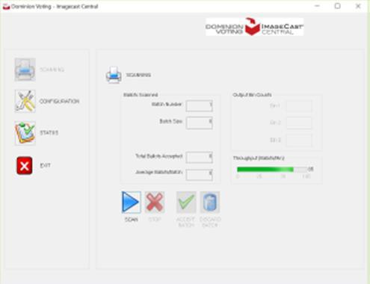

Tracking and Managing Batches
Batches that do not have any outstack conditions are routed to the Results Tally and Reporting module for tabulation. Batched containing ballots with outstack conditions are routed to the Adjudication stations for further scrutiny.

Adjudication Administrators have the ability to track and review what batches are in adjudication (In Progress pane), which batches are ready for review (review pane) and which batches have been submitted to tally (Submitted pane), as seen in the screenshot below. The Adjudication Administrator can see at a glance how many ballots remain to be adjudicated.

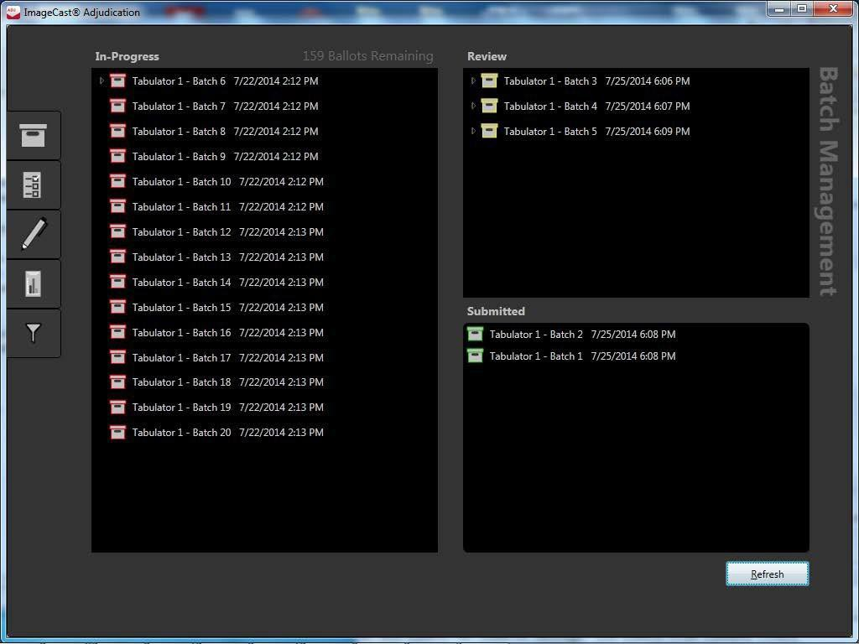

Tabulating
Results Tally and Reporting (RTR) module allows for the upload of results files from in-person and central tabulation equipment. The consolidated results are verified, tabulated and published. RTR offers maximum flexibility to create predefined reports, in addition to a variety of standard Election Day reports including election summary, Statement of Votes Cast, Cards Cast and RCV round by round report. RTR also houses the algorithm for Ranked Choice Voting contests. Results files may be automatically uploaded to Results Tally and Reporting and consolidated results are available for verification prior to publishing.

An additional efficiency built into the Democracy Suite RTR module is that reports can be generated as ballot processing continues uninterrupted. Under legacy systems, pulling reports causes a disruption to ballot processing. This efficiency enables Counties to better respond to the community requests for real time election data; results are instantaneous.

- Once data is uploaded, the County will store all log files, data, and images.
- All data is reviewed, and published, then reported. These checks and balances occur prior to publication, thus reducing errors and increasing transparency.
- Reporting options are highly flexible. Counties can choose to complete a normal, standard based report, or on-the-fly election reports that are highly customizable, that can meet any of the needs of the office and its constituents. Democracy Suite has the flexibility to output data in many common file formats such as excel, pdf, html, CSV and XML.

