Section 4 – Central Scanning Device

File 4-1 CSD

4.1 Complete the attached form titled "Central Scanning Device" and include narrative.
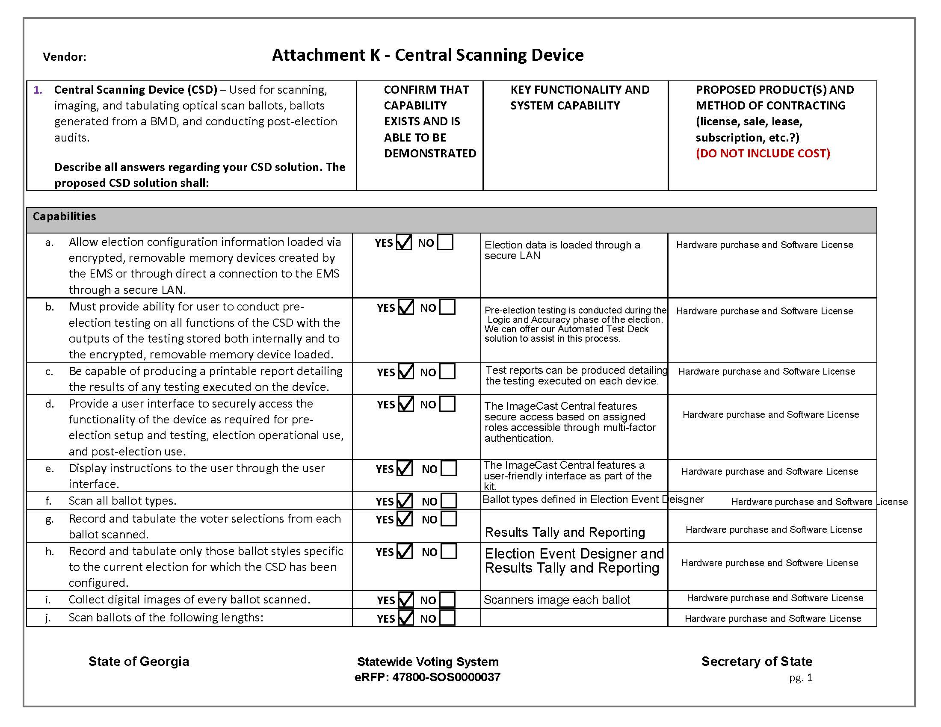

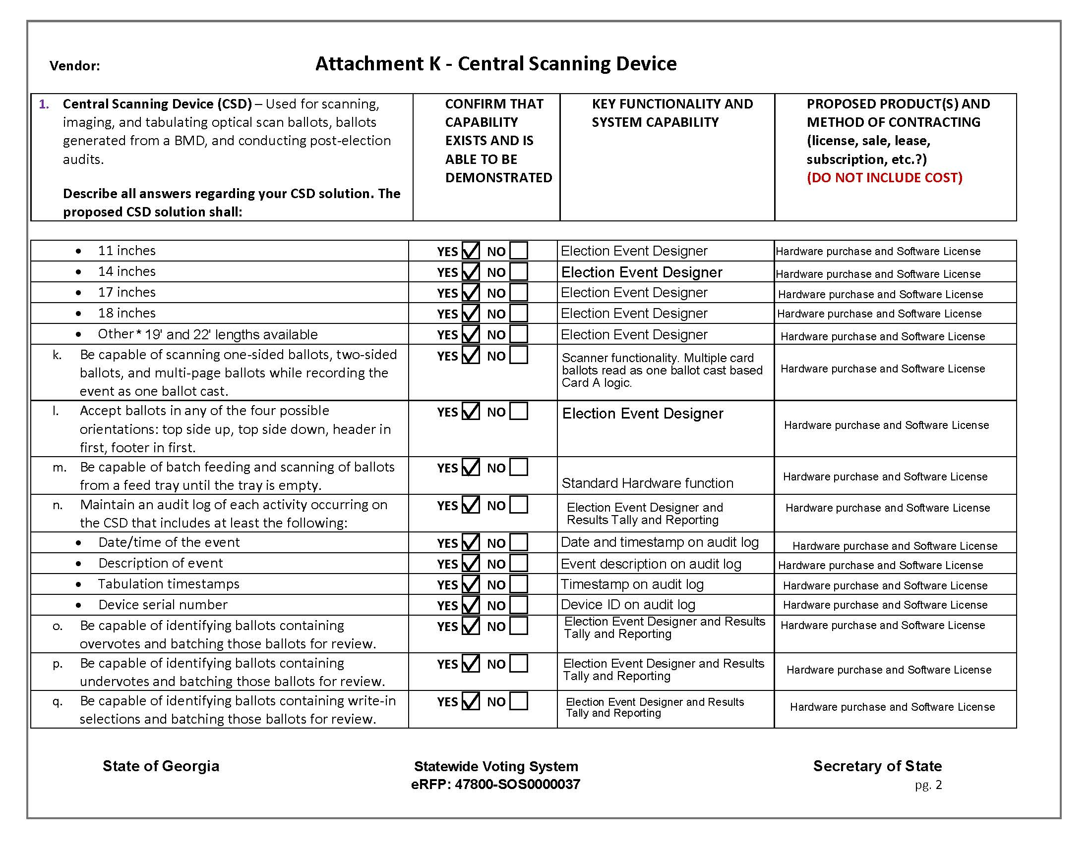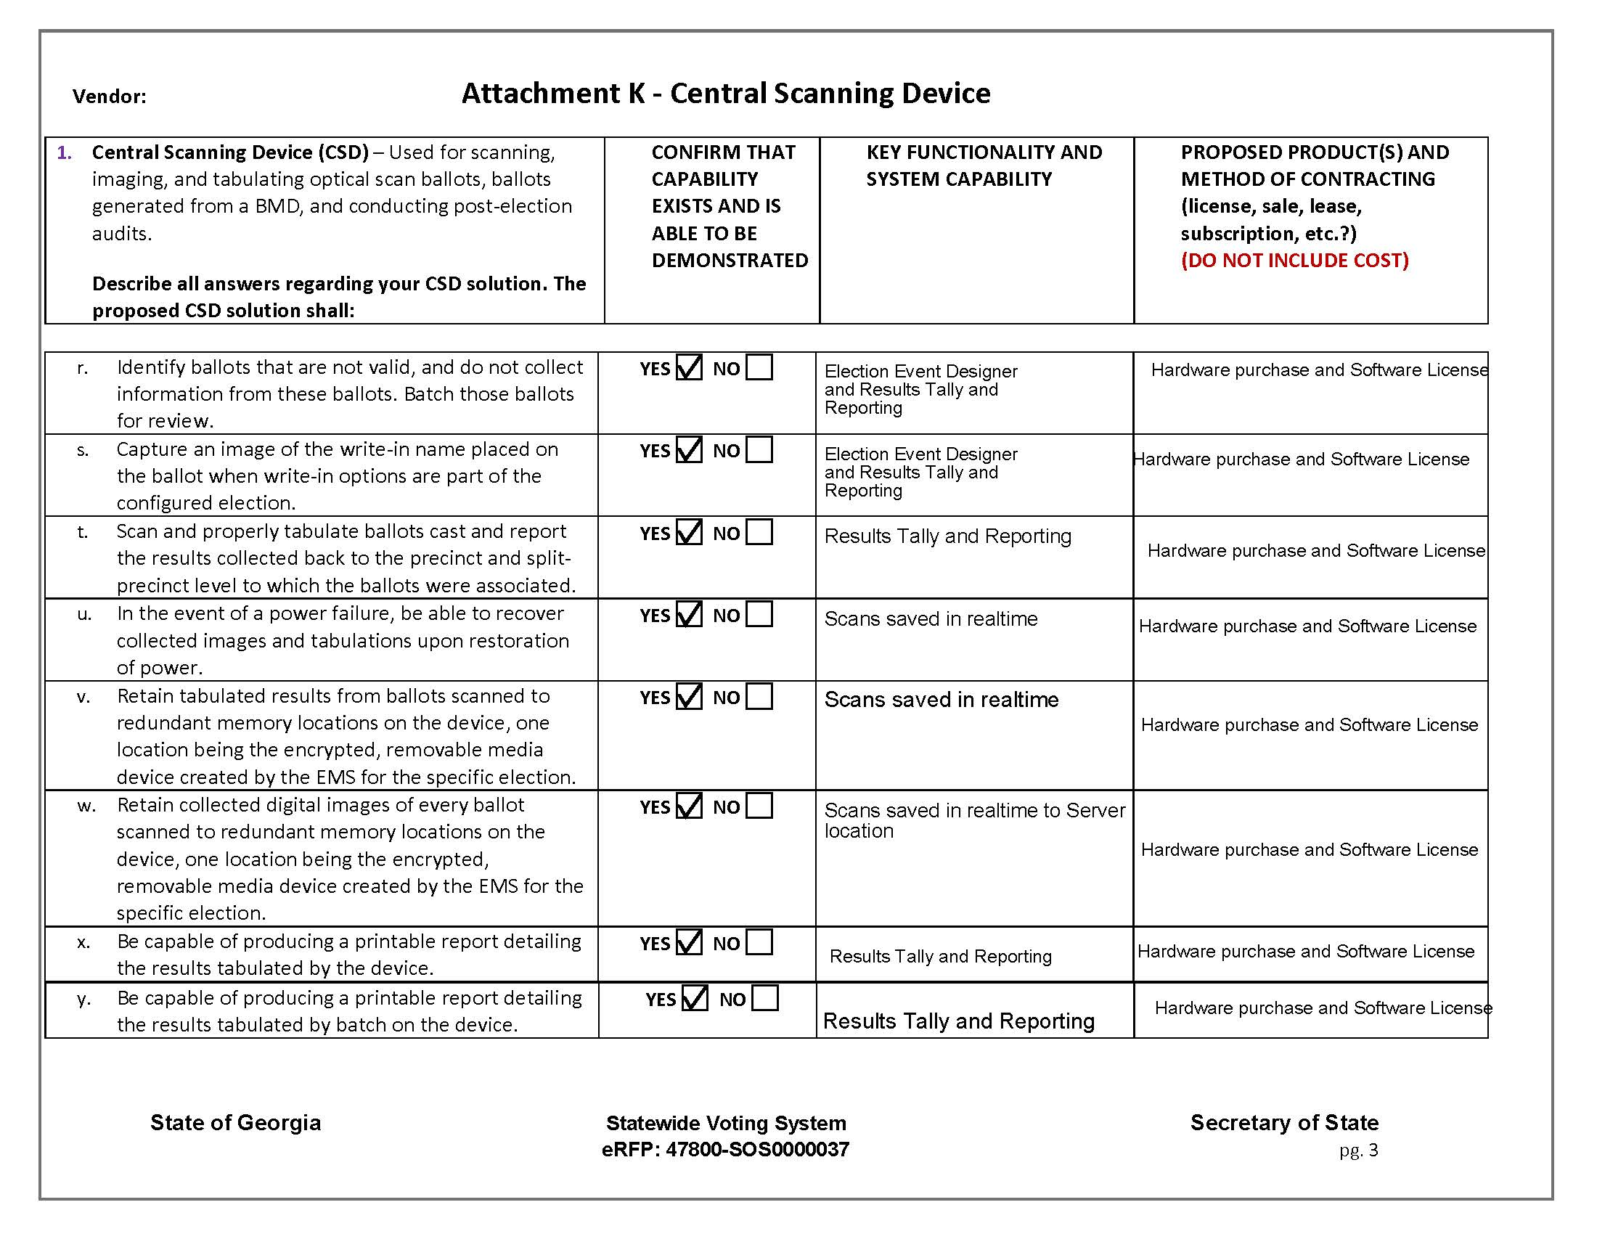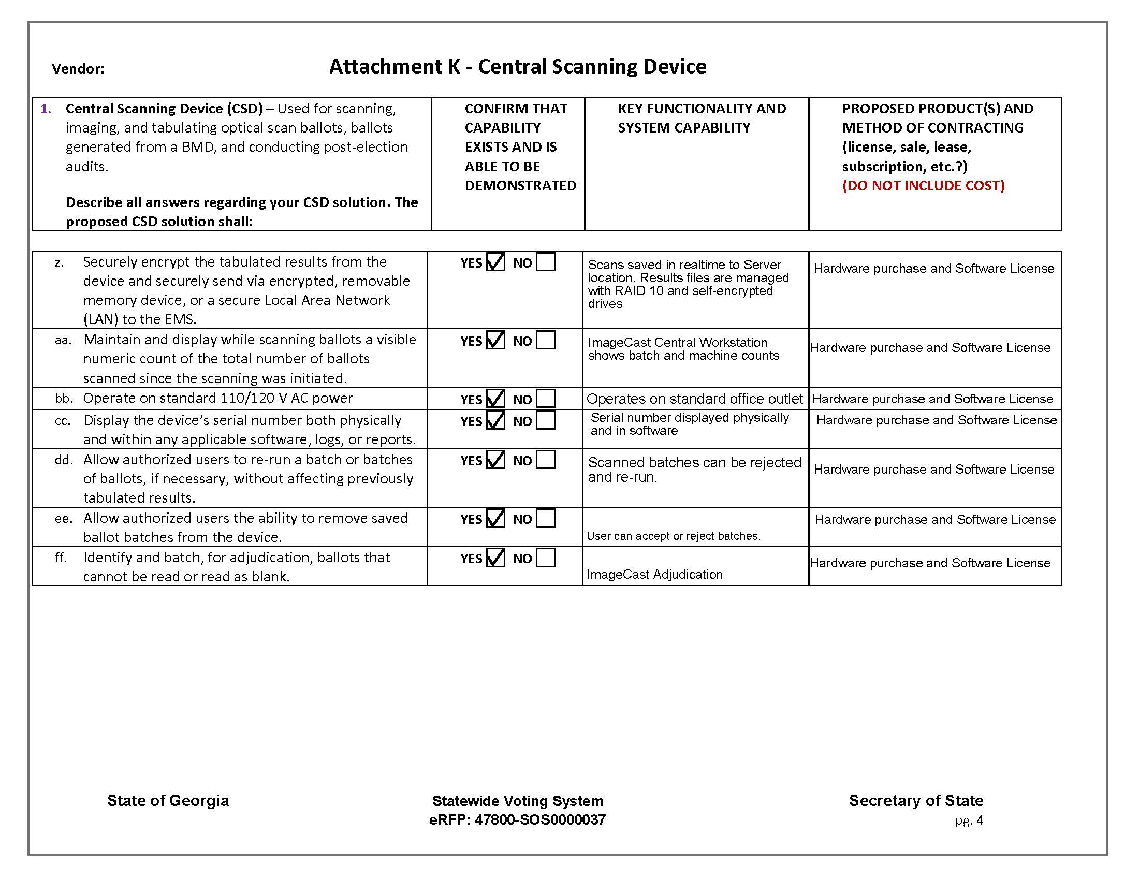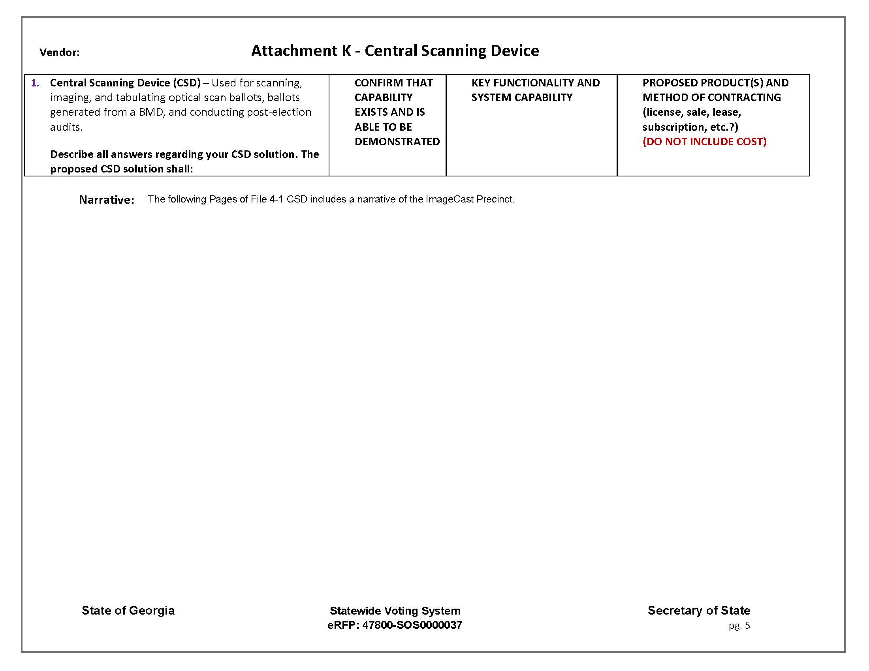
Dominion’s ImageCast Central, like all of our ImageCast products, stores the ballot image with the secure AuditMark. The system’s flexibility allows the jurisdiction to customize outstacking conditions, such as overvotes, undervotes, marginal marks, and certified write-in contests. The ImageCast Central has all the tools election officials are looking for to make their central count process easy and more efficient.
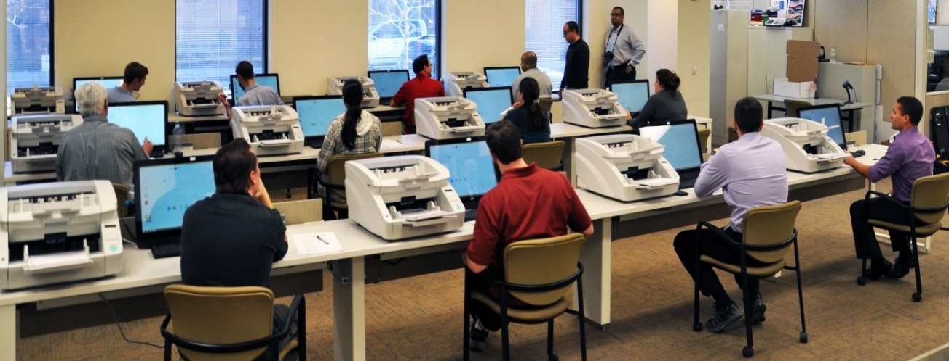
Jurisdictions can add ImageCast Central units to maintain efficiency while remaining cost-effective.
Dominion’s ImageCast Central solution consists of commercially-available-off-the-shelf components. This allows Dominion to focus on software and increase efficiencies of the vote tabulation process. There are several options of hardware including the Canon DR-G1130, which is a solid, consistent scanner which scans ballots 8.5” by 11” and up to 22”. For smaller precincts, the Canon M160ii can be deployed, which can also run ballots that are 8.5” by 11” and up to 22”. All the Dell computer hardware is specified through certification.

Easy to Use
The software is intuitive and requires minimal training for users. It is simple – the operator loads the batch into the scanner and presses Scan. When complete, the operator presses the Accept button and moves onto the next batch. The operator does nothing but process the ballots. The system’s intelligence does the rest. Along with the requisite COTS hardware, the ImageCast Central provides ample flexibility to meet the needs of small, medium, and larger jurisdictions. ImageCast Central allows jurisdictions to consolidate results in an efficient environment, in real time.

Flexible and Scalable Solution
Along with the requisite COTS hardware, the ImageCast Central provides ample flexibility to meet the needs of small, medium, and large jurisdictions. ImageCast Central allots jurisdictions to consolidate results in an efficient environment, in real time.

Better Scan Reliability
This use of less expensive and compact third-party devices enables the ImageCast Central count solution to offer higher sustained throughputs in the face of hardware failures, flexible site layouts when space is at a premium, and access to a vast pool of readily available replacement parts and certified technicians. Additionally, these units have minimal moving parts, which increases the reliability. A simple microfiber towel is all you need to clear the dust and particles left by paper ballots. The uptake rollers and be easily removed for cleaning or replacement. All of these factors translate to improved maintainability, and lower cost of ownership.

The ImageCast Central has a proven track record of being able to scan ballots in real- life ballot scenarios, such as folded ballots, and ballots that have been crushed, stained or are dirty. Customers have noted that this has significantly reduced the number of ballots that need to be hand duplicated before being processed through the system. The Canon scanner features a simple paper path, limiting the number of paper jams. There is no pre-sorting of ballots or re-orientation of ballots needed before scanning.

Programming the ImageCast Central
Central scanning is typically used to process absentee or mail-in ballots. The election definition is taken from EMS, using the same database that is utilized to program any precinct scanners for a given election. Multiple ImageCast Central scanners can be programmed for use in an election. The ImageCast Central application is installed and later initialized on a computer attached to the central count scanner. Ballots are processed through the central scanner(s) in batches based on jurisdictional preferences and requirements.

Results from the ImageCast Central
The ImageCast Central stores ballot images by scanned batches. The scanned ballot images are migrated to the Election Management System through computer internal secure LAN networking or removable media. As with results data from any precinct scanners in use for an election, Results Tally and Reporting is the portion of EMS that processes the images to provide tabulation and operational reports to the jurisdiction.

Batches can be appended, deleted, and processed in a number of ways to suit typical election workflows, intake of ballots before, during, and after Election Day, jurisdictional requirements surrounding absentee ballot tabulation, and canvassing needs. The ImageCast Central also features all of the technological advances present in the precinct-level tabulators – the AuditMark and the Dual Threshold technology.

