Hand Counting Process - A Florida Handbook
for
Collier County FL
(Based on Linda Rantz Missouri Hand Count Process)

- Why Hand Count? (p.2)

- Guiding Principles (p.3)

- Florida Statutes (p.4)

- Collier County Supervisor of Elections (p.6)

- Batches, Ballots, and Results (p.7)

- Ballot Judges, Tally Judges, and Observers (p.8)

- Preparation (p.10)

- Interpreting Ballot Marks and Florida Rule 1S-2.027 (p.11)

- The Tally Process (p.16)

- Documenting Results (p.17)

- Expect the Unexpected (p.18)

- General Reminders (p.19)

- Appendix (p.20)

Why Hand Count?

All across the U.S., people have lost trust in our election process. In a Rasmussen poll in June 2023, two thirds of likely voters are concerned that the outcome of the 2024 Presidential Election will be affected by cheating.

Elections have become a huge apparatus of Statutes, Rules, local Supervisor of Elections process and practice, vendors, associations, consultants, NGOs, and government agencies (both federal and state). Our votes, what we mark on a piece of paper, are buried somewhere in all of that complexity.

There are many Florida Statutes (FS) impacting elections, but there are two key Statutes most relevant to hand counting the paper ballots:
- FS 101.5604, requiring the use of electronic machines to count the votes, and
- FS 101.031, the Voter’s Bill of Rights, which clearly states “each registered voter in this state has the right to vote and have his or her vote accurately counted”.

Returning to hand counting will not eliminate the apparatus, at least not all of it, but it will save time and money, give substantially more transparency and security, and put our election results back in human hands.

Hand counting alone, without a process to ensure only legal voters can vote and only valid ballots are counted, will not guarantee the legitimate outcome of any candidate race or question on the ballot. However, it will help restore confidence by assuring proper counts of the ballots that have been tallied by the machines.

Guiding Principles

There are four key principles guiding this specific hand count process:

- Bi-partisan volunteers. The volunteers in all aspects of the process should be selected from Registered Voters of both major parties (Republicans and Democrats) whenever possible. Voters registered as ‘No Party Affiliation’ or one of many independent parties also should be welcomed to participate. This approach helps build trust in the process and results.

- Observers are there to observe. Each party may wish to have Observers participate in the process. However, just as we have Poll Watchers today whose role it is to observe and report concerns or issues, the role of hand counting Observers is likewise to observe and report. The process will not be slowed down by Observer concerns - with the possible exception of ballots that may appear to be inauthentic, which will be documented.

- Speed is an outcome, not a goal. The primary goals of hand counting are accuracy and transparency. There is no goal or reward for speed. That being said, it is important that the process proceed as quickly and efficiently as possible to demonstrate the capability for its application in the future as a way to certify election results.

- Common Courtesy. All participants are required to be respectful and courteous at all times.

Florida Statutes

It is important to have an understanding of the key Florida Statutes that impact this hand count process.

Let’s look at them here briefly. It is suggested that each volunteer in the hand counting process read and be familiar with them. The applicable section of the full Statute is provided in the Appendix.

- Requirement for electronic voting (FS 101.5604)

The State of Florida requires that ‘A county must use an electronic or electromechanical precinct-count tabulation voting system.’

- Certification versus Verification (FS Chapter 102)

Until such time the above law is changed, we must CERTIFY elections based on machine counts. However, there is no Statute that precludes a hand count of the ballots to VERIFY the results.

- Handling the Ballots (FS 101.572)

Florida law prohibits all but SoE Office staff (or the canvassing board) to physically touch the ballots. This will slow down the hand counting process, however, it is considered an important safeguard for preservation of the physical ballots.

- Precinct Level Election Results (FS 98.0981)

Voting results are required to be reported by Precinct and voting method. In a city election such as Everglades, there is only one Precinct. In most other elections, we will need a modified process to sort ballots by Precinct before counting. And we will need to batch and count separately Early Voting, Election Day, and Vote By Mail ballots.

- Undervotes and Overvotes (FS 102.166)

Florida statutes have requirements for counting of undervotes and overvotes. This is necessary in determining whether a recount may be required based on close races (generally, ¼ of one percent separating the top candidates). In such cases, a recount is ordered and often done manually to ensure the machine has properly captured the voter intent. Given that we are already conducting a manual count and can see the voter intent, separate tracking of undervotes and overvotes is unnecessary. However, inquiring minds may want to know, so we will track them for this particular hand count for the mayor race only.

- Write-in Candidates (FS 99.061)

The SoE Office is responsible for determining, and submitting to the Department of State the names of all qualified write-in candidates.

When hand counting an election where there are no qualified write-in candidates, such as the City of Everglades election, any write-in names will be ignored.

A separate process is used where there are qualified write-in candidates. This will be explained in a future edition of this document as needed.

- Blank Ballots (no Statute)

Blank ballots have been the subject of much speculation in recent months. There is no specific statute relating to blank ballots. However, a required State form (DS-DE 40) defines the field called ‘Blank Ballots’ as follows: ‘A blank ballot contains no selected vote targets’.

For purposes of hand counting, a blank ballot (that which contains no vote targets) is treated as a Rejected Ballot.

Collier County Supervisor of Elections

It is important to note that our Collier County Supervisor of Elections (SoE), Melissa Blazier, has agreed to allow us to hand count the ballots (post-election) for the City of Everglades election being held on November 28, 2023.

There is nothing in Florida Statutes that requires any SoE to allow hand counting of the paper ballots. Importantly, there is also nothing that precludes it as a process to verify the machine counts.

We applaud Melissa Blazier for allowing us to apply a hand counting process to the City of Everglades election. We appreciate her decision. We also appreciate the time she and her Staff have taken as we discussed the process, addressed questions, and ensured understanding for all in advance of the counting event.

The following details have been agreed:

- The event will be considered a post-election audit. That means, it will occur some time after the results of the elections have been officially certified.
- As is stipulated in Florida Statutes, ballots will be physically handled only by SoE Staff.
- A limited number of Observers will be allowed.
- The cost for this process will be determined by the SoE based on the number of hours and hourly rate of pay for SoE staff required.
- The SoE Office is not responsible for identifying or inviting any volunteer participating in the process.
- The SoE staff will bring the ballots into the room in a container that is clearly secured with the same protocol used in all elections to ensure no tampering. Likewise, at the conclusion of the event, SoE staff will return the ballots into a secure container for return to appropriate storage.
- There will be no objects on the table where the ballots will be handled except for the ballots and the ballot tray.
- Ballots marks may be interpreted differently by the Ballot Judge than the machines (the ES&S system coding). This may result in explainable differences between the hand count process versus the certified ES&S results.
- No camera for capturing the process through photos or video will be permitted.
- Cell phones may not be used in the room where the event will occur except that, at the conclusion of the event, cell phones may be used by volunteers to capture a photo of the voting results forms.
- The SoE, or other members of the SoE Staff are allowed in the room at any time to observe the process.

Batches, Ballots and Results

The best process is one that is simple and quick to teach. Many who have already tried this hand counting process express surprise – they expected it to be complex and realized they were “over-thinking” it.

The hand count process has 3 basic segments: Ballots, Batches, and Results.

First, tally the ballots using the Tally Sheets.

Second, add up the batches (if there is more than one counting group).

Third, document the results.

Ballots
Hand counting is done by bi-partisan teams of Ballot Judges at the polling place using a simple tally form. Counting is NOT done by marking 4 tick marks and then crossing through them on the 5th. The Hand Count Tally Sheet is designed to be as quick as recording pitches at a baseball game, and as easy as marking numbers called at Bingo.

Batches
As each batch of ballots is counted, the totals will be tabulated (added up) by copying the column totals onto a summary sheet. The Batches Summary sheet makes transferring totals quick and easy to double-check for accuracy when there are multiple counting groups.

Results
When all ballots are counted and tallied, the calculations are done and entered on the Overall Results form. The bi-partisan team of Tally Judges reviews and double-checks results again. When the agreement is reached on the results, the Statement of Returns is completed.

(Note: If the process were to be conducted during an actual election, some additional steps would be required.)

Ballot Judges, Tally Judges, and Observers

Each Group consists of 2 Ballot Judges (ideally, 1 REP and 1 DEM), and 2 Tally Judges (also ideally, 1 REP and 1 DEM).

Each party (REP and DEM) may also allow two Observers per Counting Group.

One option to consider for the small Everglades election is to schedule two Counting Groups. This will reduce the total time to tally the ballots by half.

When hand counting of ballots has begun, it must continue without adjournment or
postponement to ensure the chain-of-custody of the ballots and documents.

Reading and Counting the Ballot Marks

- The SoE Staff will bring the ballots into the room and remove them from their secure container.
- The SoE Staff will take one ballot at a time and hold it in such a way that both Ballot Judges may easily view it. (For this election, it is a one page ballot - front only.)
- One Ballot Judge will begin by announcing the vote mark for the first candidate race. This will be done by calling the race, and the vote mark for the candidate as indicated. For example, ‘Mayor - Grimm’.
- The second Ballot Judge will only interrupt if there is a disagreement.
- Both Tally Judges will mark their own Tally form accordingly.
- The next ballot marks will be read by the second Ballot Judge, and mark calling will continue to alternate between the two Ballot Judges.
- If the Ballot Judges disagree, they must discuss and come to an agreement. (In a real election, this would be set aside for the Canvassing Board.)
- If a Tally Judge mistakenly marks their Tally form incorrectly, the Tally Judge should call ‘hold please’ and the mark should be crossed diagonally with a pencil. The next time that ballot mark is called, that pencil mark is erased.
- If the Ballot Judges are calling marks faster than either Tally Judge can enter the marks on the Tally form, the Tally Judge shall state ‘please slow down’. It is appropriate for conversation between the judges to occur so that the process can be adjusted as needed to ensure accuracy.
- Every candidate race and ballot question are called before moving to the next ballot.
- After all ballot marks on a ballot have been called, the SoE Staff will place the ballot in a marked space on the table or in a container. There will be three categories of ballots after review - accepted, rejected, or unreadable.
- There are two instances where a ballot is rejected: (1) if every candidate race and question is ‘overvoted’ (i.e., more than the allowable number of choices), or (2) there are no voting marks on the ballot (blank ballot).
- Unreadable ballots are those where every mark on the ballot is unclear as to voter intent. Rejected and unreadable ballots should be set aside and placed in separate envelopes by the SoE staff.

(Note: In a real-time election hand counting process, ballots that contain a valid write-in candidate will be counted in the same manner as described above, however, there will be no mark recorded for the write-in candidate and the ballot will be set aside to identify and count the write-in candidate name separately after all other ballot counting is complete.)

Observers:

For the purposes of hand counting, the role of the Observer is…..to observe!

The Ballot Judges will be fully occupied reading and calling the ballot marks. They will be unable to look for anomalies on the ballot itself.

Therefore, we are asking our Ballot Judge Observer to look for and make notes of the following:

- Were the ballots brought into the counting area in appropriately sealed containers?
- Do the ballots appear to be uniform in size?
- Do the ballots appear to be uniform in weight?
- Are there any observable ‘patterns’ in how the ovals are ‘filled’ among ballots?
- Are the ‘timing marks’ in the right place?
- Are the ‘headers’ all in the same font and size?
- Are mail ballots creased in the same place on the ballot?
- Are there any other distinguishing marks that are repeated on multiple ballots?
- Were the ballots returned to an appropriately sealed container at the conclusion of the hand counting?

Tally Judges Observers are primarily there to ensure that the marks on the Tally Sheet agree with the mark that has been called. Also, to call a ‘TIME OUT’ if a Tally Judge is having difficulty keeping pace so that adjustments may be made.

Preparation

The Hand Counting Clerk will provide all the necessary supplies to conduct the hand count. These include:

- Various colored sharpie markers (Tally Judges must select different colors)
- Pens (blue ink)
- Pencils with erasers
- Stapler
- Non-electronic calculator
- All necessary forms
- Notebooks for Observer notes

No cell phone usage is permitted while conducting the hand counting. All cell phones are to be silenced.

You may bring a beverage, however, no beverages are permitted on the table with the ballots.

Also, no other items are permitted on the table with the ballots.

No purses, backpacks, etc are allowed in reach of either Ballot Judges or Tally Judges.

Generally, each single batch of ballots should be counted by the same Ballot Judges and Tally Judges unless there is an emergency.

Interpreting Ballot Marks - Florida Rule 1S-2.027

This Florida Rule provides clarification of how the ballot marks are to be interpreted. A copy of the full Rule is included in the Appendix. The goal is to determine whether the voter has clearly indicated a definite choice.

One interesting requirement in the Rule is that, in the event of a manual count, the Canvassing Board reviewing such ballots must first look at the entire ballot for consistency. It is our intention to look at each race and question for voter intent, as voter marks being consistent on the entire ballot is NOT specified in the ballot instructions.

We have no way to confirm whether the machines are interpreting voter intent to these standards.

The following criteria will be used by the Ballot Judge to determine voter
intent:

- A partially or completely filled oval
- A distinguishing mark (such as an ‘x’ or a ‘slash’ in the oval or next to the candidate name or yes/no for questions
- A circled name, or yes/no

Some examples of valid marks are shown on the following pages.

Example 1: Applying the Florida Rule, since the voter did not mark the state representative race in the same manner as in the other races, the mark for Don Nichols would be invalid. We WILL count the mark for Don Nichols in our hand counting process as that is clearly the voter’s intent.
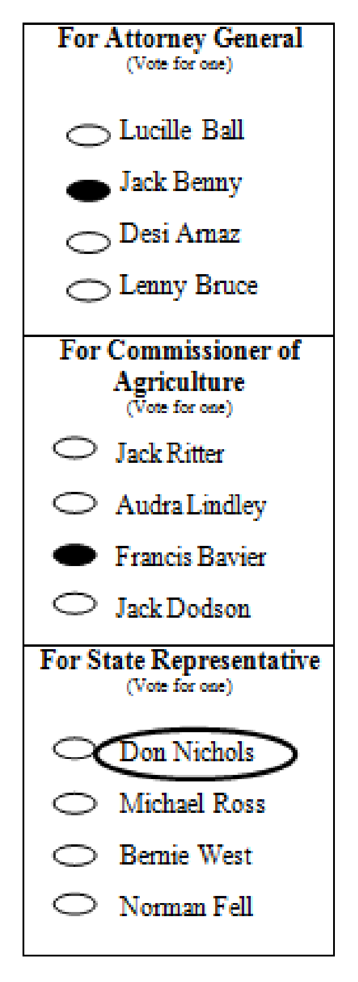
Example 2: VALID VOTE for Lucille Ball.
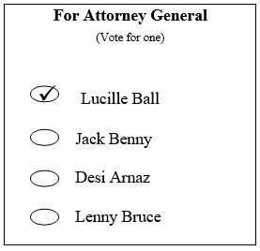
Example 3: Under Florida Rule, this would be an invalid vote for Jack Benny because the ‘tail’ of the check mark extends into the oval for Lucille Ball. We WILL count the mark for Jack Benny because the check mark symbol clearly indicates that is the voter intent, albeit an extended symbol.

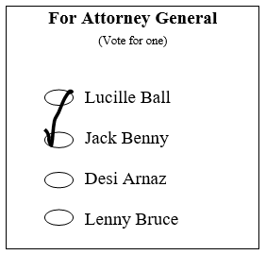

Example 4: Valid vote for Lucille Ball.

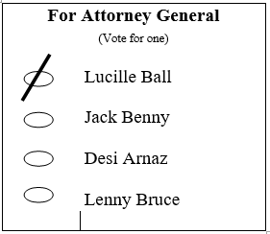
Example 5: Invalid vote as it cannot be determined whether the voter intended to vote for Ball or Benny.

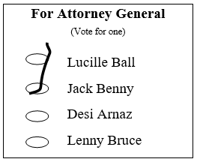

Example 6: By Florida Rule, this would be an invalid vote because the horizontal line strikes through the name of the candidate. We WILL count this as a valid vote for Lucille Ball as the voter intent is clear.

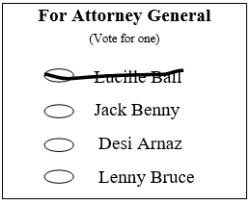

Example 7: Valid vote for Lenny Bruce, as all other candidates names are crossed out.

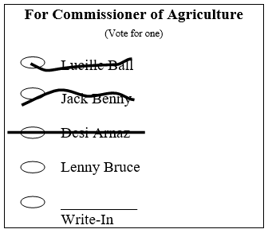

Example 8: Valid ‘no’ vote on this question.

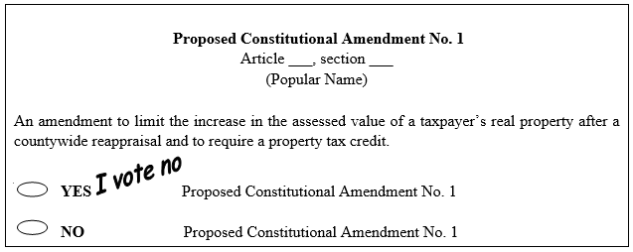

The Tally Process

A short description of the process is as follows:

The SoE staff will be the only one handling the ballots. He or she will hold the ballot so that both Ballot Judges can easily see it. A Ballot Judge will call the marks on the ballot so that both Tally Judges can hear it. Both Tally Judges will mark their Tally Sheet accordingly. As each ballot is completed, the SoE staff will place it on the table in a designated spot or in a container. When all ballots have been tallied, the counts will be recorded on a summary sheet.

A detailed description is below.

- Ballots will be brought into the counting room in their sealed containers. It is imperative that the chain-of-custody be transparent.
- SoE Staff only is allowed to handle the paper ballots.
- SoE Staff will not verbally communicate any ‘marks’ on the ballots. Only volunteer Ballot Judges will do that.
- Ballot Judges will sit at a table separate from those tallying the ballots (Tally Judges).
- No pens, beverages, or other materials are allowed at the table with the ballots.
- A limited number of ‘observers’ may be present. Generally, one Observer may be assigned to the Ballot Judges, and the Tally Judges for a total of 2 per Counting Team.
- The Tally Judges will need to be seated close enough to hear the Ballot Judges.
- The Ballot Judges will need to be able to easily see the ballot (without touching it).
- Volunteers will provide all the necessary materials required (except the ballots).
- Provisional ballots that have been counted as part of the election certification will be included in the hand count. Provisional ballots that have been rejected will not be included in the hand count. (Note: There are no Provisional ballots for the Everglades election.)
- Each ballot, including a provisional ballot, or any other ballot that has been rejected as part of the election certification is to be made available for inspection and counting (but not counted as votes).
- For each group that is counting, one SoE Staff and two Ballot Judges will sit at Table 1. Tally Judges will sit at Table 2.
- SoE Staff will select one ballot at a time from the batch and hold it for viewing by the Ballot Judges.
- Upon completion of the calling of the marks on a ballot, the SoE Staff will place the ballot onto a designated space or container on Table 1 for a ‘counted’ ballot, a ‘rejected’ ballot, or an ‘unreadable’ ballot.
- This process will continue until all ballots have been reviewed and tallied.
- The SoE staff will then gather all the ballots and return them to an appropriate container to be sealed and filed in accordance with normal chain-of-custody requirements.
- At the conclusion of the ballot review, the volunteers will complete forms that will identify the vote counts and ballot counts which they will sign and date.
Documenting the Results - Forms:

The following forms will be used to document the both the process and the results, and provide accountability:

- Sign In Sheet

- Oath

- Tally Sheets and Signatures

- Batches Summary Sheet (applicable when there is more than one counting group)

- Statement of Returns (not applicable for Everglades - to be used for counting multiple precincts)

Note: Copies of each of the relevant forms for Everglades will be provided separately.

Expect the Unexpected:

This will be the first time using this process for an election in the State of Florida. We need to remember that the primary goal is to demonstrate the ease of hand counting paper ballots, by hand, in a manner that is efficient and effective using existing Florida laws. The purpose is to help ensure every legal vote is counted the way the voter intended.

This will be a learning process. There will likely be questions or issues that have not been anticipated. That’s part of the journey!

We have heard and seen some unusual stories about ballots over the years. Voters sometimes put unidentified marks on them, or tape a coin to it, or write in names that aren’t on the ballot, some of which are quite humorous. There might be folds or bends or tears that are unexpected.

Quite frankly, we’re not sure how any of these are ‘counted’ by the machine, or if they are counted at all.

The rule of thumb will always be ‘use common sense’. This is how our parents and our grandparents had their votes counted. And, with a lot of effort and better legislation, perhaps this is how we will have our votes counted again.

General Reminders:

Please keep the following in mind to help the process flow smoothly.

- Arrive 20 minutes early to the Counting Process. Plan for unforeseen traffic, etc. This will allow time for signing in, signing the Oath, and confirming your assignment as a Ballot Judge, Tally Judge, or Observer.

- Bring a sweater. We won’t know the temperature of the room we will be using.

- Cell phones are allowed in the room but must be silenced.

- Keep purses, backpacks, notebooks, etc out of reach for Ballot Judges and Tally Judges.

- Bring your eyeglasses if you use them for reading.

- You may bring a beverage, however, no beverages are allowed on the table with the ballots.

- Speak up if, at any time, you have a concern or question.

- Do not touch the ballots. If any issue occurs that makes it difficult to see the ballot, please ask the SoE staff to make an adjustment.

- When hand counting of ballots has begun, it must continue without adjournment or
postponement to ensure the chain-of-custody of the ballots and documents.

- Avoid small talk once the process has begun.

- Treat every person the way you want to be treated.

APPENDIX

Florida Statutes:

101.5604 Adoption of system; procurement of equipment; commercial tabulations.—The board of county commissioners of any county, at any regular meeting or a special meeting called for the purpose, may, upon consultation with the supervisor of elections, adopt, purchase or otherwise procure, and provide for the use of any electronic or electromechanical voting system approved by the Department of State in all or a portion of the election precincts of that county. Thereafter the electronic or electromechanical voting system may be used for voting at all elections for public and party offices and on all measures and for receiving, registering, and counting the votes thereof in such election precincts as the governing body directs. A county must use an electronic or electromechanical precinct-count tabulation voting system.

http://www.leg.state.fl.us/statutes/index.cfm?App_mode=Display_Statute&Search_String=&URL=0100-0199/0101/Sections/0101.5604.html

102.111 Elections Canvassing Commission.—
(1) The Elections Canvassing Commission shall consist of the Governor and two members of the Cabinet selected by the Governor, all of whom shall serve ex officio. If a member of the commission is unable to serve for any reason, the Governor shall appoint a remaining member of the Cabinet. If there is a further vacancy, the remaining members of the commission shall agree on another elected official to fill the vacancy.
(2) The Elections Canvassing Commission shall meet at 8 a.m. on the 9th day after a primary election and at 8 a.m. on the 14th day after a general election to certify the returns of the election for each federal, state, and multicounty office. If a member of a county canvassing board that was constituted pursuant to s. 102.141 determines, within 5 days after the certification by the Elections Canvassing Commission, that a typographical error occurred in the official returns of the county, the correction of which could result in a change in the outcome of an election, the county canvassing board must certify corrected returns to the Department of State within 24 hours, and the Elections Canvassing Commission must correct and recertify the election returns as soon as practicable.
(3) The Division of Elections shall provide the staff services required by the Elections Canvassing Commission.

http://www.leg.state.fl.us/statutes/index.cfm?App_mode=Display_Statute&Search_String=&URL=0100-0199/0102/Sections/0102.111.html

101.572 Public inspection of ballots.—
(1) The official ballots and ballot cards received from election boards and removed from vote-by-mail ballot mailing envelopes and voter certificates on such mailing envelopes shall be open for public inspection or examination while in the custody of the supervisor of elections or the county canvassing board at any reasonable time, under reasonable conditions; however, no persons other than the supervisor of elections or his or her employees or the county canvassing board shall handle any official ballot or ballot card. If the ballots are being examined prior to the end of the contest period in s. 102.168, the supervisor of elections shall make a reasonable effort to notify all candidates whose names appear on such ballots or ballot cards by telephone or otherwise of the time and place of the inspection or examination. All such candidates, or their representatives, shall be allowed to be present during the inspection or examination.
(2) A candidate, a political party official, or a political committee official, or an authorized designee thereof, shall be granted reasonable access upon request to review or inspect ballot materials before canvassing or tabulation, including voter certificates on vote-by-mail envelopes, cure affidavits, corresponding comparison signatures, duplicate ballots, and corresponding originals. Before the supervisor begins comparing signatures on vote-by-mail voter certificates, the supervisor must publish notice of the access to be provided under this section, which may be access to the documents or images thereof, and the method of requesting such access. During such review, no person granted access for review may make any copy of a signature.

http://www.leg.state.fl.us/statutes/index.cfm?App_mode=Display_Statute&Search_String=&URL=0100-0199/0101/Sections/0101.572.html

98.0981 Reports; voting history; statewide voter registration system information; precinct-level election results; book closing statistics; live turnout data.—
(3) PRECINCT-LEVEL ELECTION RESULTS.—
(a)1. Within 10 business days after the Elections Canvassing Commission certifies a presidential preference primary election, special election, special primary election, primary election, or general election, as applicable, the supervisors of elections shall collect and submit to the department precinct-level election results for the election in a uniform electronic format specified by paragraph (c). The results must specifically include for each precinct the total of all ballots cast for each candidate or nominee to fill a national, state, county, or district office or proposed constitutional amendment, with subtotals for each candidate and ballot type. When one or more ballot types, also known as counting groups, in a race or an issue have fewer than 30 voters voting on the ballot, the ballot type must be reported as zero except for the total votes counting group for that precinct. Ballot types or counting groups include election day, early voting, vote-by-mail, provisional voting, and total votes. For purposes of this paragraph, the term “all ballots cast” means ballots cast by voters who cast a ballot, whether at a precinct location; by vote-by-mail ballot, including overseas vote-by-mail ballots; during the early voting period; or by provisional ballot.

http://www.leg.state.fl.us/statutes/index.cfm?App_mode=Display_Statute&Search_String=&URL=0000-0099/0098/Sections/0098.0981.html

102.166 Manual recounts of overvotes and undervotes.—
(1) If the second set of unofficial returns pursuant to s. 102.141 indicates that a candidate for any office was defeated or eliminated by one-quarter of a percent or less of the votes cast for such office, that a candidate for retention to a judicial office was retained or not retained by one-quarter of a percent or less of the votes cast on the question of retention, or that a measure appearing on the ballot was approved or rejected by one-quarter of a percent or less of the votes cast on such measure, a manual recount of the overvotes and undervotes cast in the entire geographic jurisdiction of such office or ballot measure shall be ordered unless:
(a) The candidate or candidates defeated or eliminated from contention by one-quarter of 1 percent or fewer of the votes cast for such office request in writing that a recount not be made; or
(b) The number of overvotes and undervotes is fewer than the number of votes needed to change the outcome of the election.

102.166 Manual recounts of overvotes and undervotes.—
(5) Procedures for a manual recount are as follows:
(a) The county canvassing board shall appoint as many counting teams of at least two electors as is necessary to manually recount the ballots. A counting team must have, when possible, members of at least two political parties. A candidate involved in the race shall not be a member of the counting team.
(b) Each duplicate ballot prepared pursuant to s. 101.5614(4) or s. 102.141(7) shall be compared with the original ballot to ensure the correctness of the duplicate.
(c) If a counting team is unable to determine whether the ballot contains a clear indication that the voter has made a definite choice, the ballot shall be presented to the county canvassing board for a determination.
(d) The Department of State shall adopt detailed rules prescribing additional recount procedures for each certified voting system which shall be uniform to the extent practicable. The rules shall address, at a minimum, the following areas:
1. Security of ballots during the recount process;
2. Time and place of recounts;
3. Public observance of recounts;
4. Objections to ballot determinations;
5. Record of recount proceedings;
6. Procedures relating to candidate and petitioner representatives; and
7. Procedures relating to the certification and the use of automatic tabulating equipment that is not part of a voting system.
(6) Nothing in this section precludes a county canvassing board or local board involved in the recount from comparing a digital image of a ballot to the corresponding physical paper ballot during a manual recount.

http://www.leg.state.fl.us/statutes/index.cfm?App_mode=Display_Statute&Search_String=&URL=0100-0199/0102/Sections/0102.166.html

99.061 Method of qualifying for nomination or election to federal, state, county, or district office.—
(6) The Department of State shall certify to the supervisor of elections, within 7 days after the closing date for qualifying, the names of all duly qualified candidates for nomination or election who have qualified with the Department of State.

http://www.leg.state.fl.us/statutes/index.cfm?App_mode=Display_Statute&Search_String=&URL=0000-0099/0099/Sections/0099.061.html

This handbook would not be possible without the guidance and materials prepared by Linda Rantz, https://frankspeech.com/article/return-hand-counting-missouri-elections-emanual This version has been prepared by Pam Bolger, Collier County FL.
https://www.rasmussenreports.com/public_content/politics/biden_administration/81_million_votes_nearly_half_say_no_way

