Seven Steps to Take Back Your Elections
Dr Douglas G Frank
March 19, 2023

I have been continuously engaged in the fight against systemic election fraud since December 2020, working closely and in-person with elected leaders and grassroots patriots in over forty states. I have spoken at several hundreds of events, met privately with dozens of election officials, Secretaries of State and Attorneys General, and given formal public testimony in court and before state legislatures.
Mike Lindell featured my early analytical work in two of his documentaries, Scientific Proof and Absolute Interference, I emceed at his Cyber Symposium, and I testified during his Trial of the Machines at the Moment of Truth Summit. I was a featured speaker at President Trump’s first post-presidential rally in Wellington, Ohio. I’ve been so busy across the country that retired Air Force Colonel Shawn Smith recently dubbed me the “Johnny Appleseed of Election Integrity.”
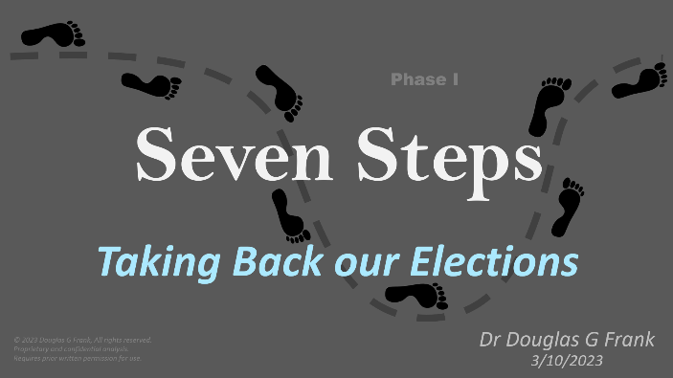
During my travels I’ve observed that some of our election integrity efforts are making incremental progress, but most are struggling because they are up against institutionalized ignorance, incompetence, and corruption. I’ve prepared this article to review a basic strategy that is currently achieving a measure of success, to discuss strategies that are not working, and to disseminate some of the wisdom I’ve collected along my journey from some inspiring and remarkable patriots.
The national election reform movement is growing so fast that I am booked months in advance and am overwhelmed by requests for help. What a great problem to have! My hope is that grassroots teams will find this information beneficial, and that it will enable us all to be more effective in the battle to take back local control of our elections.

The First Thing to acknowledge is that the vast majority of our citizens instinctively knows that something is seriously wrong with our elections. Nevertheless, “That ain’t natural, buddy.” is an insufficient foundation upon which to build a reform movement capable of waking our citizens and motivating our elected officials to action. Our intuitive biases actually get us into trouble, because we too readily accept anecdotal evidence instead of using rigorous logic and scrutiny. The sense of urgency we feel following suspicious election outcomes compounds this dilemma, because careful investigations take time. And then, when angry citizens challenge our election outcomes and demand recounts and audits based upon poor evidence and mere instinct, we lose credibility and are too readily dismissed as poor-losers and conspiracy wingnuts.

“That ain’t natural, buddy.”
Dr Frank

This predicament leads to the Second Thing we need to acknowledge: both citizens and community leaders desperately need education, but officials also require evidence. But—it needs to be the right kind of education, and the right kind of evidence. Community members need to understand how their elections are being stolen from them so that they can collect the right kind of evidence. Empowered with this evidence they can then engage other members in their community, and together they can compel local officials into action.
The Third Thing to understand is that the solution to our election debacle does not lie at the state level, nor in the courts. Instead, the fix is local. I know, it is tempting to prepare an extensive report which recounts large numbers of anomalies in the voter rolls and election violations at the polls, and then deliver a thick report to senior government leaders, expecting it to make a difference. I can recount multiple examples of local heroes who have worked hard doing data analysis, collecting affidavits, and preparing exhaustive reports. But even when these reports were widely disseminated to election officials, District Attorneys, legislatures, and Secretaries of State, they were essentially dismissed and ignored. It is disappointing and demotivating to the grassroots.

“Education is key;
the fix is local.”
Toni Shuppe
There are several reasons why nothing happens when election officials are presented with these large reports. In most cases state level officials are already aware of the issues, but they are reluctant to act because they like having central control of their elections. Further, if they were to validate the myriad problems recounted in the reports, they believe that it would make them look bad (it does!) and that they would begin losing central control of their elections (they should!).
Local District Attorneys see investigations into these large reports as too extensive an undertaking, and where the amount of actual fraud listed is insufficient to overturn the outcome of their elections anyway. So, the reports are given low priority or simply ignored. Also, such reports typically itemize myriad instances of gross incompetence and improperly (often illegally) executed complex election procedures (e.g. dirty voter rolls, poorly run elections, procedural violations). In 2020, I doubt there was a single election held in our country where all the legally required procedures were properly followed. District Attorneys are not interested in prosecuting gross incompetence, and they want a substantial crime to prosecute. Otherwise, they will just defer to state election officials. Since the legislature is responsible for this mess, let them fix it.

“A mountain of corruption survives in a sea of incompetence.”
Glen Morgan
Local law enforcement officers (who tend to be proficient in penal law) find themselves overwhelmed by the technically complicated reports. They typically have to consult with their county election officials, who quickly dismiss the reports, claiming that their citizens don’t understand the election systems and are essentially a bunch of conspiracy wingnuts. Ironically, local election officials also don’t understand their own election systems and their own predicament. They are rarely IT specialists, and their election systems are a complicated and compromised conglomeration of networked and unsecure electronic systems.
Local officials are also reluctant to cooperate with any close examination of their election records and systems because they are terrified of being “Tina Petered” by state officials and state clerk associations who keep close tabs on them. Election managers are just doing their jobs, collecting their paychecks, and completing their long checklists. And if you have a problem with that, talk to the state legislature.
“One of the penalties for refusing to participate in politics is that you end up being governed by your inferiors.”
Plato
Even in our most conservative states, our state legislatures are now run by majorities that lean more to the left than the citizens they are supposed to represent. This happens because it is essentially impossible to get elected in such states as a Democrat, so candidates with left-leaning politics run as Republicans and then vote and act like Democrats once they are in office. Obviously, citizens need to do a much better job screening their candidates, and to become more engaged in their party politics.
The fourth thing to understand is that the core problem we face is not a lack of evidence of election fraud, but rather a lack of public understanding compounded by widespread apathy of our citizens. For too long we’ve been paying others to run our governments, paying others to teach our children, and paying others to manage our elections. It is hard to imagine civic responsibilities that are more important, and yet we’ve delegated these tasks to others. Our founders conceived of this country as an experiment in self-government where the citizens are the sovereigns. But today, this experiment is rapidly failing unless and until our citizens wake up and re-engage their civic duties.
“We’ve forgotten that We the People are the sovereigns. For too long we’ve been paying other to people to teach our children, to run our governments, and to run our elections. Now, we are reaping the consequences of generations of apathy.”
Dr Frank

Figure 1. Mosaic of “Lady Liberty” in the Wisconsin State Capitol Building.
The basic problem with our elections is brilliantly and succinctly captured by this one-hundred-year-old mosaic featured in the Wisconsin state capitol dome, Figure 1. It depicts Lady Liberty pointing toward heaven with one hand—because Heaven is the source of our unalienable rights—and with the other hand she is protecting the ballot box, because that is how we protect our God-given liberty.
Unless and until We the People reclaim local control of our elections, we will continue to incrementally lose our liberty, because we otherwise will be unable to elect leaders who do not represent our values and are busily centralizing and ratcheting-in their government power. State-run, centrally controlled elections are not transparent nor secure, and are easily manipulated by nefarious forces.
Throughout the four years following the 2016 general election we were bombarded with claims by the Hilary Clinton campaign that our elections were insecure, complete with federal testimony and investigations by national experts confirming the vulnerability of all of our election systems. Now, suddenly, the 2020 general election is “the most secure election in our history.” Are we just going to continue on this preposterous, alternating, sour-grapes path, or are We the Sovereign going to re-embrace our civic responsibilities and take back local control of our elections?
“We need to reintegrate our civic duties into our normal lifestyle.”
Urson Russell
The most important thing people need to understand for reaching an effective solution to our election dilemma is that evidence only plays a supporting role. The key to success is awakening the public by building a movement.
“This is not about evidence; we already have mountains of evidence and have had it for years. What we haven’t had is an educated, motivated public that understands our predicament, and a strategy which enables them to remedy the situation.” Dr Frank
Having all the evidence in the world is impotent without a critical mass of informed citizens demanding reform, equipped with clear evidence. Imagine President Trump sitting in the Oval Office in December of 2020. He had mountains of physical and electronic evidence which demonstrated widespread election fraud. He had evidence of foreign interference in our elections, he had anticipated this situation in advance, and he had given himself recourse in the event of foreign interference. What Trump lacked was a single legislature that would stand with him, and an educated and awake public that would pressure their legislatures to address the obvious fraud that had taken place. Even Vice President Pence did not support him. Not only is public ignorance and apathy deep, so is the swamp.
“A smart man learns from his mistakes;
A wise man learns from the mistakes of others.”
My Dad
When I first discovered the extent of the election fraud in this country during the few months following the November 2020 General Election, I remember naively believing that I could help save the country by setting my career aside for a short period of time to present the evidence to senior government officials. Of course, I was thinking like a rational citizen scientist, where truth matters, and our elected leaders take action when the evidence dictates it. I had no idea the depth of the corruption I would encounter. I suspect President Trump underestimated it as well, and also the degree to which he is despised by the government establishment. Since then, I have re-learned the important truth that We the People do have the power, we’ve just forgotten. I plan to spend the balance of my career reminding citizens what America was conceived to be, and what it can be again if they will simply awaken and repent.
God is standing by, ready to restore us.
The Seven Steps
Now that I have explained the problem and the challenge before us, here are my recommended Seven Steps which address previous shortfalls and provide a roadmap for success in the first phase of your local battle for election integrity. I’ve been gleaning these steps for two years in the school of hard-knocks, and they are certain to change as I continue to learn. No doubt much more can be said, but here are the basic principles that I have found to be the most effective.
Step 1. Get Connected

If you want to make a significant difference, please don’t go it alone. Time is short, and there too many lessons to learn. Avail yourself of the experiences and resources that other patriots are willing to share. They’ve “been there, done that.”
CauseOfAmerica.org is Mike Lindell’s grassroots support hub. Sign up there to network with other people in your region and gain access to national experts and support infrastructure. Please consider supporting the Lindell Legal Fund as well, which is privately supported.
LindellTV.com and FrankSpeech.com are Mike Lindell’s websites that provide the grassroots with daily access to news and information critical to the election integrity movement. Tune in to the Lindell Report each weeknight at 6pm CST to learn what is really happening across the country.

CSPOA.org is Sheriff Mack’s organization. If you can afford the membership, please support his work by joining the posse. Your county sheriff is a critical part of our strategy, and you should begin forming a relationship with him. He doesn’t have to be on our side at first, just begin exploring where he stands on issues and who his deputies are. A constitutional sheriff has more authority in the county than any other elected official, except for the coroner. The CSPOA is an important ally in our movement because they are perfectly equipped to teach your sheriff their powers and responsibilities.
There are many patriotic and effective Grassroots Organizations in every state across the nation. I’ve listed a sampling of some in my “#1 - Get Connected” slide (above), and I encourage you to connect with them to amplify the effect of your efforts. The war to reclaim our country is a marathon not a sprint, and grassroots teams are more successful when they work together and support one another. Cause of America holds weekly conference calls and the weekly TakeYourPowerBackShow.com are great places to get advice and encouragement from other patriots across the nation.
Step 2. Get Organized
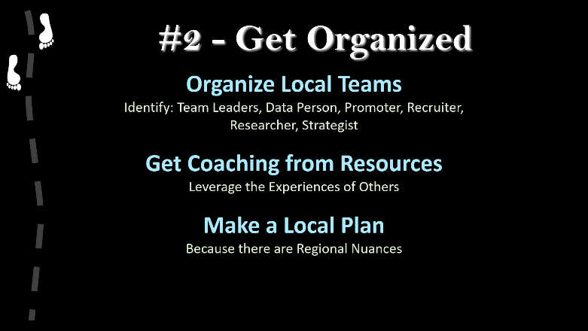
Start by assembling a local team of selfless, like-minded patriots who believe strongly in the team objectives. At first, I recommend that you start with a small, elite team (under ten).
Team Leaders arrange meetings, set agendas, manage team progress, and communicate regularly with the national infrastructure. Team leaders tend to be “supermoms,” because they often have the daytime hours available to manage the many hours of work. Managing volunteers is extremely challenging…. Precious time, have strong opinions,
Every team needs a Data Person who helps the team examine election data, prepare door-knocking lists, and analyze results. The data person doesn’t need to be a data scientist or computer programmer, but it helps. At the minimum, you need someone with good computer skills and who is comfortable working with large sets of data. There are several experienced data folks around the country who can then coach them.
The Promoter should be someone good at organizing community events. Remember, we’re building a movement, so we need to educate and interact regularly with the public. I recommend that the team organizes a publicized event about every two months to fuel the momentum of the movement. Use your connections (Step #1) to identify and bring in national speakers.
Recruiters develop relationships with elected officials, churches, and other community organizations. These relationships are critical to the success of the movement, because they leverage your efforts and amplify the movement. In the end, these organizations provide the necessary political influence.
Not everyone can or should go door-knocking, and there are lots of other critical tasks. Researchers examine state and local laws, research the affidavits collected by door-knockers, research death records, and explore leads provided by your data folks. Look for grey areas in the law to exploit, and you need to know the laws so well that you can expose how your local officials are not following them (local officials usually don’t know their own laws). Researchers empower, equip, and protect the long-term team strategy.
Strategists are important to the success of the movement because each local situation has nuances which can be exploited. Strategists should also act as a red team, exposing flaws in the team’s work and watching for infiltrators.
After identifying your team members you should meet together, in person. Use the Seven Steps to help formulate your plans. Of course, you will be remotely communicating a great deal, but don’t neglect those meals together, hugs, and handshakes. Movements are about relationships.
Step 3. Implement the Plan
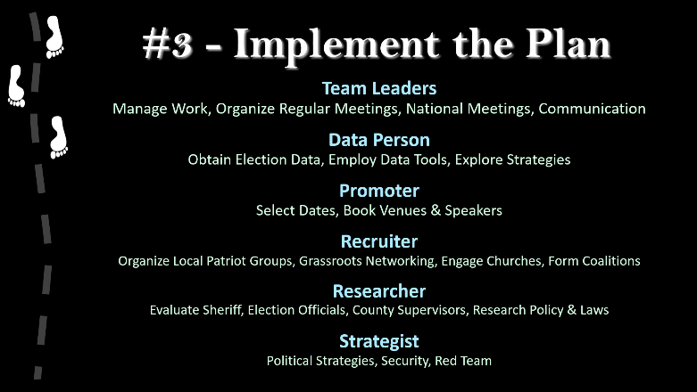
There is a large amount of work to do, and grassroots volunteers require a different kind of management and operation style than in a typical place of employment.
Team leaders will need to organize regular meetings to facilitate training, obtain support, maintain focus, identify obstacles, and build momentum. Although it is tempting to pursue big solutions, the most successful teams are the ones that are making steady, incremental progress. It has taken us decades to get into this mess, and it is not going to be fixed overnight. You are building a long-term solution, where slow and steady wins the race. Look for ways to integrate the work of the team with your normal lifestyles without neglecting family and faith priorities.
The Data Person will need to begin acquiring election data. Start by requesting the voter registration rolls and voter history files from your county election officials. This opens an important dialogue between the team and the election official. At first, try to be non-adversarial. In the long run, you want your election officials to confirm what you’ve found and to acknowledge that the problems are systemic. If you have to pay a fee to get the data, raise the funds locally. This is your project, and a sense of local ownership is a key element. Data may also be available from other local patriots or through your political party. You may also be able to obtain data from some of our national teams.
Promoters should begin securing venues, speakers, and dates. I recommend scheduling evening events for the public and daytime meetings for local officials and for the training of local teams. You can raise funds to pay for venues, travel expenses, and election data by charging admission for the events or by passing the hat. Inexperienced event organizers often make the mistake of inviting too many people to speak at their events and reserving too short a time. For evening events, schedule at least three hours and not more than two speakers, leaving time for questions. Schedule follow-up training meetings the day after the evening events to engage interested locals. My own events often run long because I have a lot say, and people have a lot of questions. It's OK for attendees to leave wanting to learn more, but you don’t want them to leave feeling frustrated. You want them to leave feeling motivated to action.
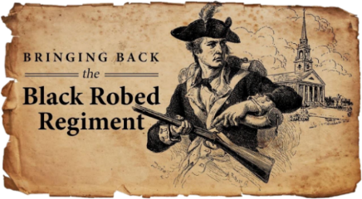
Recruiters can help identify venues as they build relationships with local churches and community organizations. Remember, this is a movement. One of the primary objectives should be to rekindle community involvement and spiritual revival, including in our churches.
Researchers should begin collecting and reviewing information, especially copies of all relevant state and local laws and procedures. Which election systems are in use? What contracts are in place, and when do they expire? Are local election officials bonded, and by whom?
Strategists should begin assessing where their leaders stand on various issues. Is the sheriff a constitutional sheriff or a member of CSPOA? If your county supervisors were to vote today, which of them would be sympathetic to your movement? What will it take to reclaim majorities and key positions in the county? Which officials are vulnerable for replacement? Are there elected officials in your community that you can rely upon once the movement is rolling?
Step 4. Do the Work
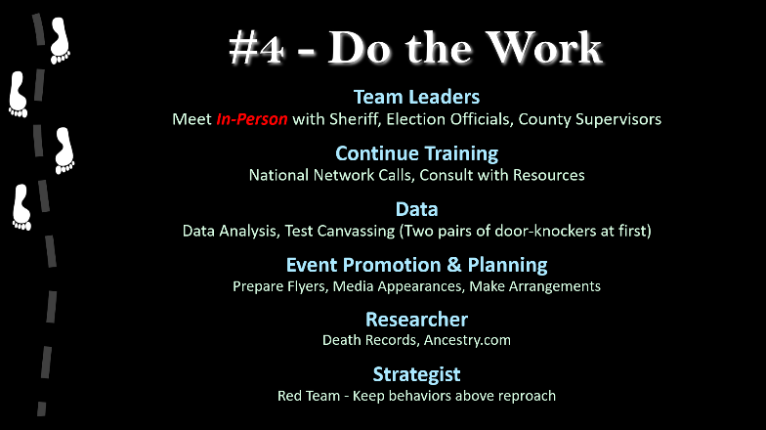
Team Leaders should be meeting with local officials throughout the effort, especially before public meetings. I’m particularly fond of “showing them their future” during the early stages. If they are going to cooperate, this gives them time to research and engage. If they are going to oppose the movement, then these meetings start them worrying, and they’ll make public mistakes. These early meetings also help team leaders set the tone of the movement.
The sheriff’s office is likely to begin receiving phone calls when your teams begin canvassing. But because you have met with your sheriff and explained what you are doing, he can allay community concerns. Local election officials are typically very unhappy that someone is exposing fraud in their elections, and they will publicly raise concerns about “voter suppression.” Just ignore their empty threats. What you are doing is not only legal, but also your civic responsibility.
Continued Training is important. You’ll need to learn how to hold events and how to prepare affidavits and to avoid important pitfalls during door-knocking. You’ll learn about your election systems and their vulnerabilities. Connecting with the national movement also empowers and encourages your team.
Promoters should prepare flyers, organize media appearances, and deploy social media to spread the word. Use the popularity and networks of your invited speaker to bring local and national attention to what you are doing. (e.g. If you provide your speakers with a copy of the event flyer, they can promote it on their social media.)
Researchers should be busy following up leads from the Data Person, including death records and postal records. Are there any legal precedents applicable to your local situation? Real estate sales and tax records are public databases sometimes worth exploring.
Strategists should be constantly evaluating the short and long-term goals and monitoring the ever-changing political landscape. I tend to assume good intentions and honest actors, but I’ve learned never to underestimate political interests. Follow the money, and remember that politicians and government systems instinctively and systemically seek power and central control. You are swimming upstream against a well-funded establishment that has a twenty-year head start.
“No battle plan survives first contact with the enemy.”
Col. Phil Waldron
The Data Person should begin using software tools and strategies developed by other successful teams around the country. For example, the National Change of Address registry (NCOA) can be used to identify voters who have moved away. County and state death records can be used to identify “dead” voters. There are several software strategies that help narrow searches to neighborhood anomalies. The key here is to begin consulting with other data folks around the country to identify the strategies best suited your area and your team.
Figure 1 illustrates the kind of election fraud you are initially looking for: ballot stuffing. It is important to explore data from recent elections, but the 2020 general election is especially burgeoning with fraudulently harvested ballots, so you should include 2020 data in your investigation as well. Essentially, you are looking for phantom voters: ballots received/recorded for someone who did not actually complete a ballot. There are other ways to manipulate election outcomes, including machine manipulation and suppression (adjudication, destruction), but the evidence required to prove these modes of cheating are not typically available to the citizens, and so are less useful for building a movement.
Your huge advantage is that every stuffed ballot must be assigned to a voter in the rolls. At this point you are only interested in finding the phantom voters associated with each of the stuffed ballots.
Your data person will be very busy throughout the work, so the team needs to provide them support. As they uncover anomalies and likely cases of fraud, assemble small teams to explore each of their leads. Don’t send large groups door-knocking until you’ve confirmed that the data strategies are working. Once you are finding the veins of gold, then you can start mining them.
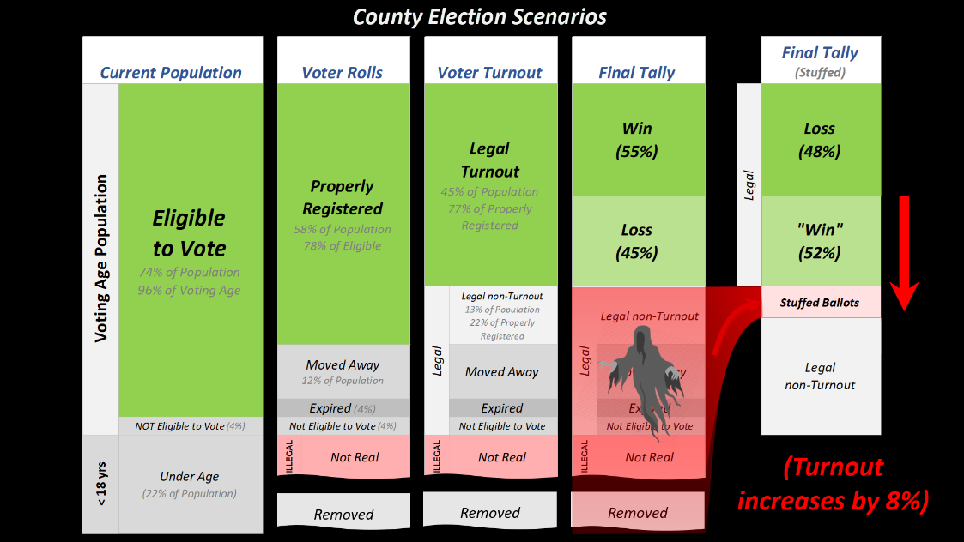
Figure 1. Schematic illustrating the types of ballot-stuffing the team will be seeking.
Step 5. Build the Movement
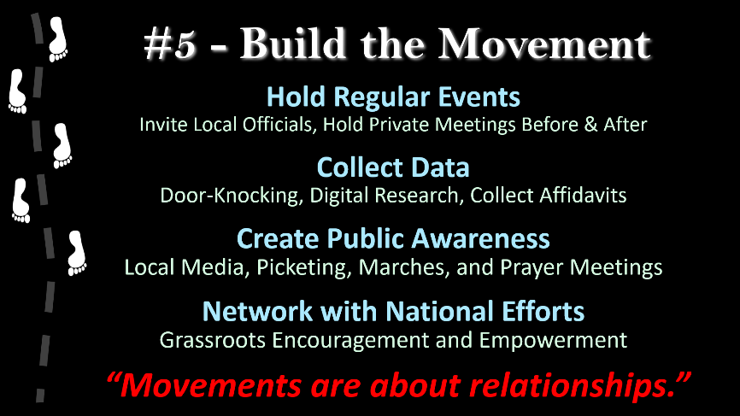
As you are nurturing your local movement, things are probably going to progress more slowly than you would like. Remind your team that things happen in “God’s timing, not ours.” We are engaged in a battle between good and evil for the very soul of our republic, and “this is God’s battle, not ours.” Nevertheless, I find it astonishing that God uses flawed individuals to accomplish his providential will. We don’t have to be perfect; we just have to be willing to serve and to stand for the Truth.
There are certainly going to be mistakes made. Fortunately for us, “God has chosen what is foolish in the world to shame the wise, and God has chosen what is weak in the world to shame the strong.” So remember to be patient with the volunteers, and to assign more than one person to critical tasks when it is feasible. Keep the momentum alive by communicating regularly and by holding regular events.
People need encouragement, so be sure to publicize the progress you are making. For example, after a successful event, publicize the attendance and the general response. After canvassing, inform everyone on the team what you are finding. Do not reveal the details yet, but certainly say things like, “We found twenty-three more cases of election fraud this weekend: three dead voters and twenty identity theft.” Cultivate an army of local social media warriors to disseminate the findings to your community. Prepare press-releases for the local newspapers and contact local radio stations to request interviews with your invited speakers to publicize your upcoming events.
Remember that door-knocking is not merely data-collection, but also evangelism. Each time you discover fraud in a neighborhood, that entire neighborhood can become awakened to the existence of voter fraud. Widespread community awareness is where the success of the movement lies.
When door-knockers find fraud, encourage them to share what they are finding with other team members and their friends, reminding them to keep the details private. When speaking with colleagues, friends, and family about the movement, encourage team members to stick to the credible evidence you are finding to avoid sounding like a conspiracy wingnuts. Begin packing the community government meetings with local patriots (standing room only), and use the community comment portions of the meetings to enter your progress into the public record. Make sure that the local press knows your findings and that citizens are showing up in droves because of them.
As the movement grows, problems inevitably arise between members in the movement, and team leaders need to address interpersonal drama before it becomes a significant issue. It is tempting to engage distractions along the way, so leaders need to “Keep the main thing the main thing.”
“Keep the main thing the main thing.”
Jon Matthews
Working with volunteers can be challenging. Patriots tend to be gainfully employed, highly-motivated folks who are quick to stand on principle. Because we have strong opinions, we are sometimes our worst enemy and our teams can self-destruct. Instead, we need to be selfless, patient, and tolerant with each other, and appreciate the variety of personalities and gifts that everyone brings to the tasks at hand.
DRAMA
Because this is a real war, I imagine myself in a foxhole: if someone else is aiming their guns at the enemy, then I am not shooting at them. But that doesn’t mean that I will invite them into my foxhole. After all, the enemy is real, and my life and the wellbeing of my family are at stake. I need to be able to trust those who are fighting at my side.
As you are building the movement, it is critical that you promote and model to your citizens the fundamental “idea of America.” America was conceived as an experiment in self-government, and our founders were only willing to trust us with a republic because we were virtuous and religious. Benjamin Franklin said, “Only a virtuous people is capable of freedom.” When asked after the constitutional convention what type of government they had settled upon, Franklin answered, “A republic, if you can keep it.” We are losing our republic because we have lost our virtue and forgotten the core principles of what it means to be “America.”
Our founders assumed other things about our communities too, including that we would be armed and proficient and that citizens would be actively engaged in their own governance. You know that we’ve lost lost our way and that our thinking is “upside down” because our first instinct when troublemakers come to town is to call law enforcement, rather than to pull out our own weapons and call our neighbors.
The principle that virtue is required to experience freedom may not be apparent at first. If my neighbor and I am both virtuous, then we will naturally respect the unalienable rights God that has given each of us, and we can coexist in peace. However, if my neighbor is raping and pillaging, then we will have to curtail his actions, limiting his freedom.
You are not merely taking your elections back, you are educating your community on their need for religious faith, the constitution, and their civic responsibilities. You should be modeling these values and challenging your community to live virtuous lives, raising ethical expectations not only of your fellow citizens, but especially of your community leaders. It is not an accident that those who are facilitating the demise of our country are rewriting history, deny the existence of truth and virtue, and describe America as a democracy rather than the republic it was designed to be.
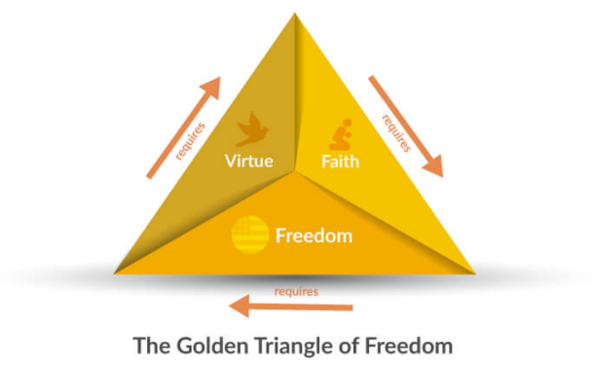
The Golden Triangle of Freedom was a core principle in the minds of our founding fathers. The diagram illustrates than in order for us to enjoy freedom we must live virtuous lives, that virtuous lives are a natural consequence of religious faith, and that freedom is required to practice our religious faith. Our founders understood that these three elements enable and amplify one another.

Step 6. Review Your Progress
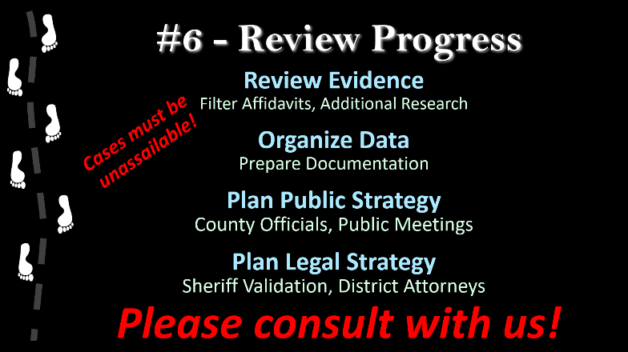
I cannot stress enough how important this step is, and how important it is that you bring in outside, experienced patriots to help you evaluate your progress and your evidence before advancing to Step Seven. In science, we call this a peer-review.
It is good that the people on your team are excited about their progress and the evidence that they’ve collected. But usually, teams have found less fraud than they think they have. You need experienced eyes to help you to evaluate your evidence.
The packet of evidence, affidavits, and documentation you prepare needs to be simple and unassailable before you deliver it to your county authorities for validation. Otherwise, you will most likely shoot yourselves in the foot.
The objective is to present to your sheriff and county election officials clear cases of election fraud, and nothing else. I’ve found that one hundred cases is a good target for the first round of validation. Why one hundred? One case is “grandma voting for grandpa,” ten cases is “someone harvested a rest home,” twenty cases is “there are a couple of bad actors.” One hundred seems to be the psychological threshold where officials concede that there is a systemic problem with their elections.
It is normal during this review to discover that the team needs more evidence or more research to shore up the evidence it already has. It is very important that the team be self-critical at this time; it is far better for the team to find out privately together now than in public later. Your public credibility matters! Every case you present must be unassailable, and it is better to deliver ninety-nine perfect cases than one hundred where one case can be used to undermine the credibility of the other ninety-nine.
I encourage teams to organize their evidence into several categories:
- Clear, confirmed cases of fraud:
  - The voter was deceased and therefore was unable to cast a ballot;
  - The voter moved away before the election, and denies voting in it;
  - The person denies they voted, and will sign an affidavit to that effect;
  - The voter does not exist.
- Cases of fraud that need more validation in order to move into Category 1.
- Likely cases of fraud that are difficult to confirm, but could be converted to Category 1:
  - 100% turnout at a long-term care facility where patients lack the cognitive ability to vote;
  - Non-resident, legal voters (e.g. UOCAVA).
- Lost or Suppressed Votes (someone signs an affidavit that they voted, but it is not recorded).
- Improperly or illegally registered voters:
  - Non-citizens and illegal aliens;
  - Dirty voter rolls:
    - Deceased voters;
    - Inactive voters (federal law requires their removal);
    - Non-residents.
- Eye-witness accounts of election irregularities, broken laws, and anomalies.
- Other evidence, perhaps useful at a later date, (e.g. statistical anomalies, reconciliation errors).
All of the categories contain valuable information and may have an ultimate use. But for this first phase, we only want to use the items in Category #1. Clear, confirmed, unassailable, voter fraud.
Once you have your peer-reviewed evidence packet in hand, you are ready to plan your visit to the sheriff. The purpose of the meeting is to show your sheriff the evidence you’ve collected that demonstrates that your elections are being corrupted and that you are being disenfranchised from your constitutional rights.
You are not asking the sheriff to prosecute anyone.
You are not asking him to become an expert at election law.
You are not asking him to confirm how the fraud is taking place.
At first, all you need him to do is to confirm that the cases you are presenting are valid. This should be straightforward because you’ve already done all the legwork and the documentation. You don’t want to overwhelm him. To keep the load light, and to answer the excuse that they are busy, suggest that he only confirm five of the cases at random. Most sheriffs will end up delegating this task to a deputy anyway.
Keep the meeting simple and small. Present at the meeting should be:
- The Sheriff and/or his Deputy;
- Team Members (two);
- CSPOA Representative;
- And Elections Expert. Someone that has done this before.
Later, you will want your sheriff to confirm to your county authorities that the fraud you’ve documented is real. So do your best to remain credible and respectful.
Research on the sheriff. Neighvoring sheriffs, CSPOA
We are NOT handing over the citizen audit to the authorities, just looking for validation which emowers us.
What to do when sheriff does not validate.

Voter suppression charges
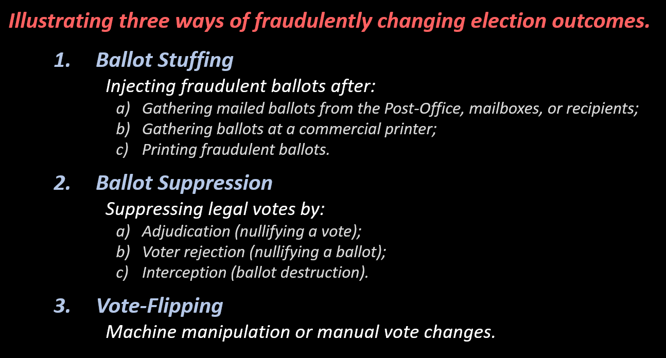

Step 7. Local Empowerment
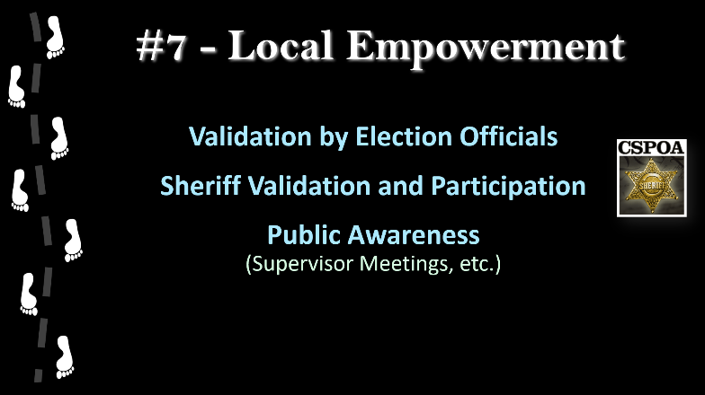
With evidence in hand, you meet with your sheriff. Do not overwhelm him at this point. Keep the meeting simple and small. Present at the meeting should be:
- Sheriff and/or Deputy;
- Team Members (two);
- CSPOA Representative;
- Elections Expert. Someone that has done this before.
The purpose of the meeting is to show your sheriff the simple evidence you’ve collected that demonstrates that your elections are being corrupted and that you are being disenfranchised from your constitutional rights. You are not asking the sheriff to prosecute anyone. You are not asking him to become an expert at election law. You are not asking him to confirm how the fraud is taking place. At first, all you need him to do is to confirm that the cases you are presenting are valid. And this should be straightforward, because you’ve already done the legwork and the documentation. To keep the load light, and answer the excuse that they are busy, suggest that he only confirm five of the cases at random. Most sheriffs will delegate this task a deputy.
Later, you will need your sheriff to confirm to your county authorities that the fraud you’ve documented is real.
Research on the sheriff. Neighvoring sheriffs, CSPOA
We are NOT handing over the citizen audit to the authorities, just looking for validation which emowers us.
What to do when sheriff does not validate.

Voter suppression charges
You never give up YOUR audit. It is a citizen audit. Your officials work for you. You are showing them that the system they are using is disenfranchising local citizens from their constitutional right to vote, and showing them the problem, and demanding that they comply with your demands, or you will replace them. After all, they work for you.
- Death of a Vision
- Finish Line
  - Single-Day transparent elections, all paper, with photo ID. Hand-count and report the outcomes in ways that every citizen can confirm the numbers.
  - Fireworks, apple pie, baseball, hot dogs. Re-engaged citizens celebrating our liberty and acknowledging our Creator who enables it.
Stgart in small, conservative counties and communities
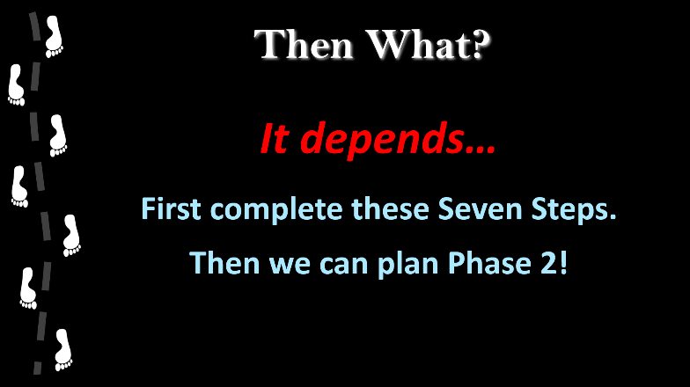
Then What?

Final Thoughts
We are engaged in a war for the soul of our country, and I often find myself using war analogies. I spent my younger years in the laboratory and becoming educated, and never had the honor of serving in the military. Recently, I’ve spent many hours with veterans who have helped me to see the world more objectively and to think more clearly about effective strategies in our current battle. I now have an even greater appreciation and admiration for those who have served, and I hope that the years that I am currently spending serving my country are at least partial repayment for their service and lifetime oaths.
I have noticed that returning veterans tend to deflect praise and credit for their service, and don’t like being referred to as “heroes.” I suspect that this is because the real heroes to them are their foxhole buddies who did not return safely from the battlefield. Their humility is instructive and contagious, and worth emulating.
Genuine humility is recognizing the gifts that God has given you, nurturing them, and then deploying those gifts in His service to accomplish His providential will. This makes it easy to give credit where credit is due—to God. I like saying, “God made me six foot, one inch tall. I had nothing to do with it. He gave me feet and hands, He expects me to walk and work. He gave me a brain and a voice, He expects me to think, to teach, to speak, and to sing.”
While it is true that I am an effective speaker and catalyst, the real credit for the successes we are experiencing nationally belongs to the local grassroots teams; they are the ones doing all the hard work. It is an honor to serve with them shoulder-to-shoulder, and I have acquired many lifetime friends… foxhole buddies. I find that the most successful teams are the ones led by patriots that are focused on the objective, and are not seeking any credit for themselves.

It is also an amazing adventure to be serving God during this amazing time of awakening and revival in America. I find it exhilarating to be serving at the whim of a God who exists outside of space and time, and so arranges for me to always be in the right place at the right time—living and traveling day to day, drifting along like a “leaf on a river.”
I pray that our efforts will be effective and the results achieved soon enough that our country will awaken and repent before it is forever lost.
Kyrie eleison.

The author can be contacted at DrDouglasGFrank@Outlook.com.
Dr Frank began his election fraud work in December 2020 with committees of the Pennsylvania state legislature.
The Absolute series of movies can be viewed at LindellTV.com and FrankSpeech.com.
Mike Lindell’s Cyber Symposium was held in Sioux Falls, South Dakota August 10-12, 2021.
Mike Lindell’s Moment of Truth Summit was held in Springfield, Missouri August 20-21, 2022.
Dr Frank was a featured speaker at President Trump’s Wellington, Ohio rally on June 26, 2021.
Retired Air Force Colonel Shawn Smith is now CEO of CauseOfAmerica.org.
Dr Frank coined this catch-phrase characterizing statistical improbability in Scientific Proof (3).
Toni Shuppe is co-founder and director of AuditTheVotePA.com.
Glen Morgan is founder and director of WeTheGoverned.com in Washington state.
A one-hour documentary featuring Mesa County Clerk, Tina Peters, can be viewed at SelectionCode.com.
Wyoming is a prime example. It has the highest percentage of Trump voters, but its legislature votes far more to the left than its citizens. When they elected a new Secretary of State to clean up their elections, the Wyoming legislature immediately began working to reduce his authority over their elections.
These are the so-called “RINOS,” for “Republicans in name only.”
See PrecinctStrategy.com to learn how to recover control of your state political party.
Eric Metaxas eloquently describes the assumptions of our founding Fathers in his book, If You Can Keep It (2016).
Photo credit: Douglas G Frank. Wisconsin state Senator Janel Brandtjen brought this to my attention.
This magnificent mosaic located in the Wisconsin State capitol dome is composed of about 100,000 pieces of glass. It was completed in 1917, and is based upon a 1912 painting by Kenyon Cox (1856-1919).
Curling v. Raffensperger, Georgia civil action 1:17-CV-2989-AT, J.A. Halderman declaration.
Debbie Georgatos, America Can We Talk?
Urson Russell is founder and director of PatriotForceCA.org
In May of 2017, President Trump established a Presidential Advisory Commission on Election Integrity: https://www.govinfo.gov/content/pkg/FR-2017-05-16/pdf/2017-10003.pdf.
In September of 2018 Trump gave himself authority to declare a national emergency in the event of foreign interference in our elections: https://www.govinfo.gov/content/pkg/FR-2018-09-14/pdf/2018-20203.pdf.
Vice President Pence was appointed chair of the Advisory Commission on Election Integrity (21), but dissolved it soon after its formation.
The swamp is comprised of unelected career bureaucrats who do the daily business of running the country.
Dr Frank has sixty peer-reviewed scientific publications, including cover articles on the world’s leading scientific journals.
A Texas patriot I met put it best: “The reason they hate Trump so much is because he is playing in their sandbox and taking away their toys.”
LindellLegalFund.org
As there may already be teams organized and underway in your region, I recommend that you first check with CauseOfAmerica.org
“Supermoms” is Dr Frank’s affectionate term to describe the remarkable army of women who’ve become recently activated in this war to reclaim our country, our schools, and our children’s futures.
Pennsylvania supermom, Toni Shuppe says, “Dr Frank, we just need to face the fact that we need to schedule to have you here at least once per quarter.” I confess… I enjoy throwing gasoline on grassroots bonfires.
I recommend that you start with the smaller, more conservative counties in your state, particularly if they have constitutional sheriffs.
Urson Russell
Dr Frank has carefully examined data for over forty states. Some of the data are incomplete, and not all of it is current. Cause of America also has a large collection of data.
Dr Frank does not charge a speaker fee, just reimbursement for travel expenses. A free-will offering near the end of the event is usually sufficient.
Examples of politically engaged churches include: VoiceOfThePatriots.net, AwakenChurch.com, and SaltAndLightCouncil.org.
BondsForTheWin.com
CSPOA.org
I encourage you to invite me to participate in one of the early in-person meetings with your officials. Bringing in an experienced national figure adds credibility to your local movement.
Col. Phil Waldron, “Your Wake-Up Call”, Rumble.com/vkze5h-mike-lindell-cyber-symposium-your-wake-up-call-col-phil-waldron.html
I Corinthians 1:17
Rev. Jon Matthews is an experienced California patriot who is relocating to engage Arkansas politics.
Eric Metaxas, If You Can Keep It (2016).
People in the media often refer to election integrity advocates as “a threat to democracy.”
During our early work in Pennsylvania, Vico Bertogli used to say, “Better to prove it wrong now than later in court.”
Parable of the talents

