Section 2 – Election Management System

File 2-6 EMS Ease of Use

2.6 Ease of Use for GASOS and Local Election Officials: Provide and demonstrate customer experiences via referrals and specific case studies or white papers including access, special features, and any other customer feedback.

Dominion works with more than 3,000 entities across North America to provide elections services, software and hardware. We pride ourselves on the partnership that we strive to build with each customer.

In addition to the references we provide in response to 0-7 References, we would like to offer several letters of reference from larger entities that are currently utilizing Democracy Suite and a similar product array as we are proposing in Georgia. Letters from Sacramento County and Contra Costa County, California will provide a high-level overview of the success we have experienced through the implementation and use of our system.

As letters can only provide a snapshot of the user experience, we would also like to provide several links to several testimonial videos produced in conjunction with our customers in the City and County of Denver, and Clark County, Nevada. We feel these video testimonials provide a picture of the type of partnership we commit to developing.

City and County of Denver:

https://www.youtube.com/watch?v=Zyqg-LcAkC0

Clark County Video #1 -2018

https://www.youtube.com/watch?v=WejC40bgvic

Clark County Video #2 – 2017

https://youtu.be/j9TsDwsHVPA

Letters of reference provided on the following pages:

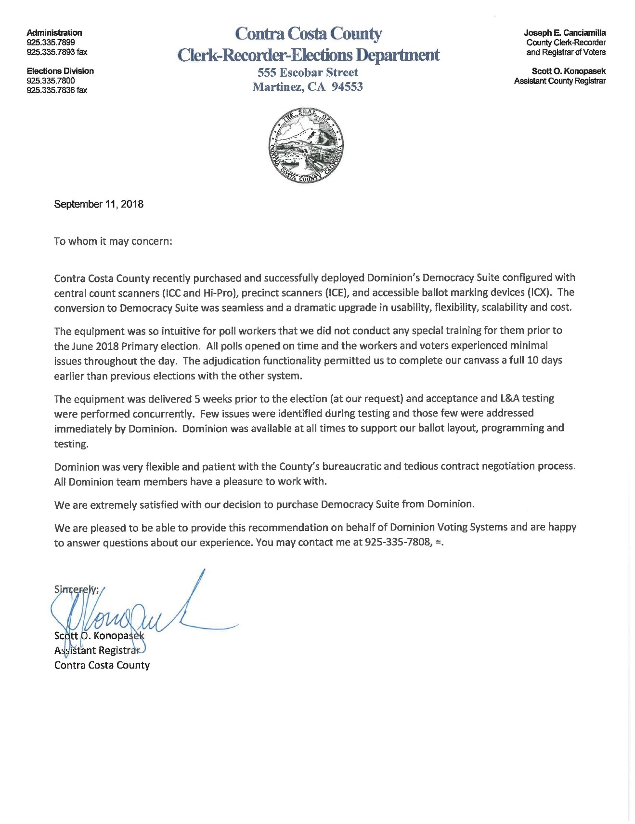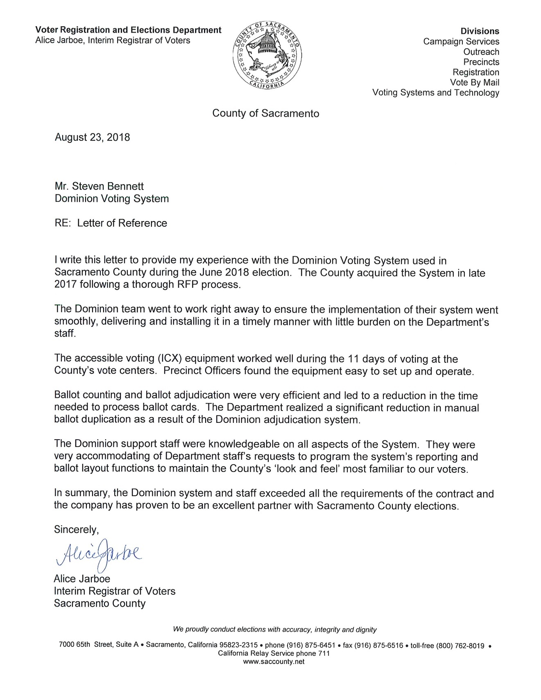

Clarification Question

How will the proposed EMS assist GASOS in preparing 159 individual databases within 25 business days, where the county has a local race and a statewide race?

The proposed Dominion solution has the proven capability to meet the State’s requirement of preparing 159 individual databases for each of Georgia’s counties, within 25 business days. Dominion’s EMS, Democracy Suite, is currently being used in statewide production environments where a dedicated team of election programmers create the election projects used in multiple counties. In the EMS, template or master election projects will be built in the Election Event Designer (EED) module to streamline the process. These template projects are saved and then used from election to election eliminating the need to create projects from scratch for every county’s election event.
Statewide Ballot Development
Dominion has a dedicated programming team that produces election projects for the following states simultaneously:

• New Mexico – All 33 Counties
• Colorado – 59 of the 64 Counties
• Nevada – 15 of the 16 Counties

The average time frame for this single team to create all the election projects for these 107 counties in 3 different states is 18 calendar days.

Three different methods are used in the production of these elections – which are explained herein.

Additional features of Democracy Suite that facilitate an election production environment include:

- EED’s built-in Cepstral voice synthesizer is leveraged to automatically generate all the audio needed for ADA-compliant audio ballots, which results in a significant reduction in production time. Human recorded audio can be imported if desired.
- All ballot types including paper absentee, audio, screen, and BMD are created and formatted in a single election project using the EED application.
- All tabulator types including, ImageCast Precinct, ImageCast X-Ballot Marking Device (BMD), and ImageCast Central are defined in and programmed from a single election project using the EED.

There are three primary methods for preparing election databases: Full Import, Partial Import, and No Import.

Methodology #1: Full Import
- A template or master election project is created.
- Copies of this election project are created; one for each county.
- The State provides an import file for each county that contains all the data in all languages, including all associations, for example districts to precincts, links to existing ballot styling templates, and distribution of tabulators.
- Election data is imported then ballots are laid out.
- Minor modifications are made as needed and audio ballots are generated using the built-in Cepstral synthesizer.
- Proofing packages are created and distributed to the counties.
- Upon approval, ballot artwork is sent to the printers and finalized election projects are tested internally then distributed to the counties.

Finally, counties create the memory cards and USB’s needed to load the election onto their voting devices.

Methodology #2: Partial Import
- A template or master election project is created.
- Copies of this election project are created, one for each county.
- The State provides an import file for each county that contains some of the election data, such as associations, for example districts to precincts, needed to build the election.
- Election data is imported then additional election data is added manually.
- Ballots are laid out and minor modifications are made as needed.
- Audio ballots are generated using the built-in Cepstral synthesizer.
- Proofing packages are created and distributed to the counties.
- Upon approval, ballot artwork is sent to the printers and finalized election projects are tested internally then distributed to the counties.

Finally, Counties create the memory cards and USB’s needed to load the election onto their voting devices.

Methodology #3: No Import
- A template or master election project is created for each county that contains all of the known static information for the county such as districts and precincts.
- A copy of each county’s template is made and used to build the election.
- Election specific data is added manually.
- Then ballots are laid out and minor modifications are made as needed.
- Audio ballots are generated using the built-in Cepstral synthesizer.
- Proofing packages are created and distributed to the counties.
- Upon approval, ballot artwork is sent to the printers and finalized election projects are tested internally then distributed to the counties.

Finally, counties create the memory cards and USB’s needed to load the election onto their voting devices.

Conclusion
Dominion will work closely with GASOS to develop a plan the will efficiently and effectively meet the needs of the State’s 159 counties. The final plan may consist of any of the methodologies described above, or Dominion will collaboratively work with the State to define a new method.

Dominion is providing four (4) main redundant servers and 12 Client Workstations to the GASOS for the ballot building teams to utilize to the fullest. The amount of equipment provided to GASOS will ensure an efficient turnaround of election flies for distribution to the counties. Additionally, as stated above, Dominion will assist the State in customizing an environment to streamline the overall process including secure and efficient ways for the counties and State to share files.

The GASOS will have 45 BMD’s, 18 PPS scanners, and 6 CSD central scanners to test databases prior to sending the data to counties for upload onto their voting devices. Having enough equipment from which to test, will enable the GASOS to build and test county ballots quickly and efficiently. Dominion can offer our Remote Ballot Printing module and ballot printer, so all ballots and test decks can be printed internally for testing by GASOS if necessary. The same module and printer can be offered to all counties, so they may print absentee ballots, test decks, and election day backup ballots internally.

