Section 4 – Central Scanning Device

File 4-4 CSD Audit

4.4 Describe how the CSD assists with post-election audits.

Post-election audits can be done across 100% of the ballots cast in a given election because all ballots – hand marked Absentee ballots, provisional ballots, and BMD ballots will have been scanned and the total images stored. Each ballot scanned will include the AuditMark feature appended to each ballot image listing how each mark was interpreted by the scanning and tabulation process.

Further Dominion offers Risk Limiting Audit (RLA) functionality which is completely controlled and managed by the user. The parameters for selection of ballot populations to be audited range from a sampling of the precincts to 100% of the ballots cast is at your fingertips to validate the accuracy of the ballot casting processes.

Post election audits are performed in the Results Tally and Reporting module of Democracy Suite. The ImageCast Central assists with the overall function of a post-election audit by accurately scanning, imaging both sides of the ballot scanned and tallying all ballots fed through the unit during an election. Below we describe the major functionalities that assist the overall accuracy for the scanning and tabulation process including the AuditMark and Dual Threshold technologies and the adjudication process:

AuditMark

Enhancing Audit Capabilities and Transparency
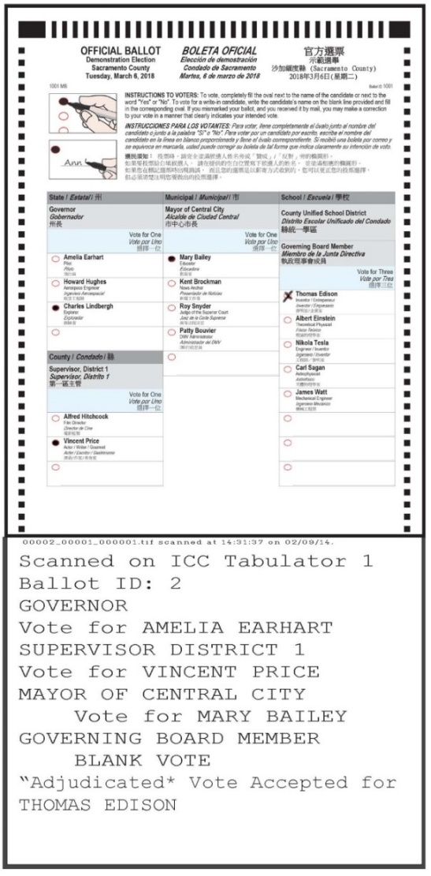
Dominion’s AuditMark technology will allow the County to provide greater transparency in the electoral process. Every single ballot in the election is imaged and appended with Dominion’s patented AuditMark, a record of how the system interpreted the voter’s intent. The AuditMark is the only technology that provides a clear and fully auditable single vote cast record for every ballot cast. This ballot-level audit trail allows election officials and other stakeholders to review not only the ballot images, but also the tabulator’s interpretation of each ballot.

Each image is labeled with the tabulator, batch, and sequence number within the batch, which corresponds to the physical ballot in the stack. The AuditMark is appended directly to the image showing how the vote was interpreted at scan time. This AuditMark will also include any adjudications applied to the ballot for voter intent. Even if ballots for a given batch are mixed after scanning, these multiple records provide a way of correlating the digital Cast Vote Record data to the image scanned and finally to the physical paper ballot. While the AuditMark allows ballot-level auditing, it is never tied to the voter.

Dual Threshold
When a hand-marked ballot is scanned by an ImageCast tabulator – at the precinct level or centrally – a complete duplex image is created and then analyzed for tabulation by evaluating the pixel count of a voter mark. The pixel count of each mark is compared with two thresholds (which are customer configurable, to determine what constitutes a vote).

If a mark falls above the upper threshold, it is determined to be a valid vote. If a mark falls below the lower threshold, it will not be counted as a vote. However, if a mark falls between the two thresholds (known as the “ambiguous zone”), it will be deemed as a marginal mark and the ballot will be flagged for adjudication where a team will review a voter’s intent and the outcome noted in the system.

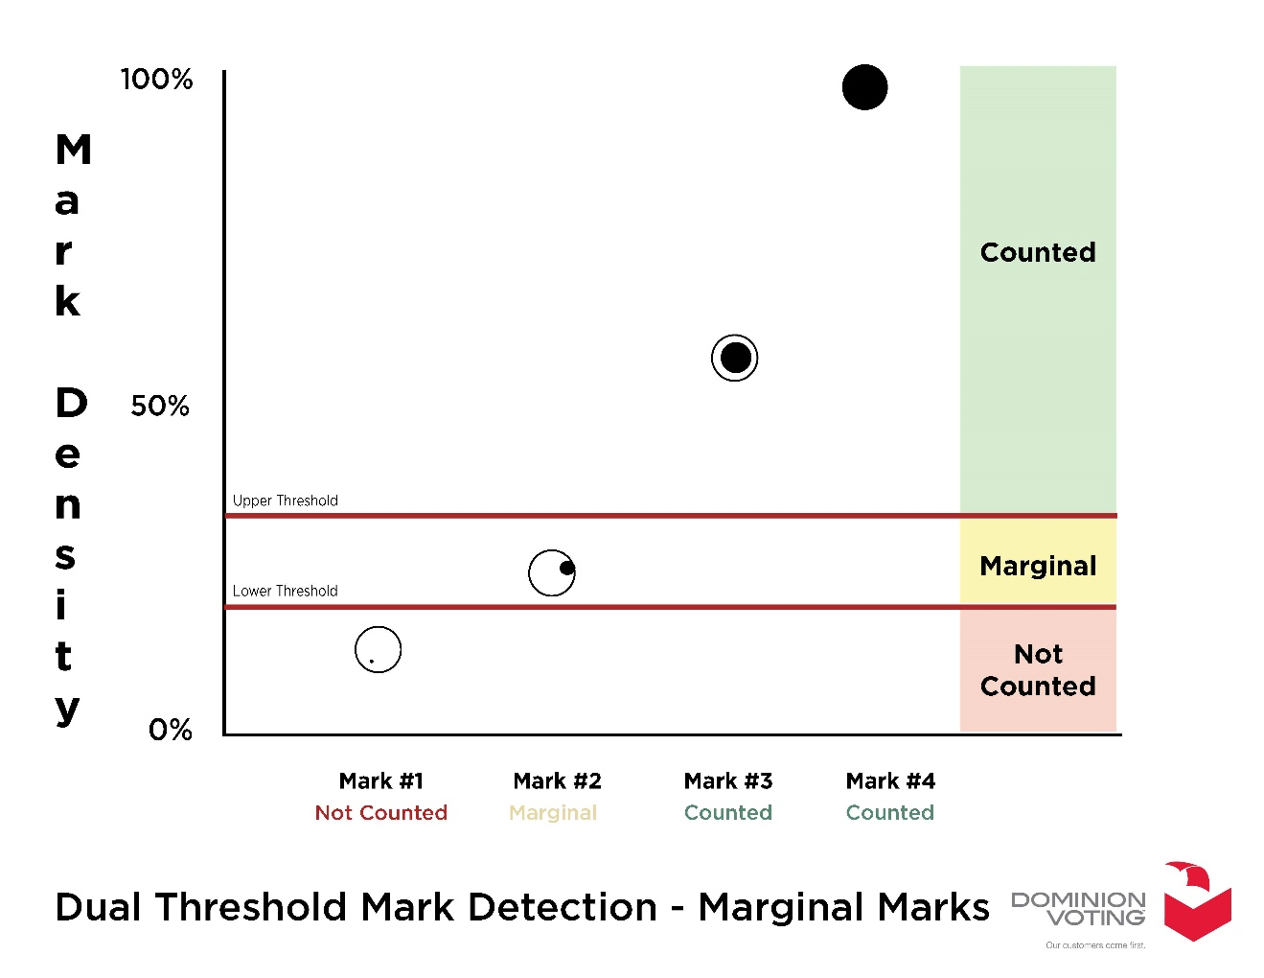

ImageCast Adjudication

The Adjudication Application is a stand-alone module that allows for the efficient processing of ballots that require resolution of voter intent on a ballot-by-ballot basis during the post-voting stage of an election. The Application has been developed to accept ballot files from ImageCast Central. After analysis and correction, the ballot files are sent to the EMS Results Tally & Reporting application for tally and reporting. The primary function of the Adjudication Application is to create an automated process that allows ballots with exceptions or “out-stack” conditions – such as overvotes, undervotes, blank ballots, marginal marks, major contests and certified write-ins – to be resolved on-screen and sent to tally. This eliminates the need for additional costs, time and resources spent on duplicating and re-scanning ballots.

Streamlining Processing of Ballots with Conditions
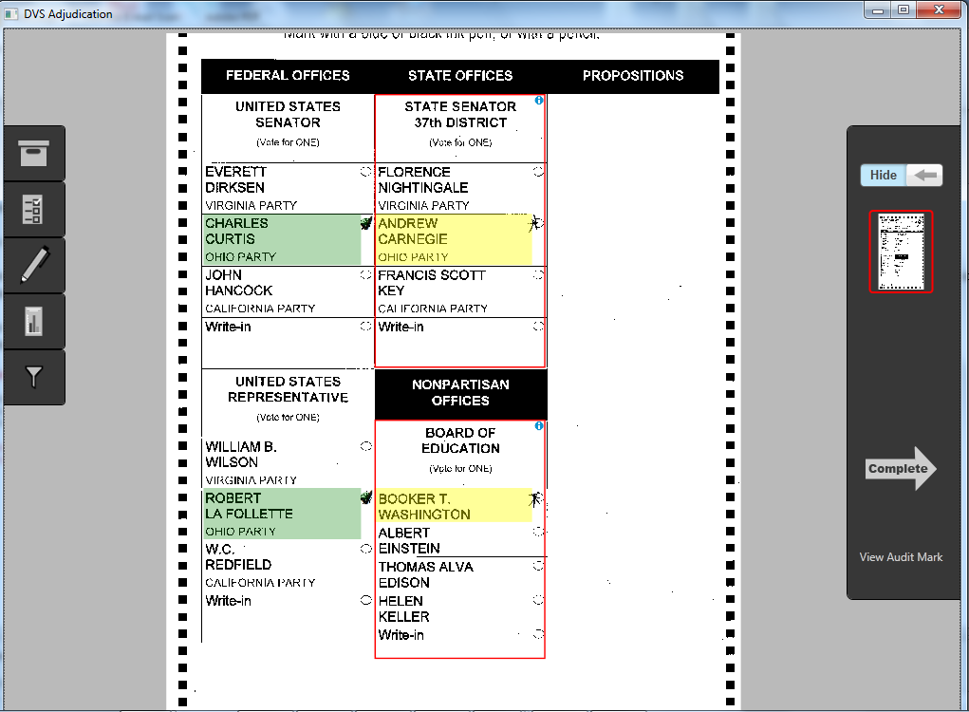
The primary function of the Adjudication module is to create an automated process that allows ballots with exceptions or “out- stack” conditions to be resolved on-screen in real-time and sent to the results tally module. The customer defines which out-stack conditions should be reviewed in Adjudication, including blank ballots, overvotes, undervotes, marginal marks, and write-ins. Dominion’s digital adjudication tool allows for easy and efficient write- in resolution.

The Adjudication Application adds to the efficiency of Dominion’s ImageCast Central County system by making it scalable to as many reviewing teams as needed for the jurisdiction. The outstacked ballots will appear on the screen for the team to review as they come available. This created efficiencies that have never been seen in elections before.

In the examples shown to the right, the top picture shows the first adjudication screen with the contests that need review highlighted with a red box, and candidates with marginal marks highlighted in yellow. The second screen shows a vote being adjudicated for Andrew Carnegie.

Adjudication also offers a robust, ballot-level audit trail. Each ballot scanned by the system is appended with an AuditMark. When a ballot is reviewed in the Adjudication module, and a user makes an adjudication decision, the ballot image is appended with a record of that decision: which user took what action at what time. This allows election officials to ensure that adjudication decisions made by authorized users can be further scrutinized and reviewed, and reversed if necessary, with a clear audit trail of which decisions were made concerning a particular ballot. When scanned centrally, the ballots are timestamped to further enhance the auditing capability of the system.

Reporting
As ballots are scanned, batches are directed to the Adjudication module if outstack conditions are detected, or sent to the Results Tally and Reporting module for tabulation.

Once batches are sent into the Results Tally and Reporting module, extensive reporting capabilities are available that will assist in reporting and auditing functions. The Results Tally and Reporting module of the Democracy Suite EMS produces fast, versatile and easy customizable reports from data available in the election project. The Results Tally and Reporting module of the Democracy Suite EMS uses SQL Server Reporting Services to produce the following standard reports:

- Election Summary Report
- Statement of Votes Cast (precinct-level results)
- Cards Cast Report
All these reports can be exported to PDF, Microsoft Word, Microsoft Excel, and Microsoft PowerPoint.

These three reports allow filtering by Polling Location, Tabulator and Counting Group. Election Summary and SOVC reports can be customized to include a number of statistics including: Times Cast, Undervotes, Overvotes, Total Votes, Counting Group breakdown, Write-Ins, Percentage by ballots cast or by votes cast, sorting of candidates by global order or by votes received. Filters by contest, precincts, or districts can be applied. Report titles can be modified to indicate unofficial or canvass results. Report profiles can be saved, loaded and exported between election projects.

Additional reports include:

- Results per precinct (simplified precinct-level report)
- Contest overview data (simplified summary report)
- Located Scanned Ballots
- Results per Tabulator
- Canvass
- Write-Ins per Tabulator
- Registration and Turnout
- Contests on Margin
- Tabulator Status
- Ballots Cast per Ballot Style
- Ballots Cast per Tabulator

All these reports can be generated at the same time that scanning and adjudication is happening, without affecting performance or accuracy.

All reports can be customized. Headers can be customized to include “official” or “non-official” wording, or other desired wording.

Extensive filtering and sorting capabilities allow for detailed breakdowns to provide information for any level of any contest as detailed below in the Election Summary Report and the Statement of Votes Cast (SoVC) Report explanations below:

Election Summary Report
The Election Summary Report displays election results by race, and is summarized across the jurisdiction. The information on these reports include the number of ballots cast, and the number of undervotes, overvotes, blank votes, and double votes.

The user is able to select one or more of the following Contest Statistics for inclusion in the report:

- Times Cast
- Undervotes
- Overvotes
- Combine Overvotes and Undervotes as ”Blanks”
- Double votes
- Total votes
- Counting Group Totals Only
- Writein Overrides
- Vote For
- X of Y

Candidate Statistics can include:
- Party affiliation
- If candidates are cross-endorsed, the user can break down results per party affiliation by leaving the item unchecked.
- Highlight Winners
- The user can show remaining Unresolved Write-in row or to hide that row
- The user can choose to count unresolved write-ins as undervotes
- The user can choose how percentages are calculated:
- No percentages
- Divided by Votes Cast
- Divided by Ballots Cast
- – The user can choose how Write-Ins are represented:
- No Write-ins
- Combine - show single Write-In
- Split - show individual Write-In positions in the contest

Additional Sorting/Splits
- – The user can indicate if the results should be broken down or not. Results can be broken
- down by:
- Tabulator - Results are grouped per tabulator
- Batch - Results are grouped per batch
- The user can choose how to sort candidates by the following criteria:
- Global Order
- Number Votes in descending order

The Filters for Report
- Filter for Contests - The user can choose to display all contests, or, by clicking the filter radio
button, the user can select one or more contests to be displayed in the report, from the list provided on the form.
- Filter for Districts or Precincts - The user can select to display the results by districts or by precincts. For either selection, the user can display all districts/precincts, or, by clicking the filter radio button, the user can display one or more districts/precincts in the report, from the list provided on the form.
- Filter for Polling Location - From the combo box on the form, the user can filter the report results by polling location.
- Filter for Tabulator - The user can choose to include results for all tabulators, or, by clicking the” filter” radio button, the user can select one or more tabulators to be included in the report, from the list provided on the form.
- Filter for Counting Group - From the combo box on the form, the user can filter report results by counting groups.

Statement of Votes Cast
The Statement of Votes Cast report provides election officials with the detailed results of an election. The report is divided into two sections: the first section is an overview of the cards cast and eligible voters broken down per precinct, district, and district type. The second section shows the election results on a contest-by-contest basis and includes the number of ballots cast, the vote totals for each candidate, and the number of write-ins, undervotes, and overvotes.

The user can customize the report title and allows for extensive filtering and customizations including:

Contest Statistics:
- Times Cast
- Undervotes
- Overvotes
- Double votes
- Total votes
- Counting Group Totals Only
- Write-in Overrides
- Vote For

Candidate Statistics:
- The user can break down results per party affiliation in the case that candidates are cross-endorsed by leaving the item unchecked
- The user can display remaining Unresolved Write-in column or to hide that column
- The user can choose to count unresolved write-ins as undervotes.
- The user can select how percentages are calculated:
- No percentages
- Divided by Votes Cast
- Divided by Ballots Cast

- The user can select how Write-Ins are represented:
- No Write-ins
- Combine - show single Write-In
- Split - show individual Write-In positions in the contest

- The user can choose how to split the data:
- By Precinct
- By District Detailed information
- Precinct Portion
- By Ballot Type

• The Filters for Report
- Filter for Contests - The user can choose to display all contests, or, by clicking the filter radio button, the user can select one or more contests to be displayed in the report from the list provided on the form. Note: This filter does not affect the first report section, if the user wishes to narrow the first section of the report the Filter for Districts or Precincts must be used.
- Filter for Districts or Precincts - The user can select if they wish to display the results by districts or by precincts. For either selection, the user can display all districts/precincts, or, by clicking the Filter radio button, the user can display one or more districts/precincts in the report from the list provided on the form.
- Filter for Polling Location - From the combo box on the form, the user can filter the report results by polling location.
- Filter for Tabulator - In the combo box on the form, the user can filter the report results by tabulator. the form by which to filter results in the report.
- Filter for Counting Group - From the combo box on the form, the user can filter report results by counting groups.
- Filter for District Type - In the combo box on the form, the user can filter the report results by district.

Sample report screenshots are provided on the following pages.

Cards Cast Report
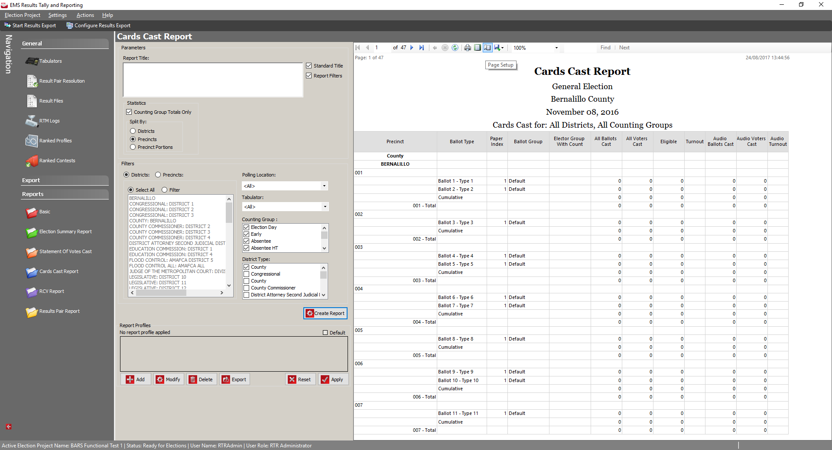

Statement of Votes Cast Report
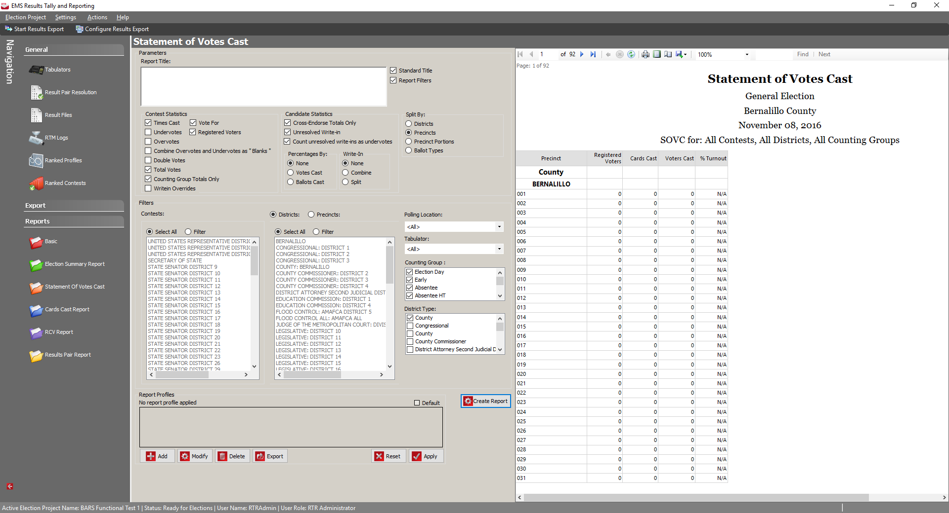

Election Summary Report
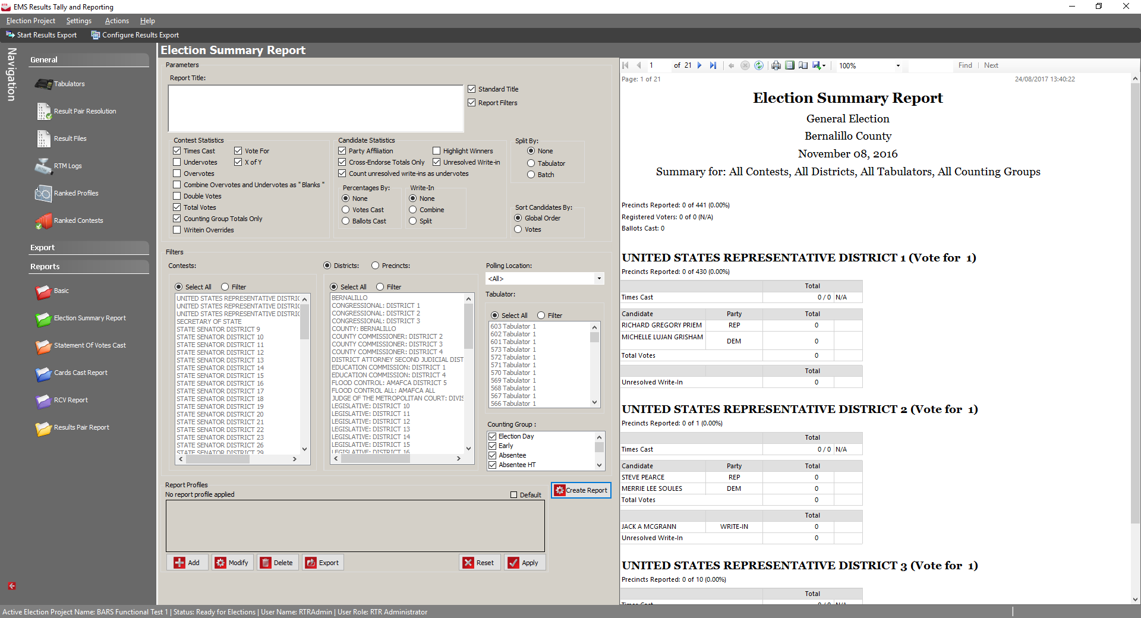

Clarification Question

How does the CSD support post election audits of the physical ballots cast? What reports or data export capability is there that would allow for tabulation audit comparison of tabulated results and a physical review and count of the paper ballots at the: A. Precinct Level, B. Ballot Box Level, and C. Any other level smaller than a precinct.

Dominion has developed a Ballot Audit and Review Module to assist election officials in performing election canvasses including audits and risk-limiting audits. This tool allows multiple officials to access digital ballot images with their digital ballot AuditMark® records, digital Cast Vote Records, and related review notes. Filtering options enable the creation of ballot review subsets for specific audit reviews, including the ability to filter images of ballots by ballot style, precinct, polling location, contest, and candidate, for the purposes of a recount or post-election audit. This tool resides in a secure post-election environment that is separate from EMS.
Officials can create ballot review sets by filtering for any given audit scenario including specific requests from Election Committees and other internal and external parties. Users may make notes to individual ballots and ballot review sets to aid in follow-up reviews and audit discussions. Administrators may create and assign a ballot review set to a specific election official. Upon reviewing each ballot, officials may add a note, mark it for additional review, or mark it as complete. Ballots within a ballot review set may be sorted against these attributes as desired.
Efficiency is realized through filtering and sorting capabilities. Officials may select specific filter criteria including District, Precinct, Precinct Split, Contest, Candidate, Tabulator, Outstack Conditions, Mark Fill Percentage, Adjudicated, Ballot Type, and or Ballot ID.
Flexibility is realized through user-friendly screen designs to aid in the rapid selection of filters and their choices in both large and small data set scenarios. Furthermore, the Administrator may choose to distribute a large ballot review set across multiple users to speed the review process. This tool will provide efficient and user-friendly interface for reviewing ballot images and associated results, as well as providing a framework to support a variety of auditing methodologies.
For ballots scanned centrally on the ImageCast Central, the ballots are identified by the order in which they were scanned, and are also stored by tabulator, and by batch. Each image is labeled with the tabulator, batch, and sequence number within the batch, which corresponds to the physical ballot in the stack. The AuditMark is appended directly to the image showing how the vote was interpreted at scan time. This AuditMark will also include any adjudications applied to the ballot for voter intent. Even if ballots for a given batch are mixed after scanning, these multiple records provide a way of correlating the digital Cast Vote Record data to the image scanned and finally to the physical paper ballot. While the AuditMark allows ballot-level auditing, it is never tied to the voter.

All ballots scanned are stored and referenced according to the scanning sequence number. Ballot images are each identified by a distinct number. This number consists of the tabulator on which the ballot was scanned, the batch number, and the index of that ballot within the batch. As an example, for the second ballot scanned in batch 245 on Tabulator 4, the scanned image filename would be 0004 0245 0002.tif). If this ballot ever needs to be located in the storage racks, the official must find the transfer case for Tabulator 4, Batch 245, open the box, and locate the second ballot from the top in the box, which will be the desired ballot.

