This guide will provide the steps taken to produce batch results at the ballot level by copying records from the Cast Vote Record (CVR). This should be used to create results outside of the CVR to avoid accidental editing of the official record. Filtering may simply be used within a single file, if desired.
- Upon opening the CVR, highlight the fields shown in Figure 1 and select the Data tab then Filter.
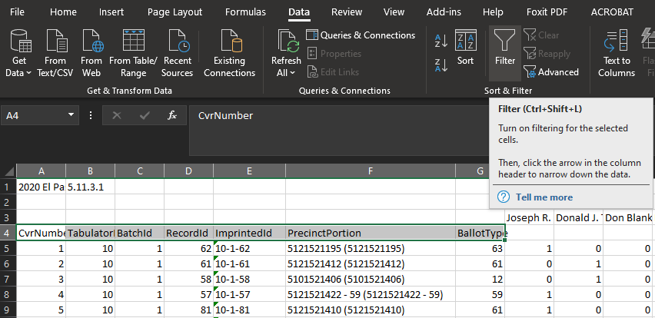

- Next select and filter the Tabulator and BatchId columns according to your desired choice.
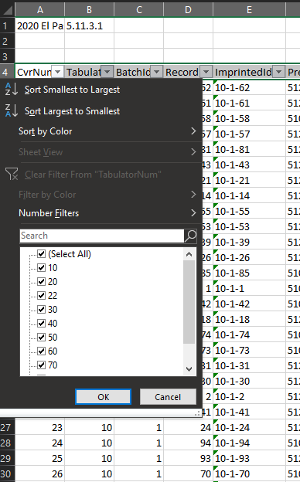

- Highlight the column names along with the candidates you wish to audit. Next, hold Ctrl + Shift and press the down arrow key to highlight all records.
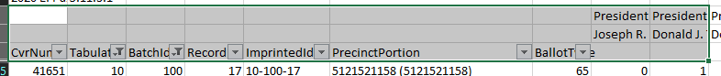

- With all records highlighted, copy (Ctrl + C) them into a new Excel worksheet.
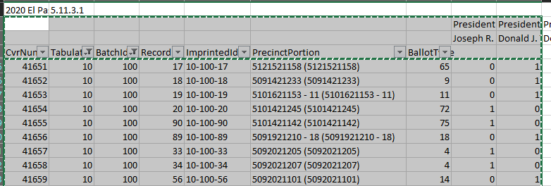

- In your new worksheet, highlight all records below the column names and select Sort from the Data tab. Add a sort (smallest to largest) on column D.
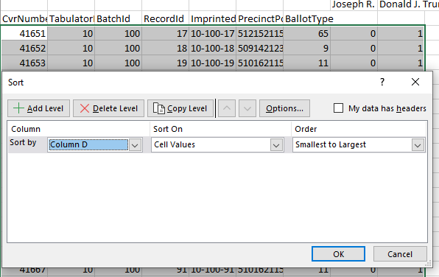

- At this point, the report should be sorted by Ballot (RecordId). This should allow for a line by line audit, matching vote record to ballot image. 0 indicates no vote while a 1 is a vote tally. Feel free to add a sum at the bottom of the vote columns for summary results.
