Section 4 – Central Scanning Device

File 4-2 CSD Tabulation

4.2 Describe your CSD's tabulation process.

Paper Feed Mechanism
The ballot feed mechanism on the Canon DR-G1130 is intended to handle ballot sizes of 8.5” to 22”. The ballot feed mechanism on the Canon DR-M160II can also handle ballot sizes of 8.5” to 22”. The paper feed mechanism is physically capable of moving the ballot paper forward into the machine and across two image sensors (one on top, one on the bottom). These sensors provide image captures of both sides of the ballot.

The basic design of the scanners consists of separate upper and lower imaging surfaces (known as upper and lower units). These surfaces open up for convenient cleaning, maintenance and freeing of ballot jams. Pickup and drive rollers are located on the upper surface, and retard rollers are located on the lower surface. The continuous movement of the upper and lower surfaces minimize the number of ballot jams. The stepper motor torque and the paper feed mechanism's forces of friction have been optimized so that over-torque (where the ballot can tear) or under-torque (where the ballot can become stuck in the machine) do not occur.

Ballot Insertion and Capacity
An automatic document feeder is used to insert ballots. The DR-G1130 has a feeder
capacity of 500 sheets. The DR-M160II has a feeder capacity of 60 sheets. Each feeder can also be operated in manual mode where one sheet is fed at a time.

Customers may elect any quantity of batch size that makes the scanning process efficient for them. The county user may default to batch sizes of 150 ballots because that quantity makes the task of adjudicating ballots that have been flagged for review within a batch easier to manage. Batches maybe rerun without jeopardizing the other batches previously committed and ready for upload. In conclusion, we will work with each county to develop the processes and procedures regarding the central tabulation of ballots that works best for them.

When the ballots to be scanned are placed on the hopper, a sensor will detect that there is paper ready to be scanned. The operator initiates the scan using the ICC application. The scanner will then begin processing ballots automatically.

If there are no defective ballots, scanned images of all the processed ballots will have passed the quality checks and are ready for tabulation.

Multiple Sheet Detector
The ultrasonic double-feed sheet detector of each unit monitors if more than one sheet of paper is in the transport at one time, and will prevent the unit from counting marking positions from two ballots at the same time. Detection is based on an ultrasonic probe that is immune to ink markings on the ballot, as well as the thickness of paper.

Diagnostic Tests
An automated test that performs a diagnostic check and formal report on the system, including:

- Detecting and reporting the system's status and degree of operability
- Confirmation that there are no hardware or software failures
- Identification of the software release
- Status of all data paths and memory locations to be used in vote recording to protect against contamination of voting data
- Other information needed to confirm the readiness of the equipment and to accommodate administrative reporting requirements
- Confirmation that the device is ready for the poll to be opened
- Upon conclusion of the tests, the software provides evidence in the audit record that the test data has been expunged.

The central scanning devices also perform a set of diagnostic tests after every power on/off cycle. Some of these tests require operator intervention and some are fully automated. At the end of the diagnostics process, the system generates a report with the system status information.

For network applications and user interfaces, Democracy Suite EMS Results Tally & Reporting has the ability to generate a zero-state report before the system is utilized. This report extracts all the relevant counters from the database which should be zero before the central scanning process is started. Electoral officers can use this report not only to check that all candidates have no votes, but also to check that the lists of elections and associated candidates are correct.

The EMS system also executes a security report which creates a list of all terminals, workstations, central scanning devices and all authenticated operators within the system.

“Election Run” Mode functionality
During scanning, all ballot batches are placed on the ballot entry tray. Upon initiating a scan, the tabulator pickup roller grabs one ballot at a time and moves the paper over both scanning read heads (thus acquiring a complete image of both sides of the ballot). The ballot is then analyzed and defined as one or more of the following:

- Fully and properly marked ballot
- Misread ballot or invalid ballot
- Blank ballot
- Overvoted ballot
- Undervoted ballot
- Write-in ballot
- Ambiguous voting mark
- Ballot not linked to the current poll ID
- Ballot to which the write-in precedence rule was applied
- Overvoted party preference
- Unvoted party preference
- Cross-voted ballot
- Major overvote
- Major undervote
- Major overvoted rank
- Major inconsistent rank
- Major duplicate candidate rank
- Major skipped rank
- Major unvoted ranked contest
- Major unused rank
- Overvoted rank
- Inconsistent rank
- Duplicate candidate rank
- Skipped rank
- Unvoted ranked contest
- Unused rank

Ballot Scanning Errors
The following will halt the scanning process.

- Misread or Invalid ballot: A ballot that cannot be processed by the tabulator for whatever reason. This includes legitimate ballots that have been mis-scanned, foreign pieces of paper, or blank pages.

- Multiple sheet warning: If more than one (overlapping) ballot is fed into the scanner at the same time.

When the offending ballot has been located in the ballot exit tray, it is removed for resolution. In addition, the scanners may be configured to halt on additional error conditions (i.e. overvotes, undervotes, blank ballots, etc.). The central scanning process is user definable and customizable to meet their exact needs.

Results from the ImageCast Central
The ImageCast Central stores ballot images by scanned batches. The scanned ballot images are migrated to the Election Management System through computer networking or removable media. As with results data from any precinct scanners in use for an election, Results Tally and Reporting is the portion of EMS that processes the images to provide tabulation and operational reports to the jurisdiction.

Batches can be appended, deleted, and processed in a number of ways to suit typical election workflows, intake of ballots before, during, and after Election Day, jurisdictional requirements surrounding absentee ballot tabulation, and canvassing needs. The ImageCast Central also features all of the technological advances present in the precinct-level tabulators – the AuditMark and the Dual Threshold technology.

ImageCast Adjudication

The Adjudication Application is a stand-alone module that allows for the efficient processing of ballots that require resolution of voter intent on a ballot-by-ballot basis during the post-voting stage of an election. The Application has been developed to accept ballot files from ImageCast Central. After analysis and correction, the ballot files are sent to the EMS Results Tally & Reporting application for tally and reporting. The primary function of the Adjudication Application is to create an automated process that allows ballots with exceptions or “out-stack” conditions – such as overvotes, undervotes, blank ballots, marginal marks, major contests and certified write-ins – to be resolved on-screen and sent to tally. This eliminates the need for additional costs, time and resources spent on duplicating and re-scanning ballots.

Each County will be supplied with an Adjudication workstation to permit Adjudication of ballots with some anomalies to be performed simultaneously while the ballot scanning process is being conducted. This is an all new central scanning process that today’s Dominion technology offers.

Streamlining Processing of Ballots with Conditions
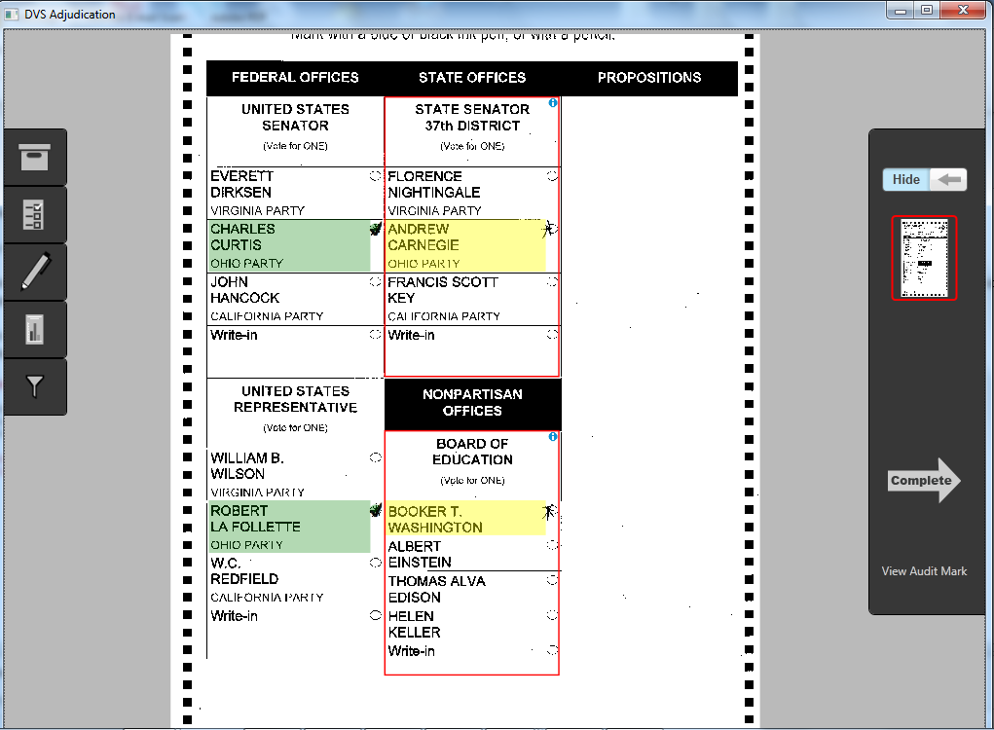
The primary function of the Adjudication module is to create an automated process that allows ballots with exceptions or “out- stack” conditions to be resolved on-screen in real-time and sent to the results tally module. The customer defines which out-stack conditions should be reviewed in Adjudication, including blank ballots, overvotes, undervotes, marginal marks, and write-ins. Dominion’s digital adjudication tool allows for easy and efficient write- in resolution.

The Adjudication Application adds to the efficiency of Dominion’s ImageCast Central County system by making it scalable to as many reviewing teams as needed for the jurisdiction. The outstacked ballots will appear on the screen for the team to review as they come available. This created efficiencies that have never been seen in elections before.

In the examples shown to the right, the top picture shows the first adjudication screen with the contests that need review highlighted with a red box, and candidates with marginal marks highlighted in yellow. The second screen shows a vote being adjudicated for Andrew Carnegie.

Adjudication also offers a robust, ballot-level audit trail. Each ballot scanned by the system is appended with an AuditMark. When a ballot is reviewed in the Adjudication module, and a user makes an adjudication decision, the ballot image is appended with a record of that decision: which user took what action at what time. This allows election officials to ensure that adjudication decisions made by authorized users can be further scrutinized and reviewed, and reversed if necessary, with a clear audit trail of which decisions were made concerning a particular ballot. When scanned centrally, the ballots are timestamped to further enhance the auditing capability of the system.

AuditMark

Enhancing Audit Capabilities and Transparency
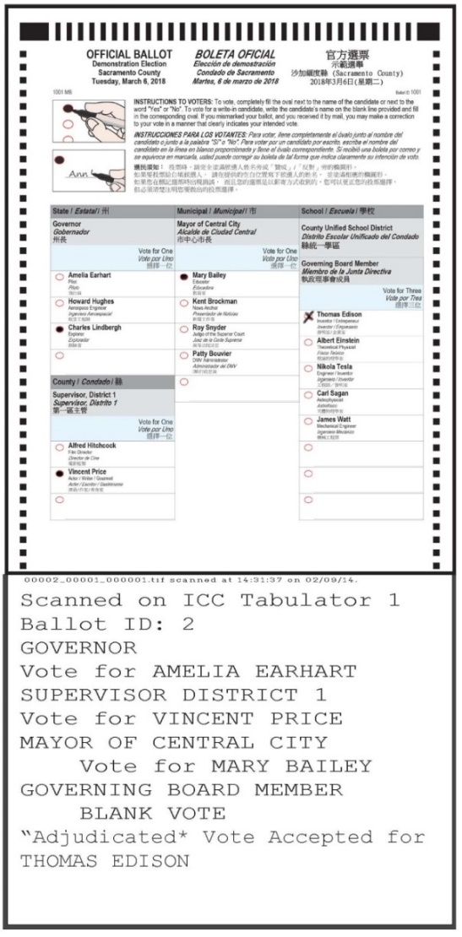
Dominion’s AuditMark technology will allow the County to provide greater transparency in the electoral process. Every single ballot in the election is imaged and appended with Dominion’s patented AuditMark, a record of how the system interpreted the voter’s intent. The AuditMark is the only technology that provides a clear and fully auditable single vote cast record for every ballot cast. This ballot-level audit trail allows election officials and other stakeholders to review not only the ballot images, but also the tabulator’s interpretation of each ballot.

Each image is labeled with the tabulator, batch, and sequence number within the batch, which corresponds to the physical ballot in the stack. The AuditMark is appended directly to the image showing how the vote was interpreted at scan time. This AuditMark will also include any adjudications applied to the ballot for voter intent. Even if ballots for a given batch are mixed after scanning, these multiple records provide a way of correlating the digital Cast Vote Record data to the image scanned and finally to the physical paper ballot. While the AuditMark allows ballot-level auditing, it is never tied to the voter.

ImageCast X ballot appended with Audit Mark and Adjudication

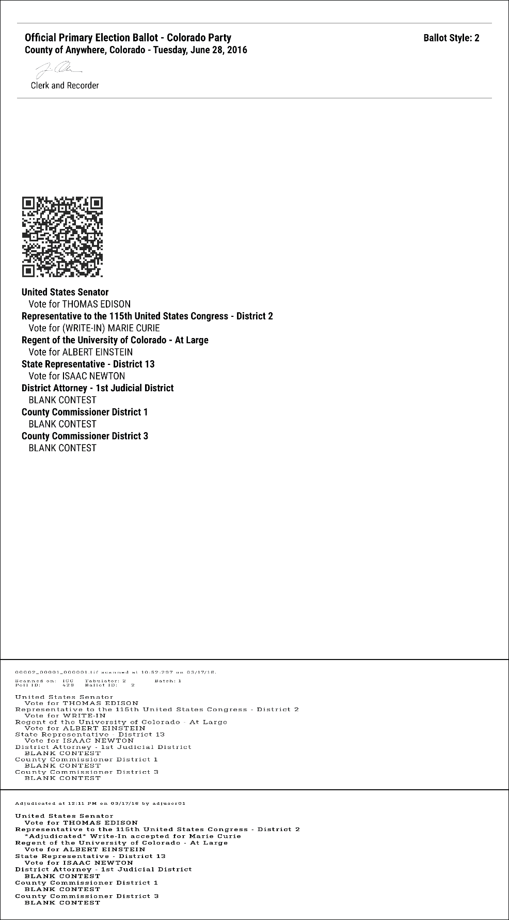

Dual Threshold
When a hand-marked ballot is scanned by an ImageCast tabulator – at the precinct level or centrally – a complete duplex image is created and then analyzed for tabulation by evaluating the pixel count of a voter mark. The pixel count of each mark is compared with two thresholds (which are customer configurable, to determine what constitutes a vote).

If a mark falls above the upper threshold, it is determined to be a valid vote. If a mark falls below the lower threshold, it will not be counted as a vote. However, if a mark falls between the two thresholds (known as the “ambiguous zone”), it will be deemed as a marginal mark and the ballot will be flagged for adjudication where a team will review a voter’s intent and the outcome noted in the system.

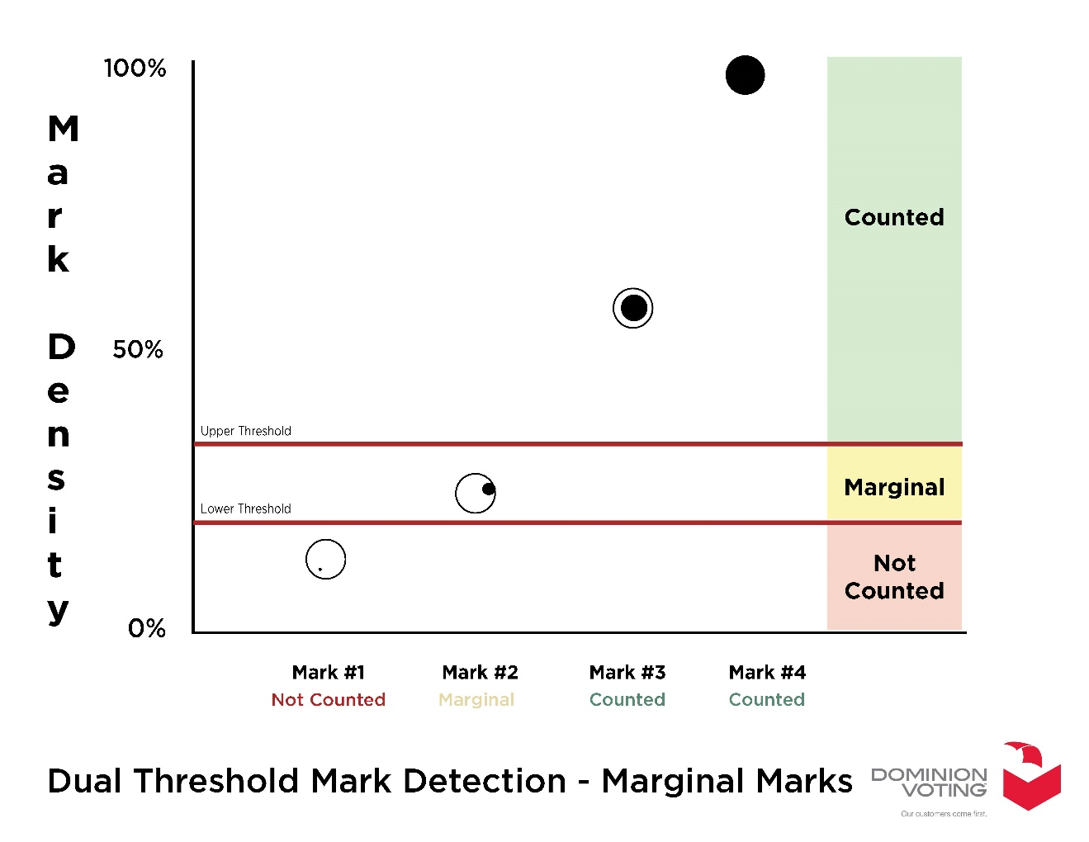
This is another advanced Dominion feature to aid the counties in increasing the accuracy of mark detection and auditability.

