Section 3 – Polling Place Scanners (PPS)

File 3-3 PPS Tabulation

3.3 Describe your PPS' tabulation process.

The ImageCast Precinct can be thought of as a sheet fed scanner. This means that as the paper is pulled through the machine, a complete image is taken of the top and bottom of the ballot. The scanner then passes this image to a software program which looks for markings (black squares which are often called `fiducials') around the ballot. If the correct number of fiducials is found, and the ballot bar code passes checksum logic tests, the software then knows that it is looking at a valid ballot.

Once a ballot is verified, the system begins to interrogate the ballot markings. To begin, the machine integrates every black pixel for each marking area corresponding to a position on the ballot. If the number of black pixels exceeds the threshold marking defined by the jurisdiction, the mark is considered a vote and a digital signal is created. If there is no mark present, an appropriate digital signal is created. For those cases where handwritten or write-in votes are present, the marks are detected and these ballots are placed in the secondary ballot compartment.

The machine is designed so that no ballot is allowed to pass the scanning stage unless:

- The scanner verifies that it is a valid ballot
- The scanner reads all the fiducials around the ballot image.

If, for whatever reason, the machine is unsure about the image, it will notify the operator with an appropriate error message (such as \Ballot Misread," \Please Insert Again," \Invalid ballot for this polling location," \DRO box not signed," etc).

In total, there are approximately 340 image checks that are performed on each image. If any check fails, the machine will report the ballot as misread and automatically reverse it. The system has been designed to have an error rate of less than 1 in 10,000,000 markings.

The imaging system is designed using a narrow paper path. This ensures that folds, creases, and crumpled ballots are imaged without any artifact appearing in the ballot image. If these artifacts appear and affect the image, an error message is given to the operator.

If proper marking devices are used, smudges do not occur. If a voter uses another type of pen, which does not dry before ballot insertion, the leading surfaces of the tabulation units contact the paper and prevent any wet ink or smudges from affecting the imaging of the initial or subsequent ballots.

The ImageCast Precinct allows ballots to be generated with marking positions for Write-Ins, if allowed under election laws, whereby a voter can write-in a candidate's name if that name does not appear on the ballot. When a ballot with Write-In markings is scanned, the ImageCast Precinct will record as many write-in votes as the number of candidates the voter is allowed to select, as per VVSG regulations.

The scanning process consists of real-time monitoring and interrogation of all ballot images before the batches are accepted. In essence, all ballots are scanned and then subjected to image processing, which determines if the ballot is valid and scanned correctly. If any scan fails this interrogation, the scanner ceases operation. It emits an audible and visual notification to the operator, and returns the ballot.

A high-level list of ImageCast Precinct features that support the scanning and tabulation function includes the following:

- Two (2) optical imaging scanners for creating a duplex scanned image of each side of the ballot. Ballots can be fed in all four (4) orientations.
- Linux Operating System.
- Two SD memory cards ports for storage capabilities. Two (2) 8GB SD memory cards will be provided and located behind two securable doors (Administrator Door and Pollworker Door).
- An interactive electronic display in the form of an ultra-high contrast graphical color 5.7” LCD screen, and a built-in touch screen for administration purposes.
- An internal 3” thermal printer and one (1) 3” paper roll for generating reports.
- One (1) administrative security key (iButton) used with an integrated receptacle (physically attached to the top of the unit and electrically connected to the motherboard) used for a variety of verification and security tasks such control, data confidentiality and integrity functions.
- A motorized paper feed mechanism for detecting and moving the ballot within the scanner. Ballots used with the ImageCast Precinct must be 8.5” wide by a variable length (11", 14", 17", 19” and 22"). The paper feed mechanism is physically capable of moving the ballot forward into the machine, across image sensors, enabling complete image capture of both sides of the ballot.
- Power supply module uses 120 Vac, 60 Hz, one phase power. It has a power consumption of 0.07 Amps at 120 Volts AC.
- An internal battery which is rated to provide six (2.5) hours of normal use in the absence of AC power. In addition to internal 2.5 hours battery an internal 6 hours battery option is also available. There is also a connection for an external 12VDC SLA battery.
- Patented functionality known as the AuditMark. For each ballot scanned and accepted into the unit, a corresponding ballot image is created and stored for audit purposes. The image consists of two parts described below:
- The top portion of the image contains a scanned image of the ballot.
- The bottom portion consists of a machine-generated text showing each mark that the unit interpreted for that particular ballot. This is referred to as the AuditMark.

Clarification Question

What is the model and size of the PPS proposed? Attach a picture.

The proposed Polling Place Scanner is the ImageCast Precinct as certified under Democracy Suite 5.5A.

ImageCast Precinct
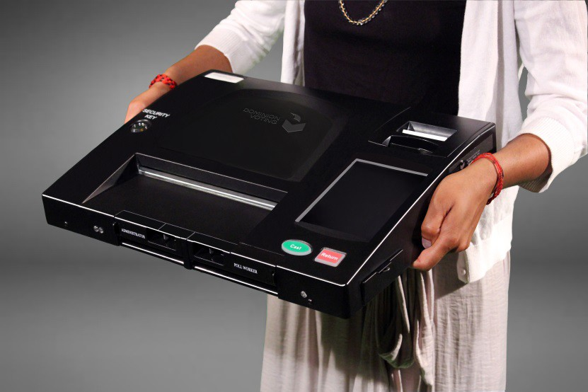
Model number: PCOS-330A 16V AC
OS: Linux
Processor: NXP ARM Cortex-A9 Dual Core 1GHz
Memory: 2GB
Modem: External Multi-Tech HSPA USB Modem
Weight: 14 lbs.
Dimensions: 17” x 13” x 3.5”

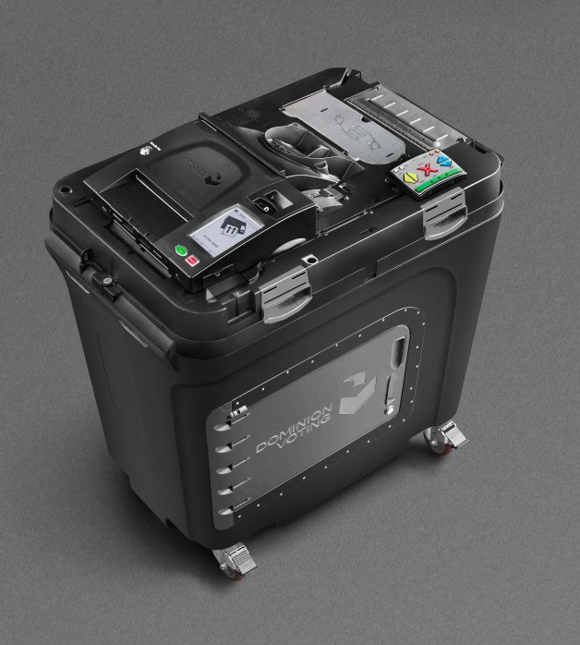
ImageCast Precinct Ballot Box
The ImageCast Precinct includes a plastic ballot box to receive cast ballots directly from the ImageCast Precinct tabulator. The ballot box specs are:

Weight: 75 lbs.
Dimensions: 25” (W) x 37.5” (D) x 44” (H)

