Section 6 – EPoll Data Management System (EPDMS)

File 6-2 EPDMS Media

6.2 Describe how election configuration information is loaded. Is it done via encrypted, removable memory devices created by the EPDMS or through direct a connection to EPDMS through a LAN?

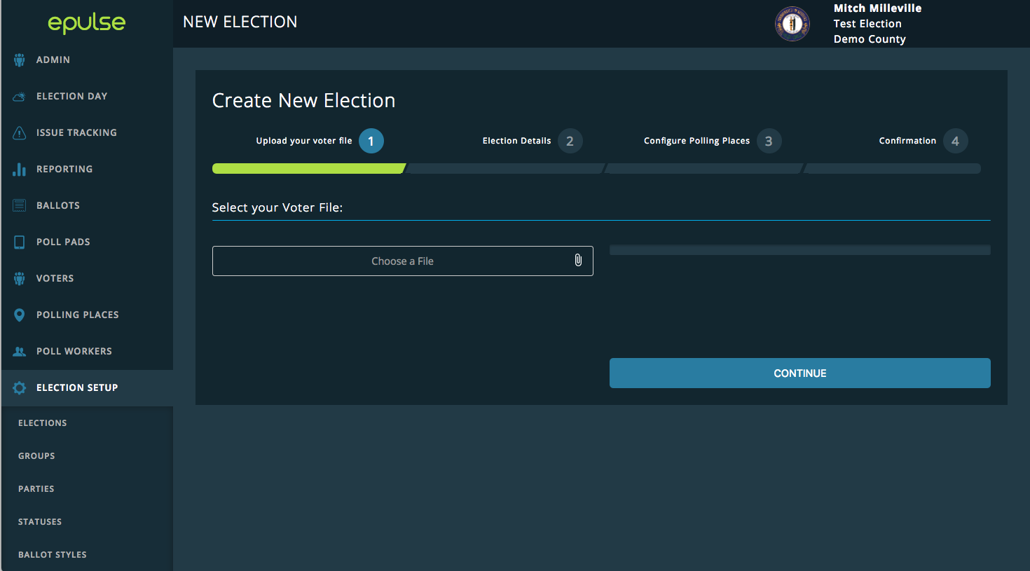
ePulse, KNOWiNK’s EPDMS, provides the option of using iSync encrypted removable memory devices, transferring the data via network connectivity from the central GASOS office or a LAN connection to securely transfer election configuration information from ePulse to the Poll Pad. In ePulse, an election administrator with proper credentials is provided a workflow to guide them through the process of properly uploading a voter file.
Figure 6-2-1. ePulse election file import. Once the file is selected, the user clicks Continue and the upload begins. ePulse is built to support VRS files natively, so that creating an election in the Poll Pad is completely seamless. Users are able to customize import flags such as statuses and absentee information at the State’s discretion.

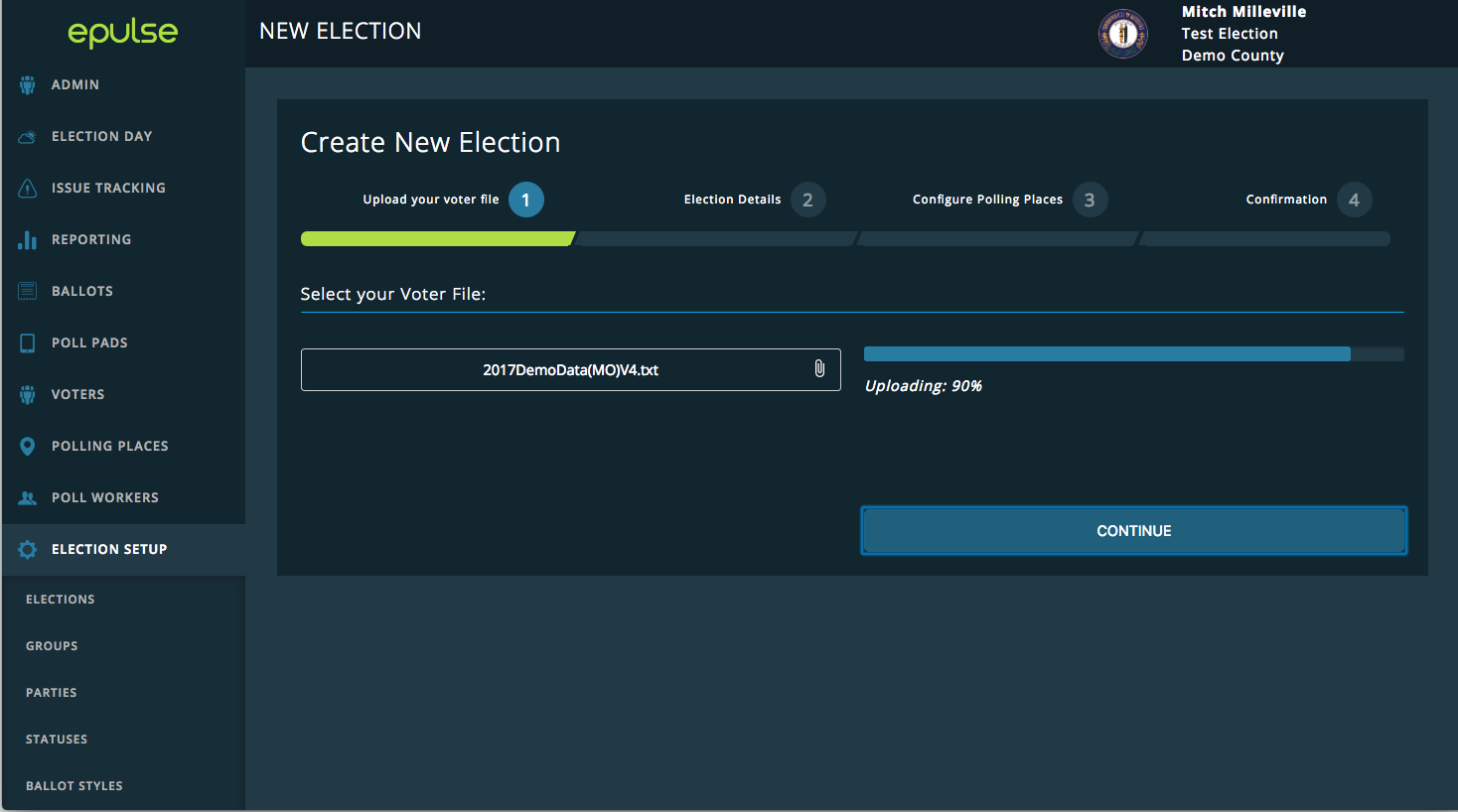
Figure 6-2-2. ePulse election file import. Once the file is selected, the user clicks Continue and the upload begins. ePulse is built to support VRS files natively, so that creating an election in the Poll Pad is completely seamless. Users are able to customize import flags such as statuses and absentee information at the State’s discretion.

Figure 6-2-3. Election Details. The ePulse user enters in the election details, including election type, date, and poll open and closing times. This establishes the initial voter file and specific election details for your Election. Any subsequent data that is loaded will make supplemental changes to your Election and will be available to be disseminated to

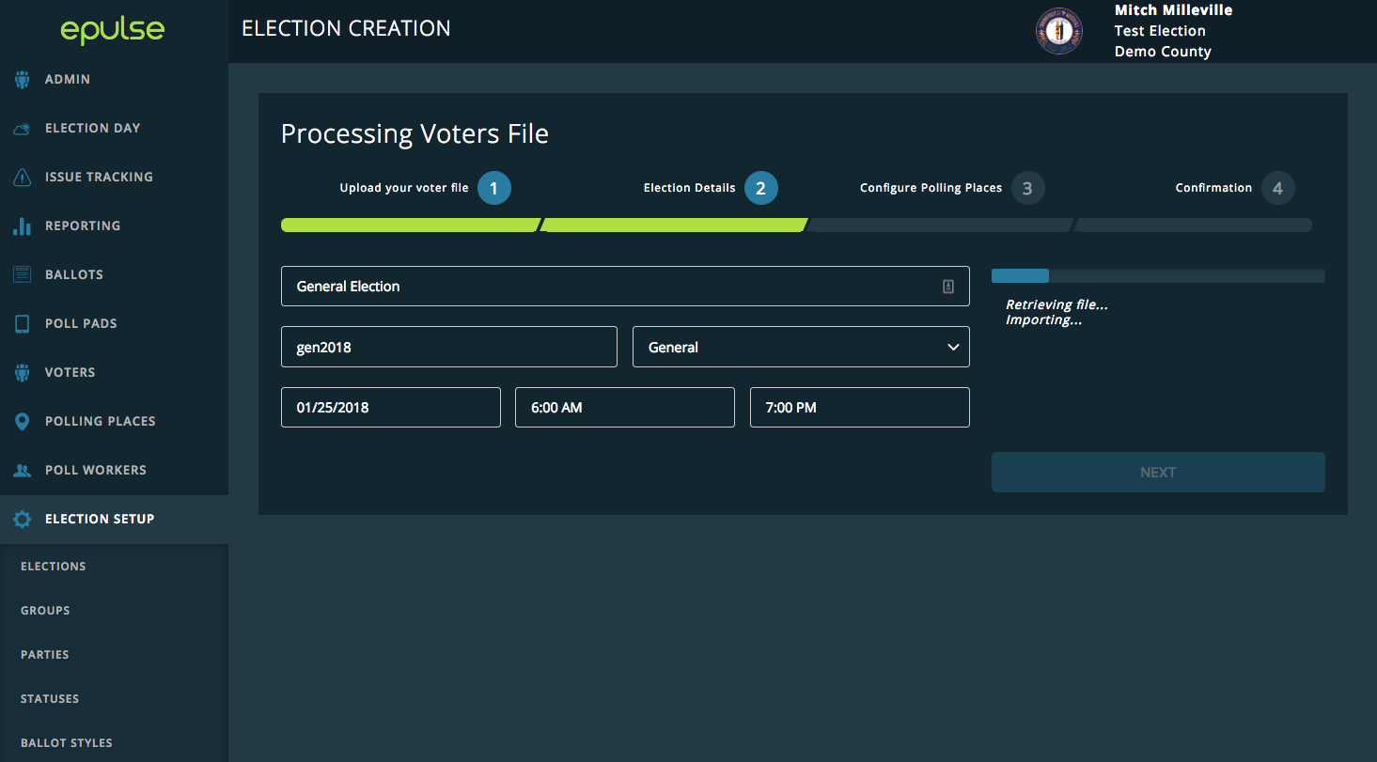
Figure 6-2-3. Election Details. The ePulse user enters in the election details, including election type, date, and poll open and closing times. This establishes the initial voter file and specific election details for your Election. Any subsequent data that is loaded will make supplemental changes to your Election and will be available to be disseminated to the Poll Pads. Supplemental updates can be distributed to the Poll Pads via wireless internet connectivity or iSync drive.

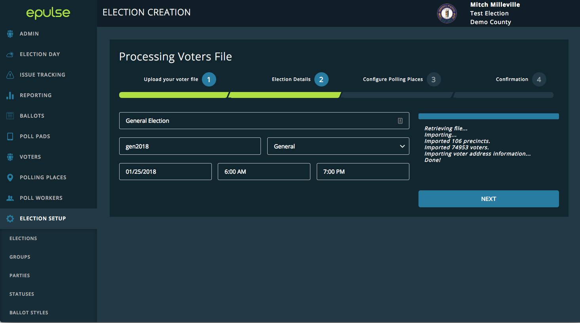
Figure 6-2-4. Election Detail Confirmation. ePulse automatically provides status updates on the imported file’s progress and verifiable statistics to ensure the data uploaded matches county records. Once complete, the user clicks Next.

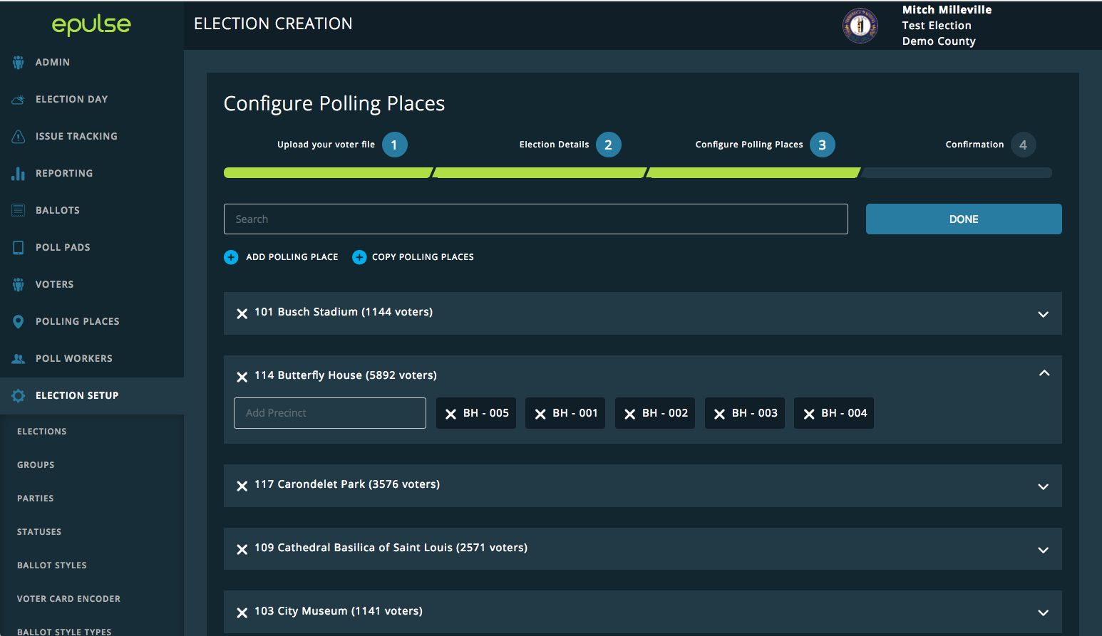
Figure 6-2-5. Configure Polling Places. The third step is reviewing the imported list of polling places. The user may customize the configuration for each Polling Place and precinct. Various combinations of polling locations can be manually added or imported in bulk into ePulse for use during an election. Vote centers, early absentee locations, or precinct specific locations are the most common types but we are also able to work with the State to set up a unique offering at your request.

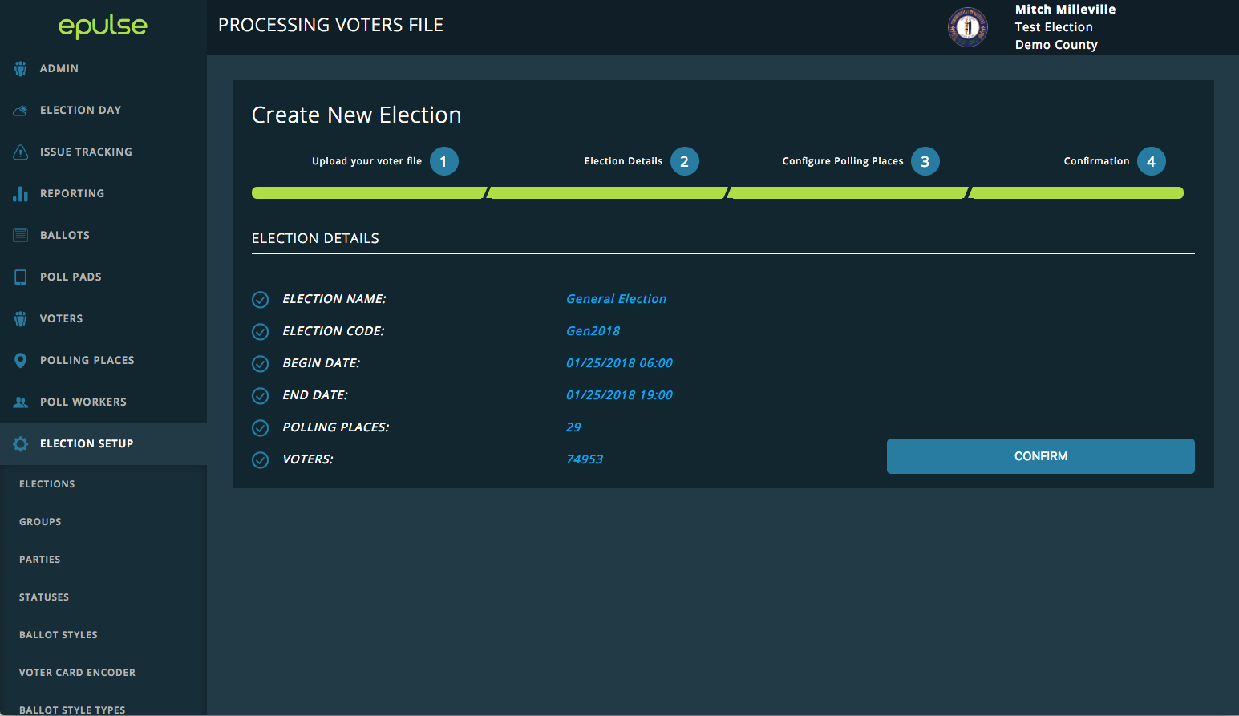
Figure 6-2-6. Election Setup Confirmation. The Confirmation page provides a summary report of the new election details. The user reviews and clicks Confirm. The Confirmation page provides a secondary summary report of the new election details and statistics for final verification. The user confirms the information displayed and clicks Confirm to finalize the initial database to be used in the Election.

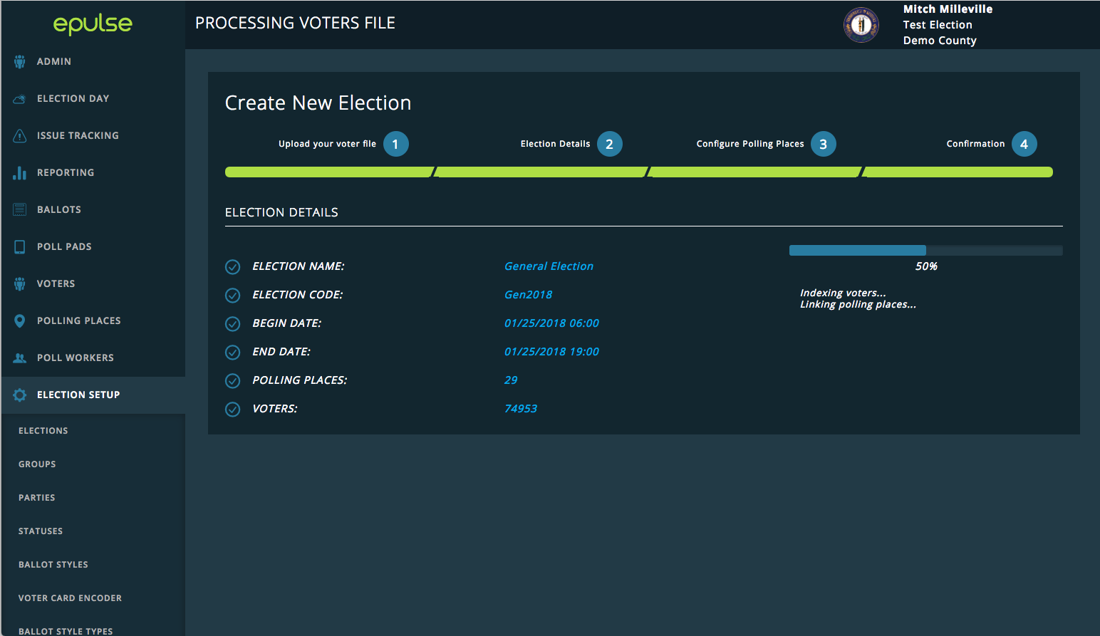
6-2-7. Final Configuration. ePulse begins indexing the voters and links voter records to the correct polling places. ePulse allows the upload of supplemental data and rosters from a VRS. Once loaded, the changes enacted by the supplemental file are then disseminated to the Poll Pad application via wireless hotspot connectivity or barcode scanning for near real-time updating of voter records.

Clarification Question

Is the EPDMS housed on a CPU that can be hosted on premise and air gapped? If the EPDMS is designed to be hosted, please describe if it is possible to run the EPDMS in a private cloud configuration, separated from other customers?

The EPDMS (ePulse) is designed to be hosted on a cloud service, specifically Amazon Web Services (AWS). KNOWiNK has implemented ePulse using AWS in nearly 600 jurisdictions. KNOWiNK prefers AWS for its vast scalability, security, and cost effectiveness. If a private cloud solution within AWS is desired, KNOWiNK will set up a dedicated Georgia environment that only hosts the Georgia system, separate from all of KNOWNK's existing client’s instances. This has been done for multiple jurisdictions in prior deployments. Deployment and preparation of Poll Pad devices may still be accomplished with air-gapped methodology; these methods are described in 6-4.

