Section 3 – Polling Place Scanners (PPS)

File 3-6 PPS Capacity

3.6 Ballot Scanning Capacity: Provide the number of ballots that can be held by the ballot box to which the proposed PPS would be connected. Specify capacity by ballot size dimensions.

Dominion has designed an innovative ballot box that includes a custom secure top which protects the precinct scanner while in transport and storage and makes it quite easy for the poll worker to roll the plastic ballot box into position in the poll and remove the top. The ballot box is built of sturdy plastic and features four large lockable swivel wheels and handles on all sides for ease of movement in storage or at the poll for poll workers to maneuver the ballot box to the desired location. The ImageCast Precinct (ICP) scanner may be securely attached to the lid for transporting to and from the polling place allowing room to store some precinct supplies inside the ballot box.

Two removable bins are included with the ballot box. One is a write-in bin which collects ballots containing write-ins so poll workers do not have to sort through all the ballots looking for ballots containing write-in votes. The other bin is for collection of emergency ballots if power is lost during the voting period, or if the in-precinct scanner is not working properly. In this case, poll workers will advise the voters to deposit their ballots into the emergency bin until such time as the scanner is working.

The clam shell cover provides a protective, secure, non-accessible condition in case the scanner and ballot box remain overnight in an Early Voting setting or the system is delivered to the polling place in advance of the poll workers arriving and having access to the device.

In many cases, we understand the poll workers may be asked to pick up the ImageCast Precinct scanner and deliver it to the poll and then attach the ImageCast Precinct to the ballot box lid as part of the Open the Poll procedures. Since the ballot box has no internal moving parts, the ballot box can also accommodate delivery of Election Day supplies inside the box. Security is enhanced as the ballot box features five locks and multiple security seal points to limit access and prevent tampering.

When the poll worker arrives to set up the polling site equipment and other items, they will be trained to unlock the cover, plug the ballot box power cord into the wall plug and the system will automatically turn on and perform diagnostic routines. Immediately following the completion of the diagnostic tests, the ImageCast Precinct will print the zero tape or tapes as required.

The Dominion plastic ballot box is:

- Built to the requirements of the EAC, the ballot box capacity is sized to US polling place requirements, with three bins (main bin, write-in bin, and auxiliary/emergency bin).
- Capacity will vary based on ballot length and weight and is approximately:
- Main compartment: 1500 22” ballots
- Secondary compartment (default diverted): 200 ballots
- Auxiliary compartment: 150 ballots
- The tabulator locks and seals onto the ballot box, which features a cover that provides additional security and ease of transportation.
- Features a sealed plastic base and is water resistant.
- Offers multiple deployment and warehousing options, including the possibility of nesting the boxes up to three units deep.

The ballot box is designed to fit through standard doorframes, and its overall size is 27” (W) by 58” (D) by 48” (H). It weighs 85 pounds.
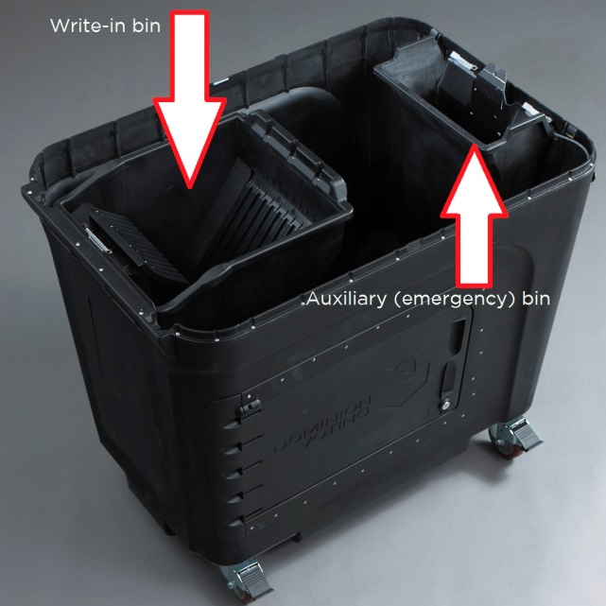
Ballot Box Compartment Bins from above
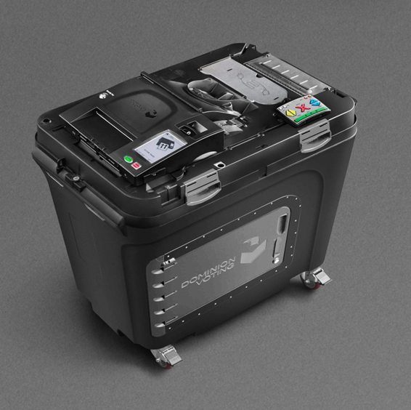
ImageCast Precinct on top of ballot box
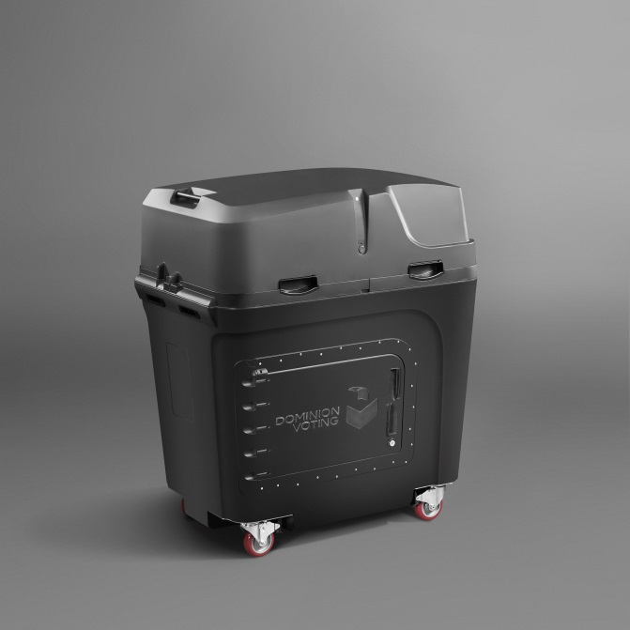
Ballot Box with Attached Security Lid
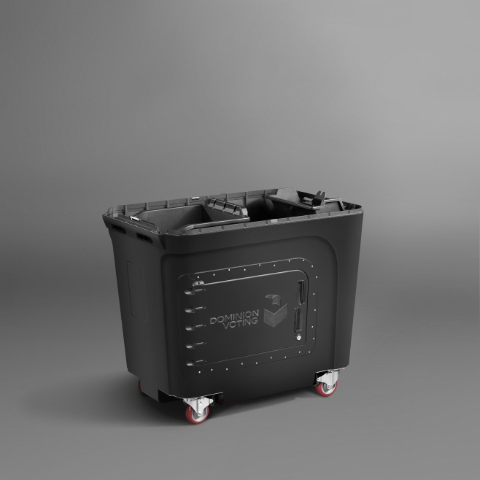
Ballot Box
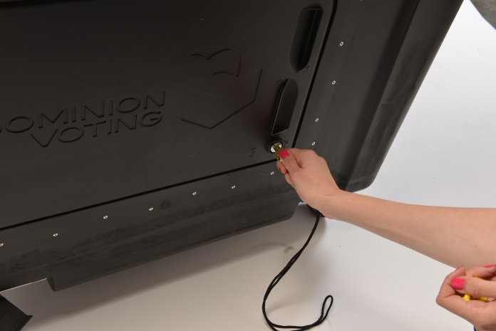
Unlocking the ballot box
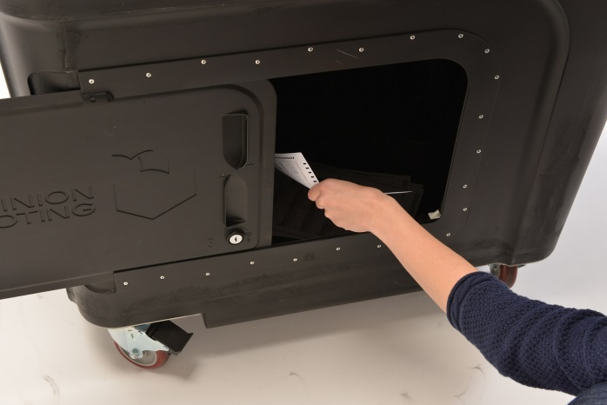
Retrieving ballots from the ballot box

As an alternative, Dominion can also offer a collapsible ballot box that has a similar capacity as the rolling ballot box detailed above. We would be happy to provide additional information on this option to suit the specific needs of the Counties.

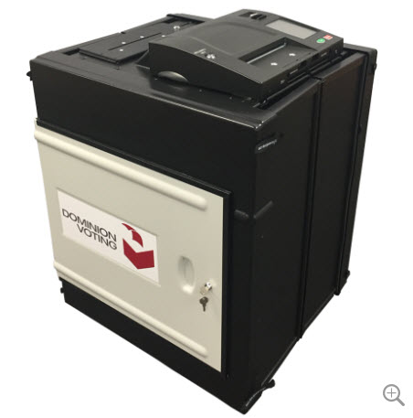
Collapsible ballot box with attached ImageCast Precinct

