Section 3 – Polling Place Scanners (PPS)

File 3-1 PPS

3.1 Complete the attached form titled "Polling Place Scanner" and include narrative.
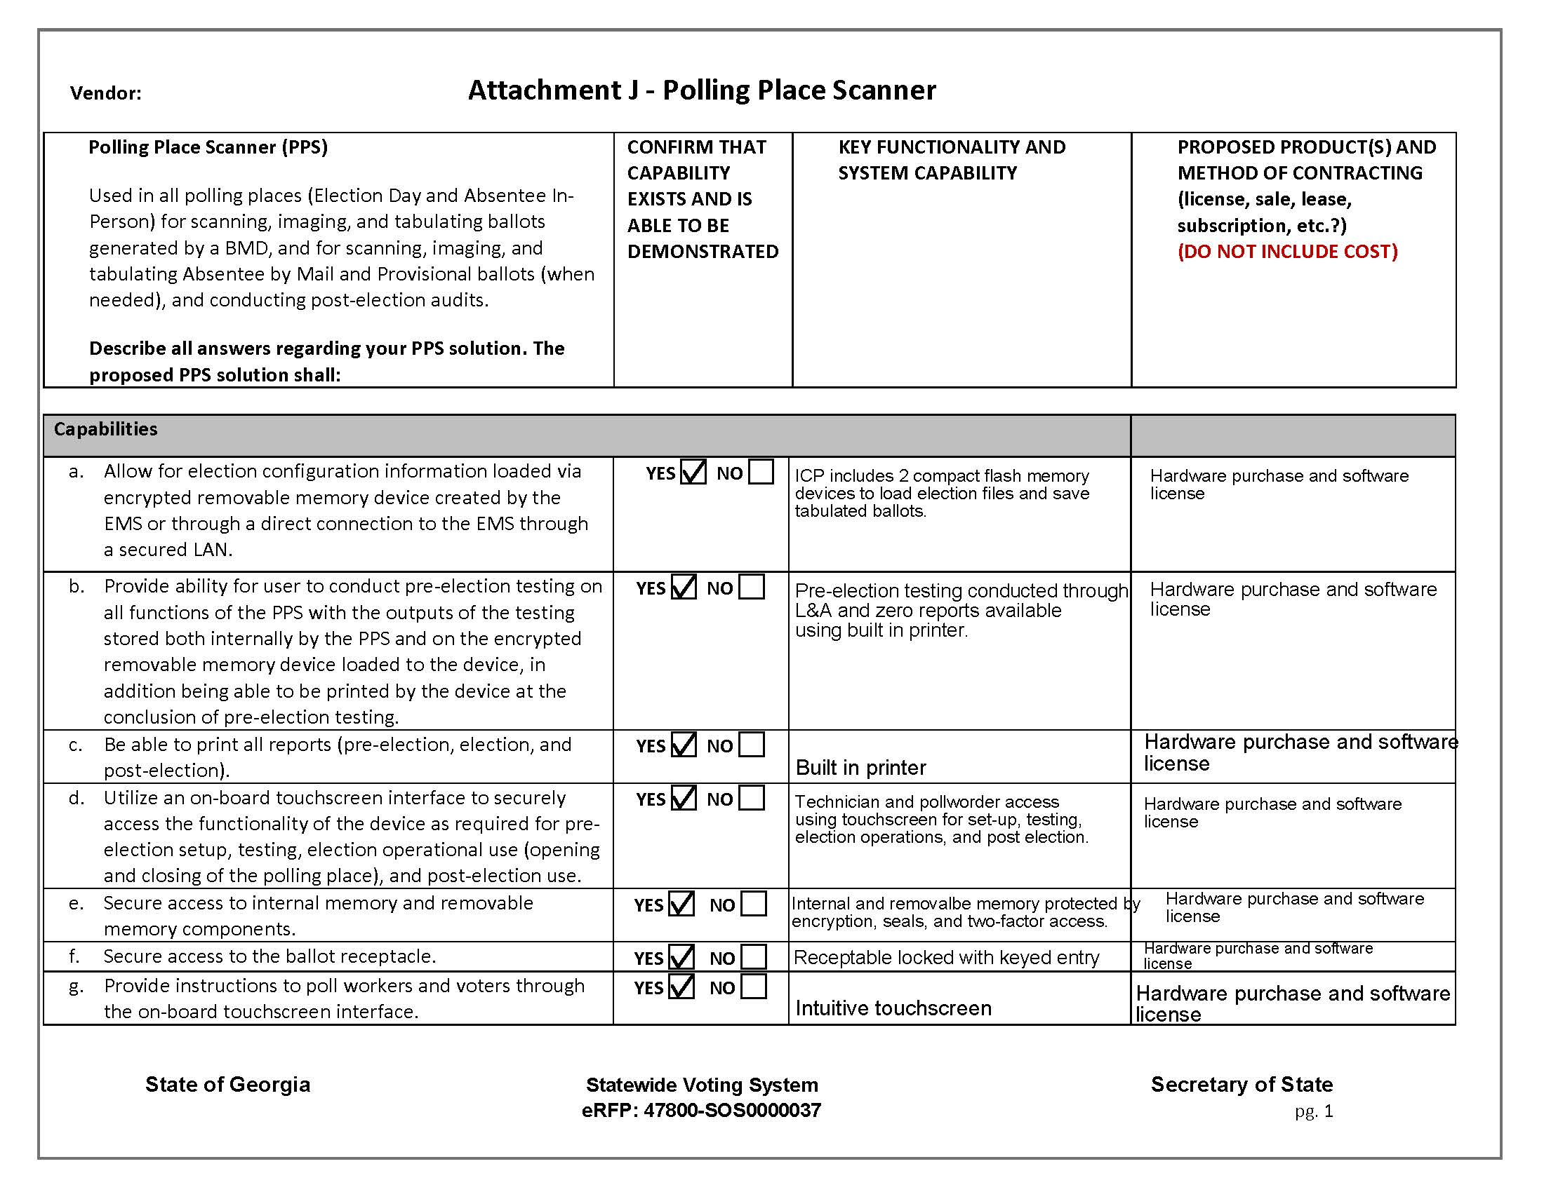

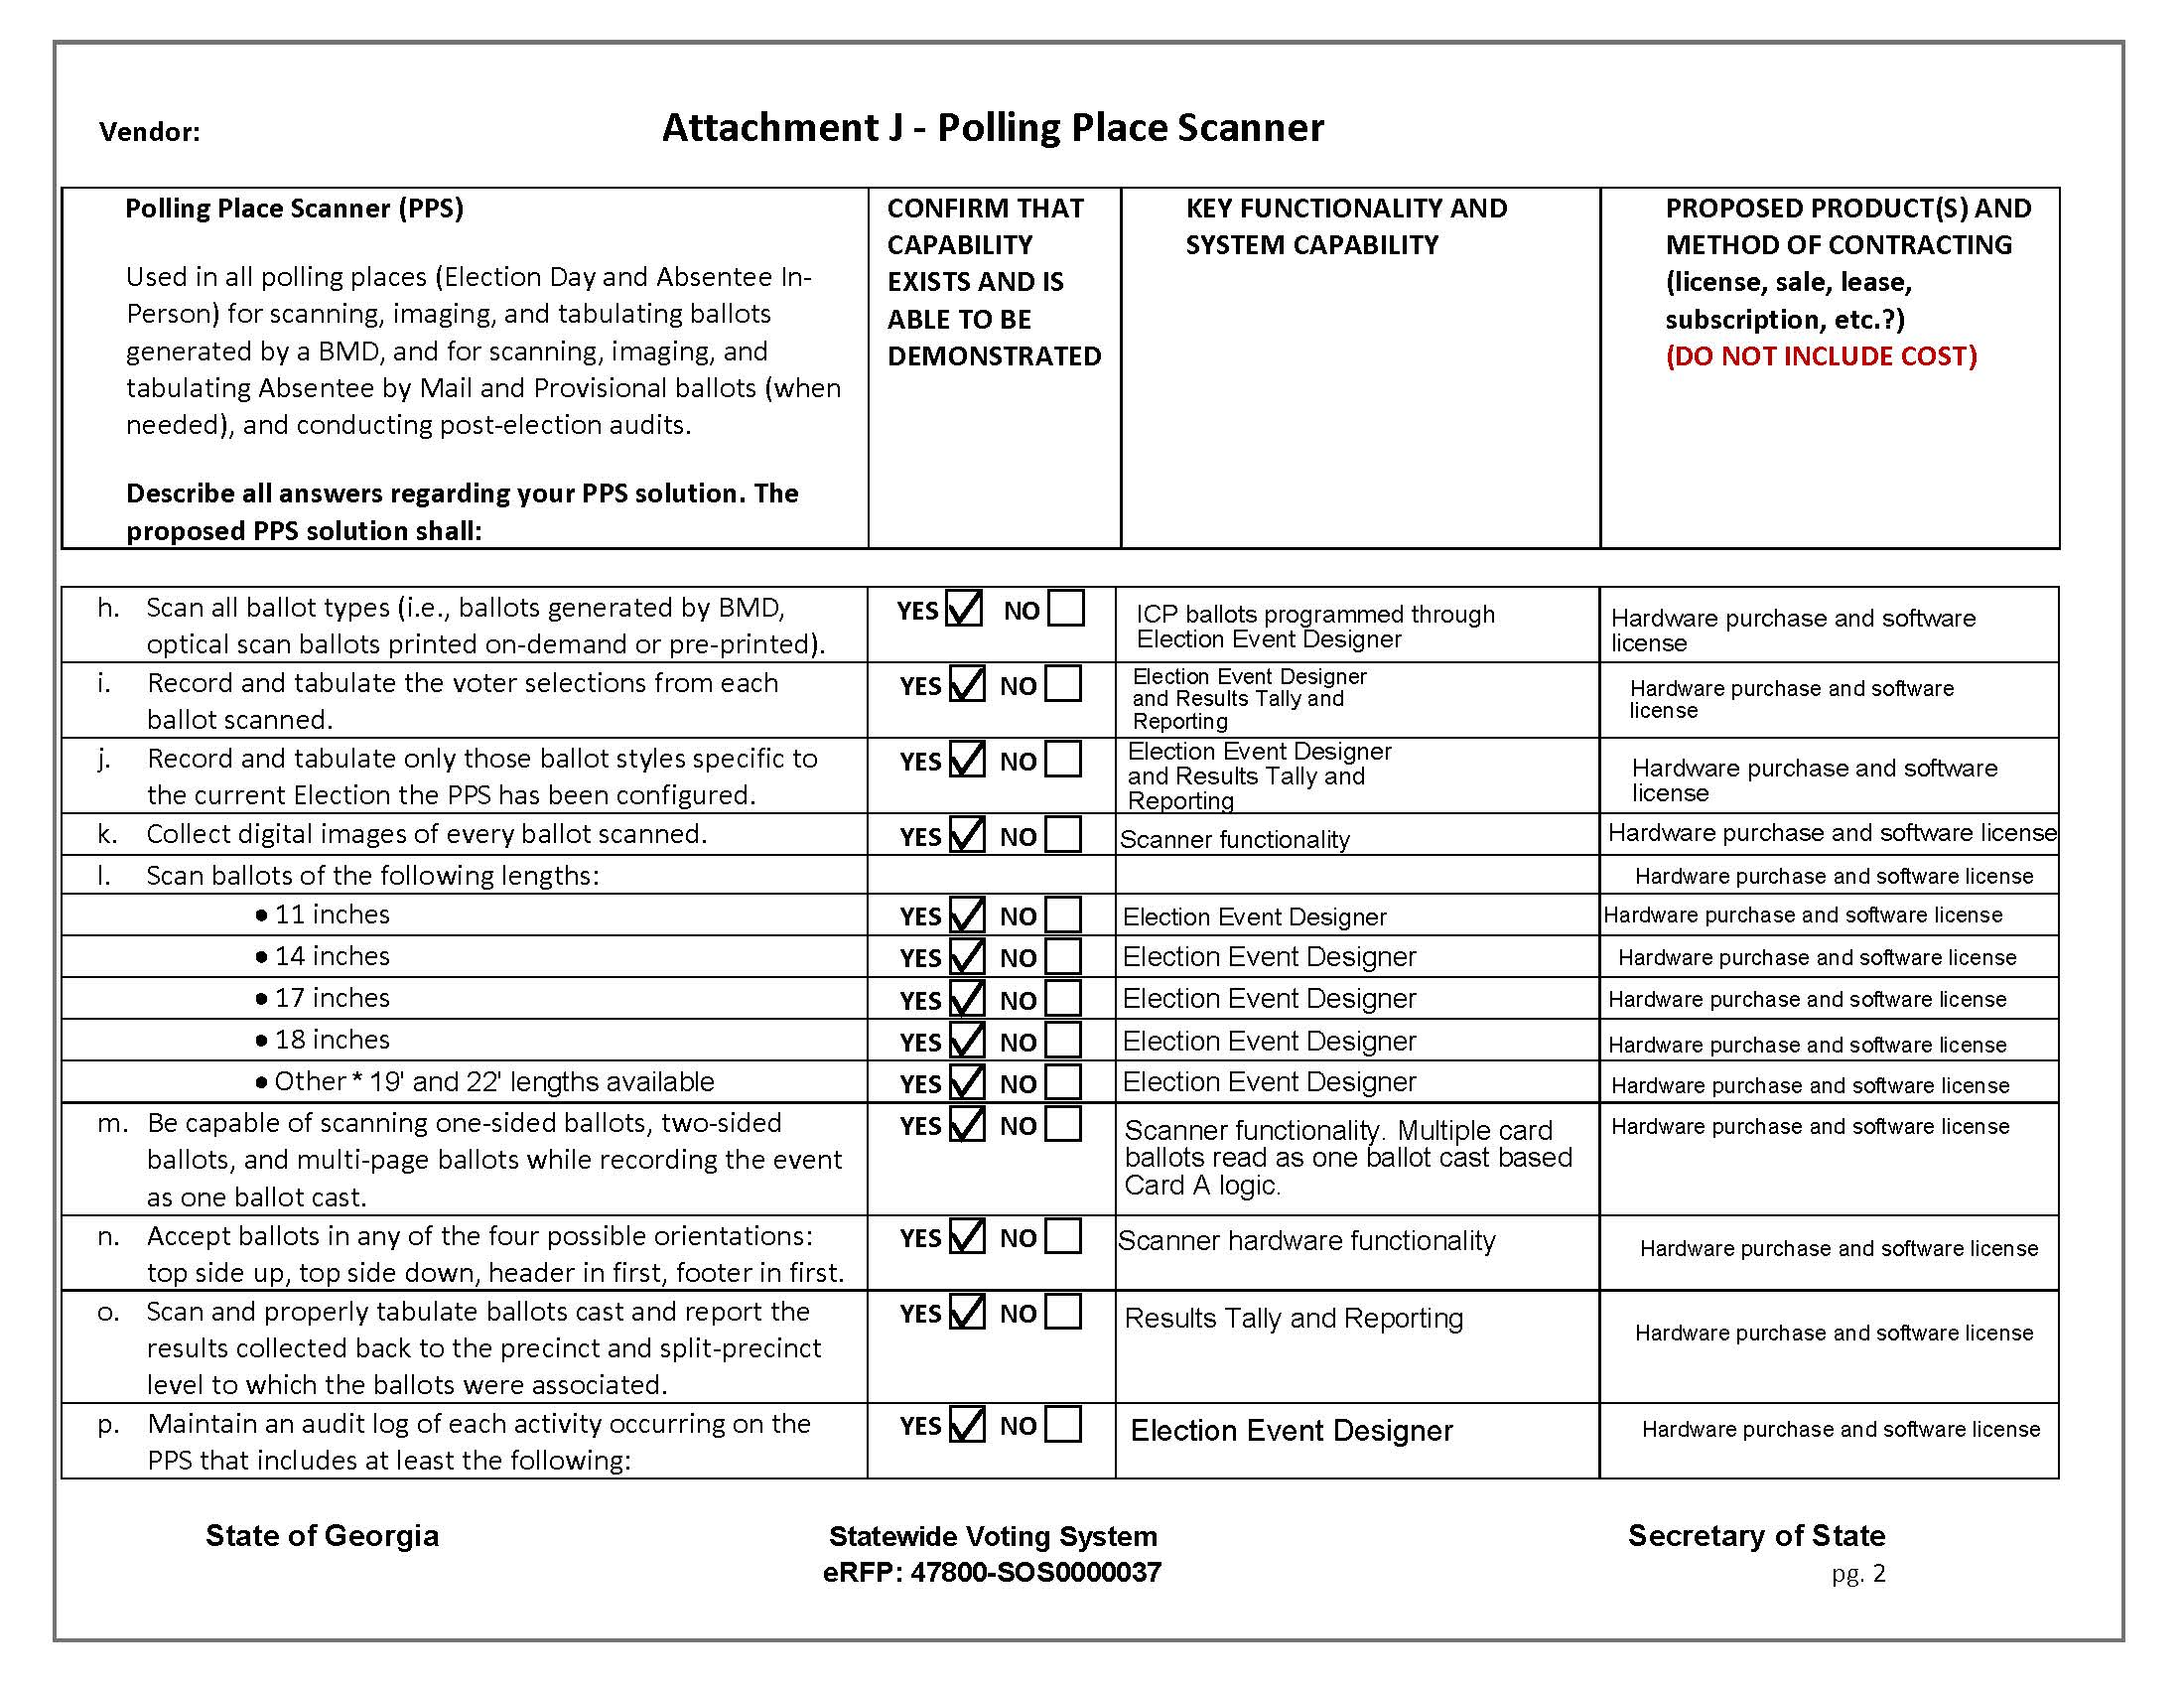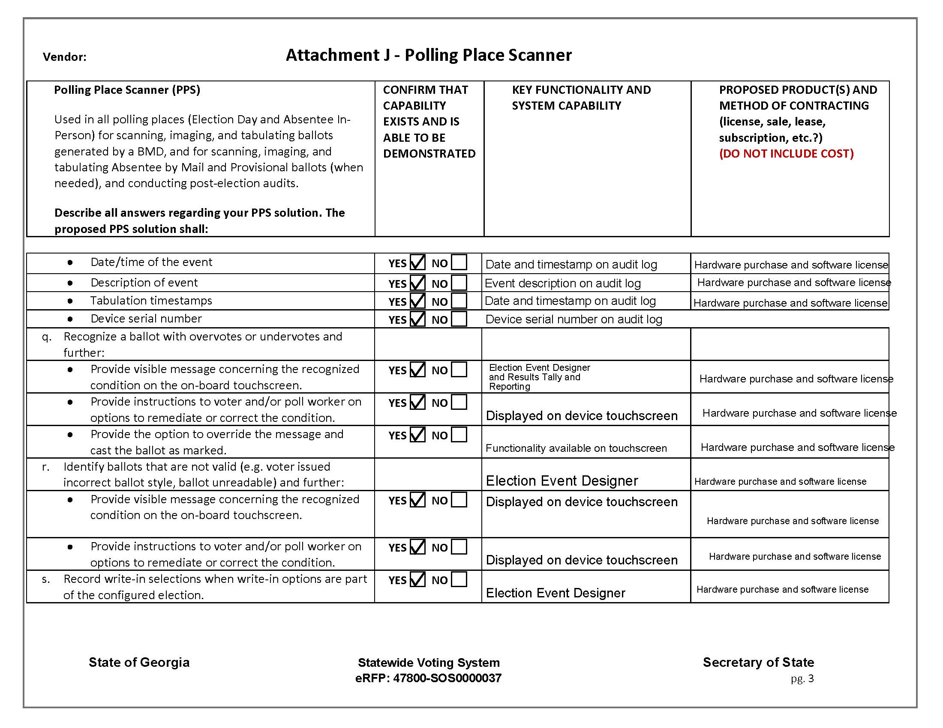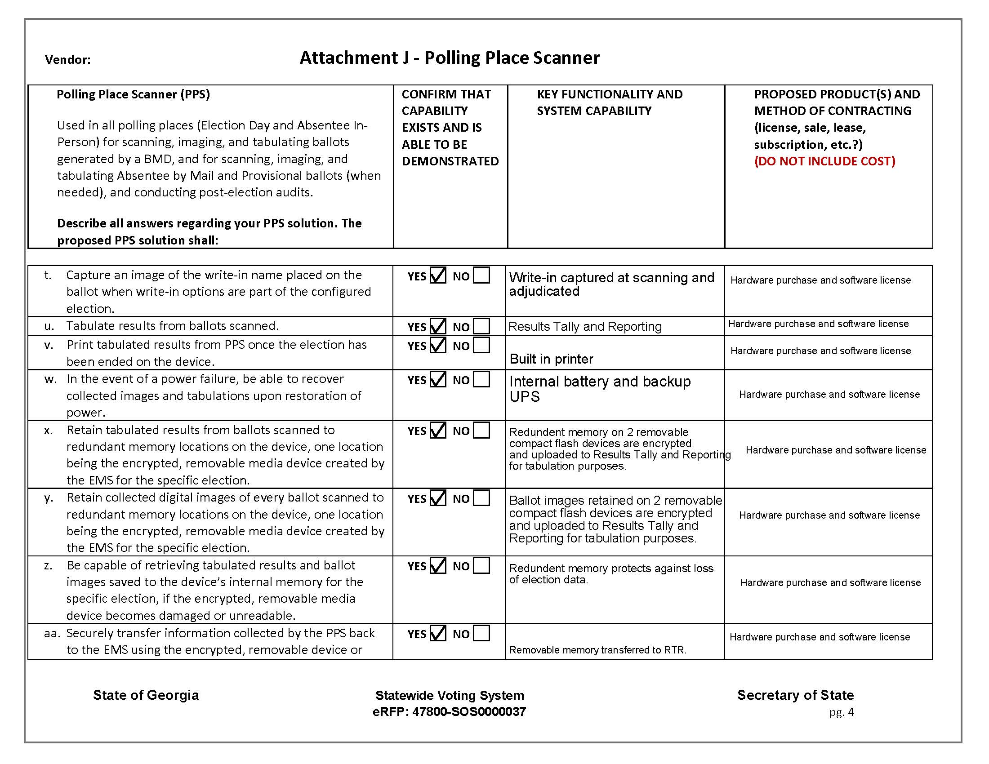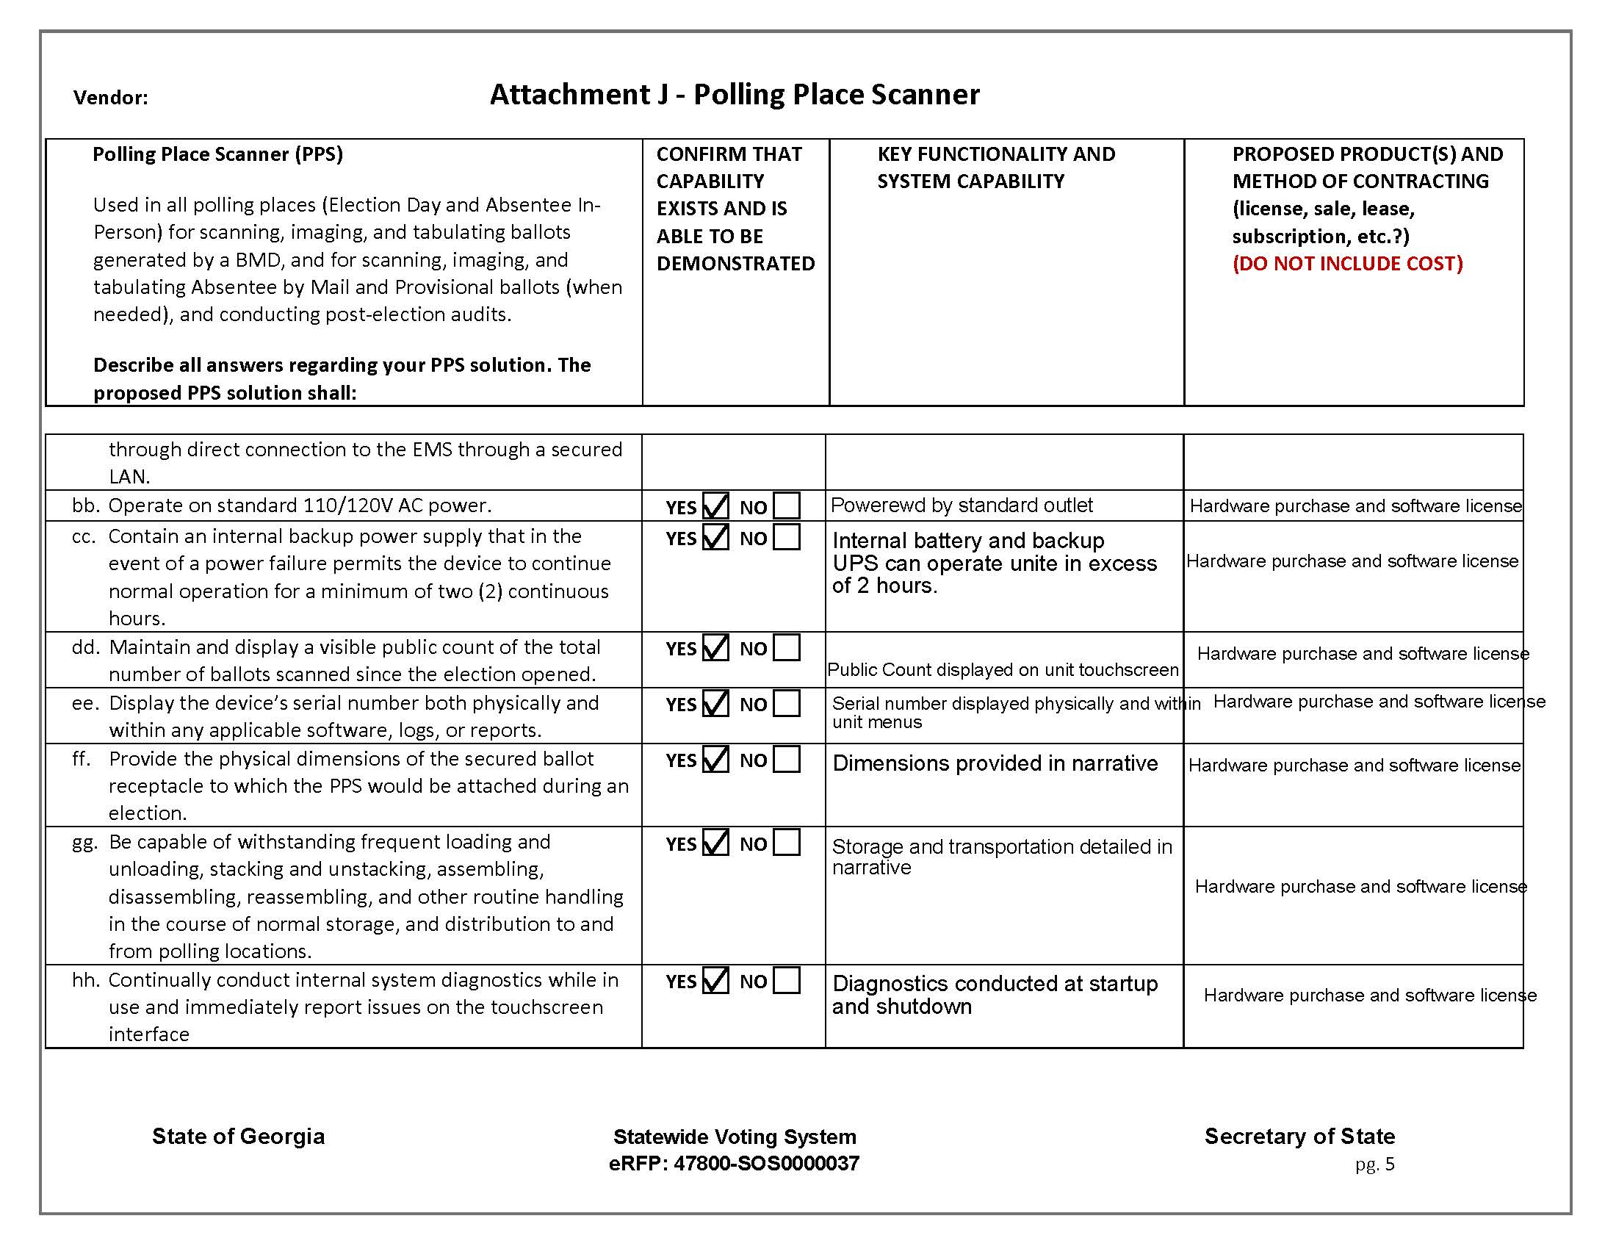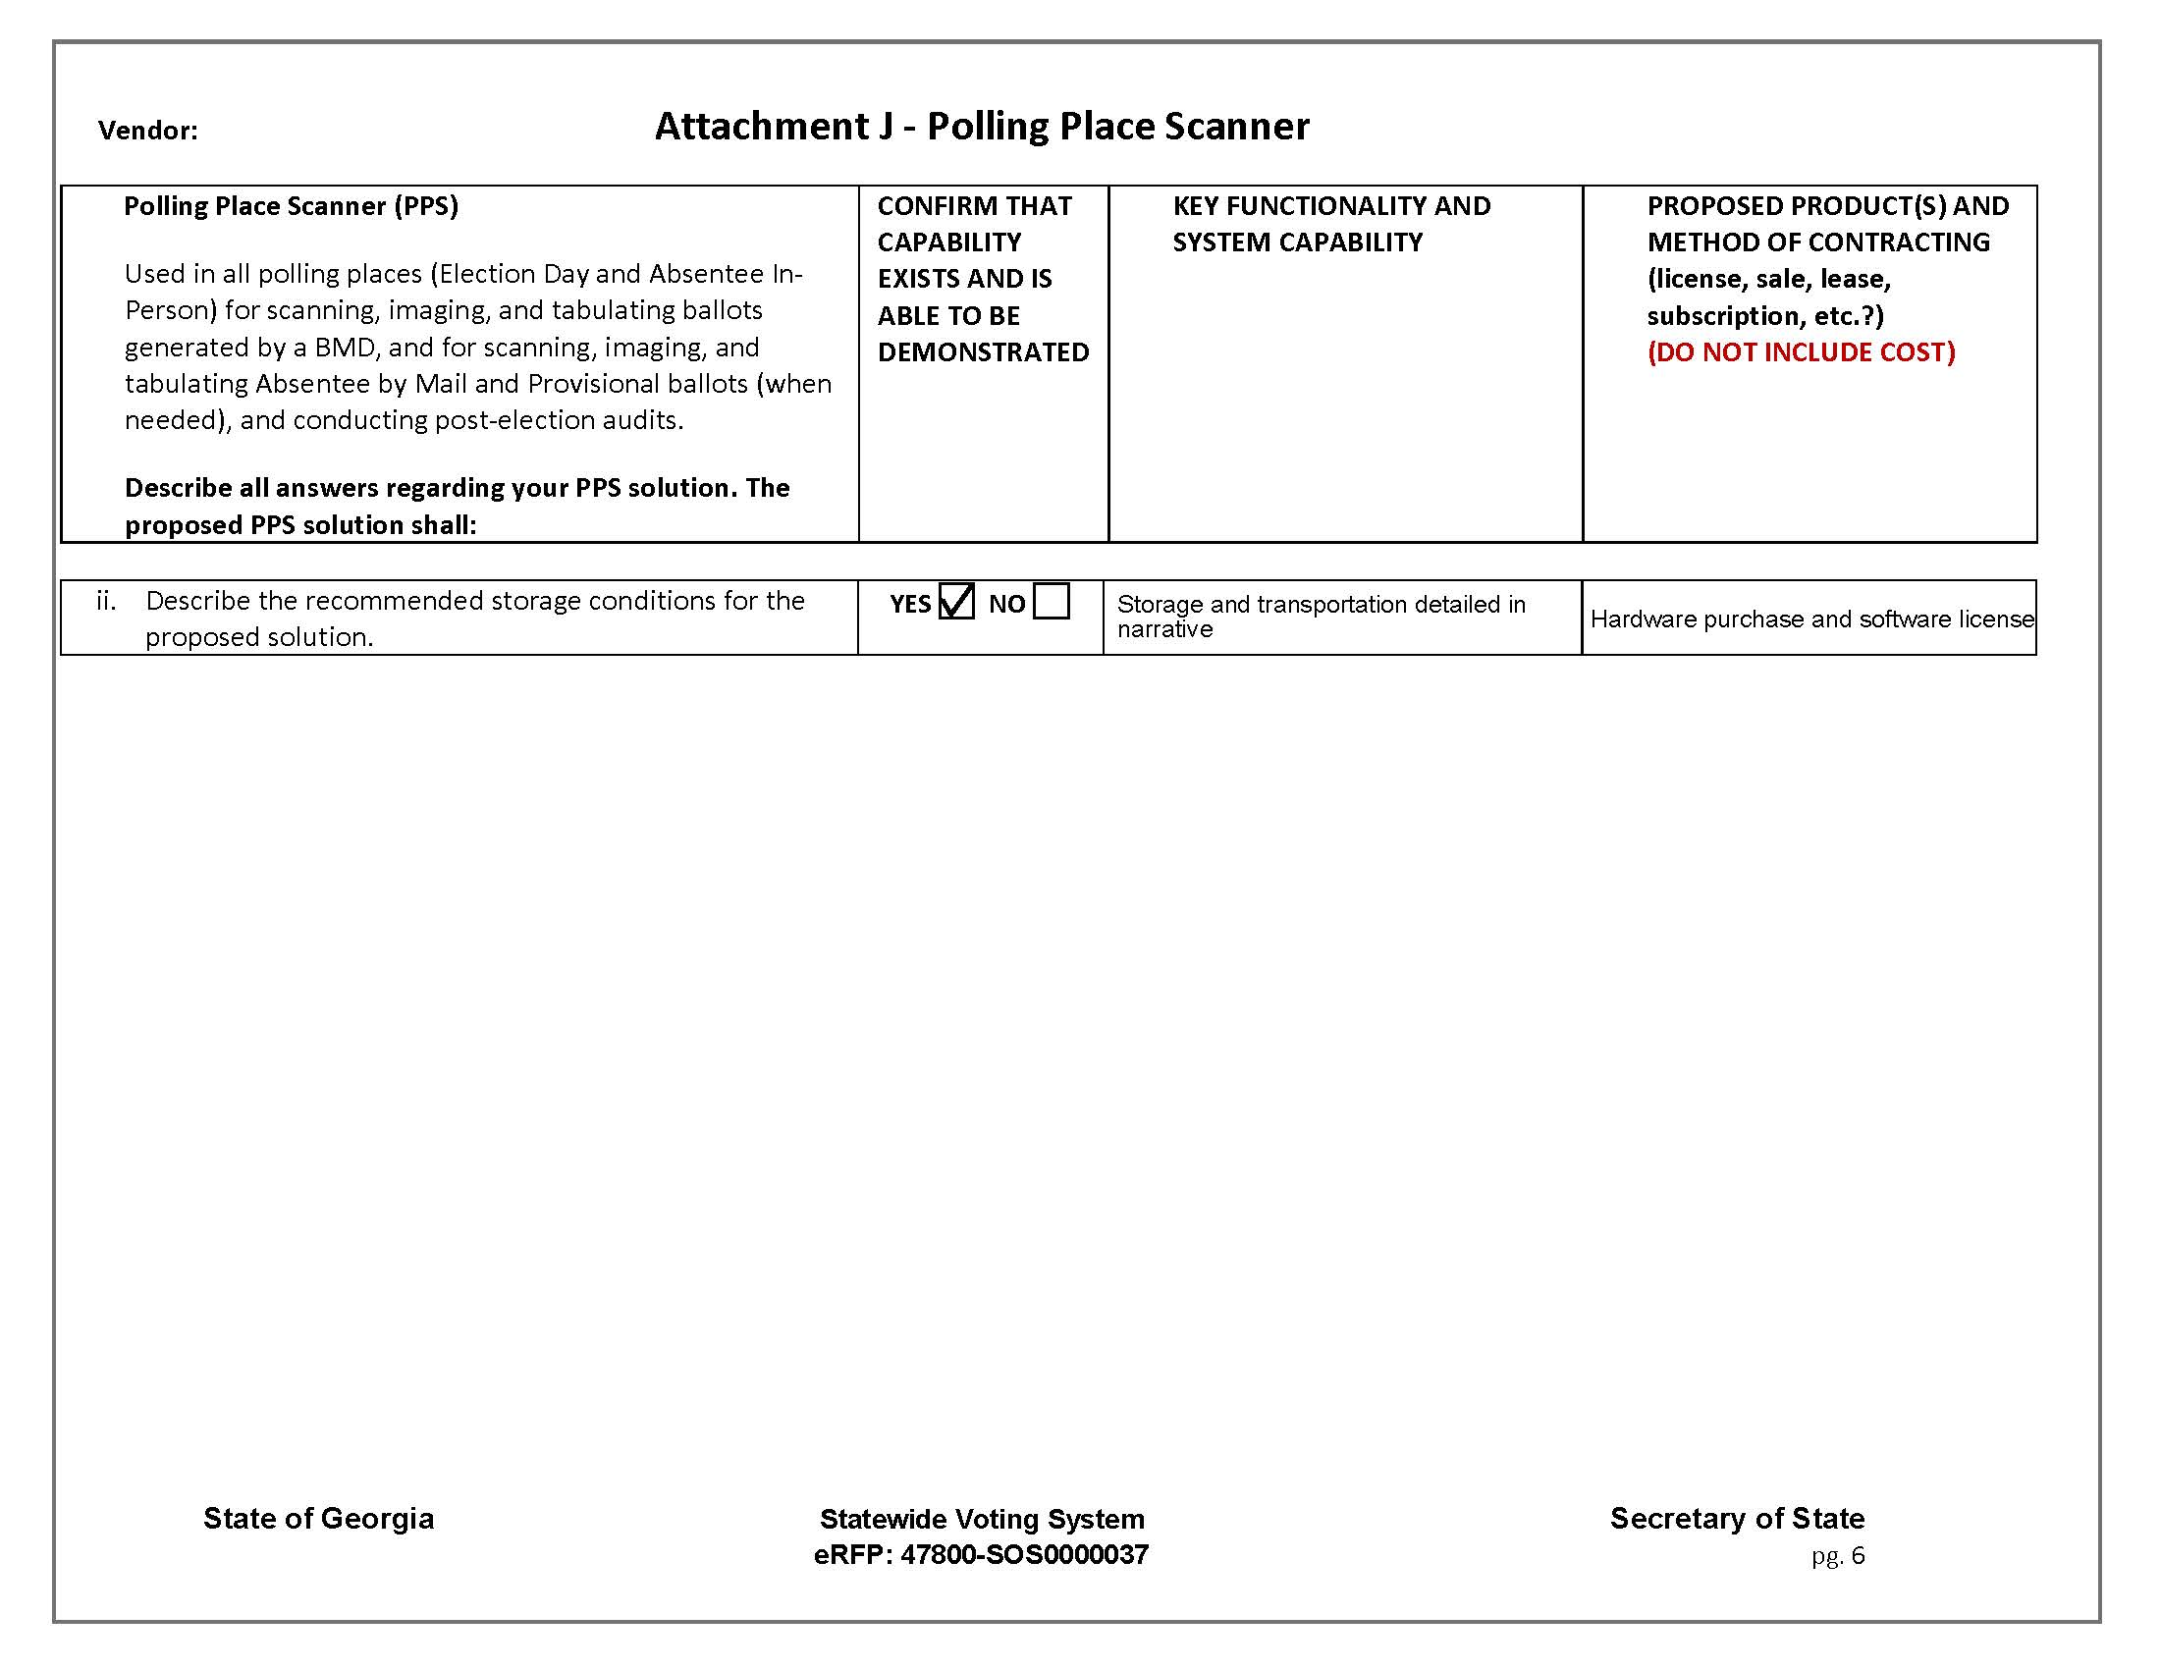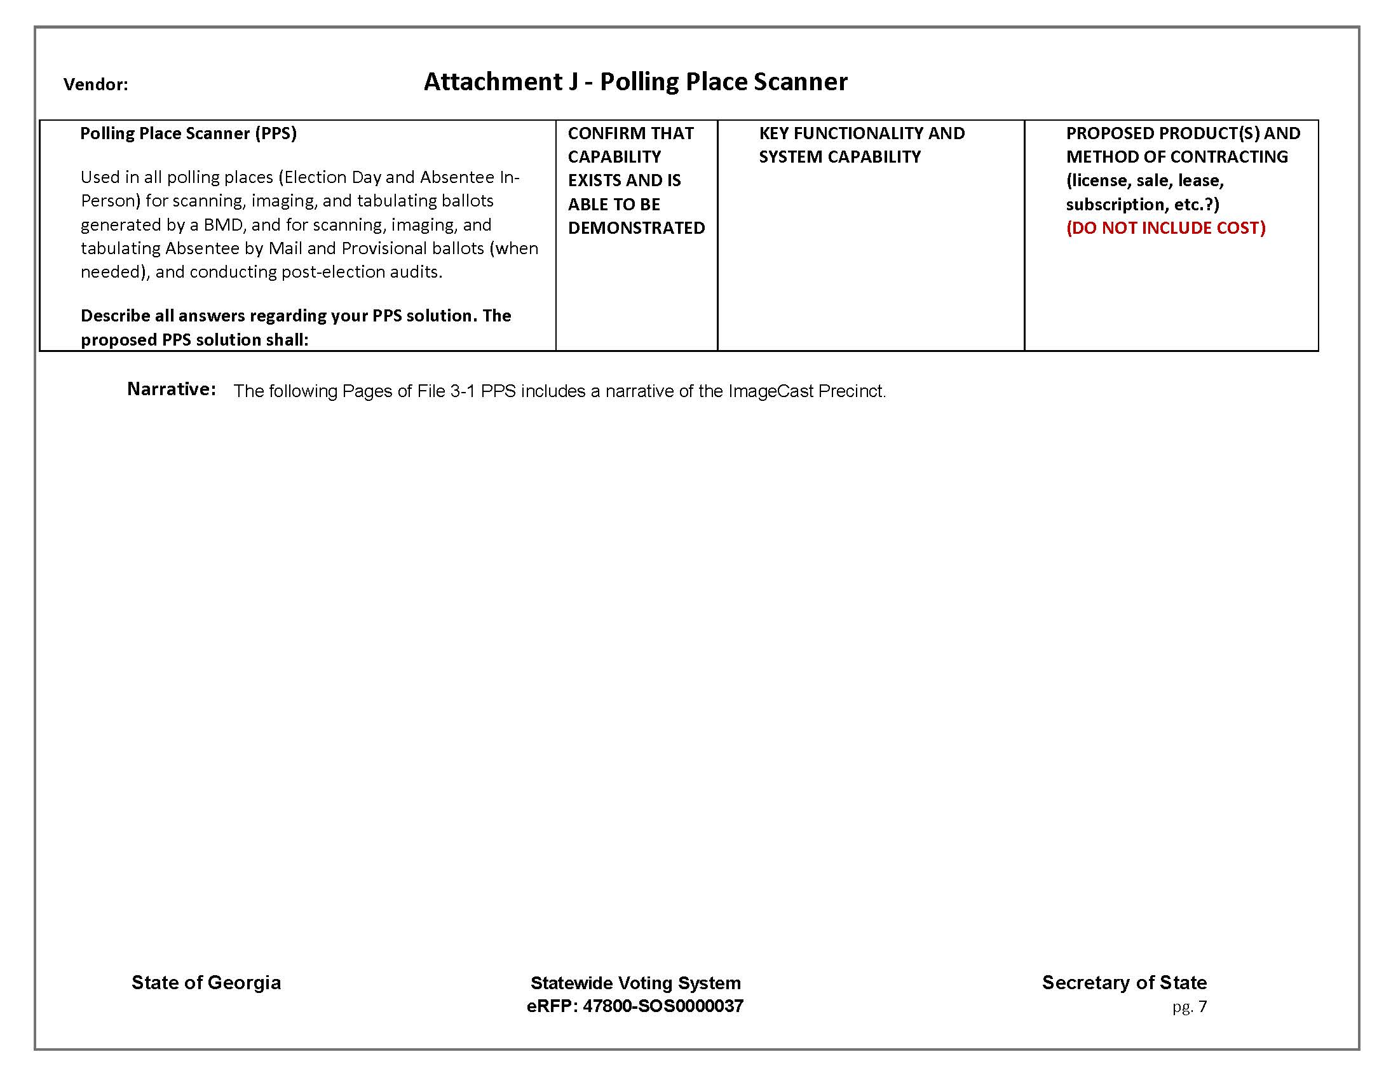

The ImageCast Precinct (or ICP) scanner/tabulator is a lightweight, robust and easy-to-use automated paper ballot tabulation system.

The system is designed to scan hand-marked paper ballots, interpret voter marks on the paper ballot and safely store and tabulate each vote from each paper ballot. The ImageCast Precinct reads single and double-sided ballots in four orientations and accepts striping and colored headers to distinguish ballots. Used in conjunction with the required consumables, supplies, and software, the ImageCast Precinct forms a complete tabulation system.

In Democracy Suite 5.5 A, the ImageCast Precinct scanner is also capable of reading and tabulating the choice summary ballots produced by the ImageCast X Prime, which include a 2D barcode read by the scanner, as well as a human-readable text summary of the voter’s selections.

The ICP is the most reliable optical scanner ever developed, with major deployments including 82,000 units in the Philippines, 11,000 units in New York, and 2,500 units in Mongolia. Most recently, over 6,000 ImageCast Precinct units were successfully deployed in the Commonwealth of Puerto Rico for their 2016 elections.

The ICP is designed to be “plug and play,” making it very straightforward and quick to set up for poll workers. It will power on upon plugging in the AC power cord. The poll worker will apply their iButton security fob and enter their credentials to open the polls and print the zero tape, and the ImageCast Precinct tabulators are ready to commence standard voting and accepting ballots. The Internal Battery will allow voting for up to 2 hours after the loss of power.

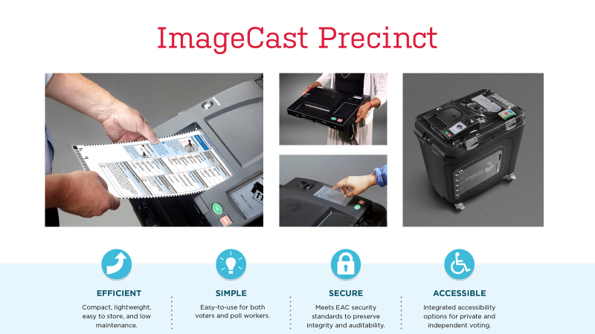

At the polling place, the ICP performs the following functions:

- Scans the ballot
- Interprets the digital image of the ballot and appends to the bottom of the image a record of how that ballot was counted on Election Day (known as the AuditMark image).
- Allows voter to correct any mistakes in marking as monitored by the Dual Threshold mark definition feature set by the State or county.
- Redundantly stores and tallies the results
- Prints cumulative totals of all votes cast after the polls have been closed

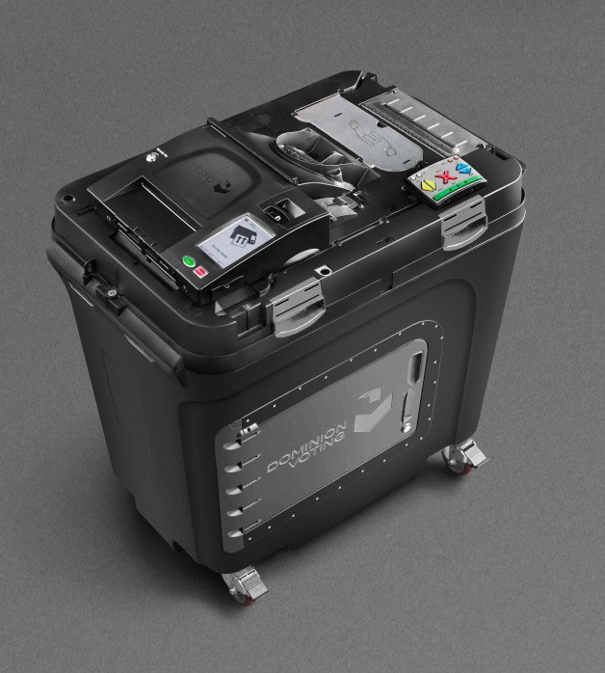
ImageCast Precinct on the Dominion Ballot Box
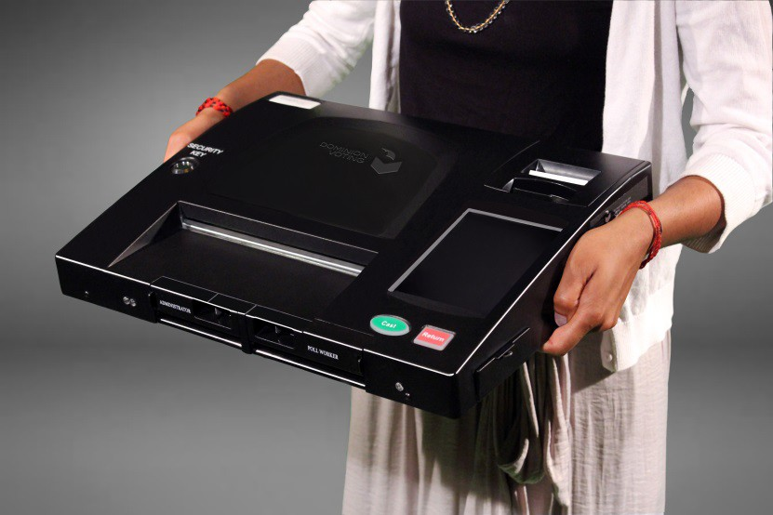
The ImageCast Precinct - a lightweight but robust and versatile tabulator
Storage and Transportation

The ImageCast Precinct comes in a standard packaging including foam inserts for maximum protection. Each box weighs approximately 15 pounds and measures:

H = 7.5 inches
W = 22 inches
D = 19 inches

The accompanying ballot box, with the lid attached weighs approximately 85 pounds and measures:

H = 44 inches
W = 25 inches
D = 38 inches

For optimal product life, storage limitations should adhere to the following specifications:

ImageCast Precinct

- Storage Temperature min/max: From -25°C - 60°C
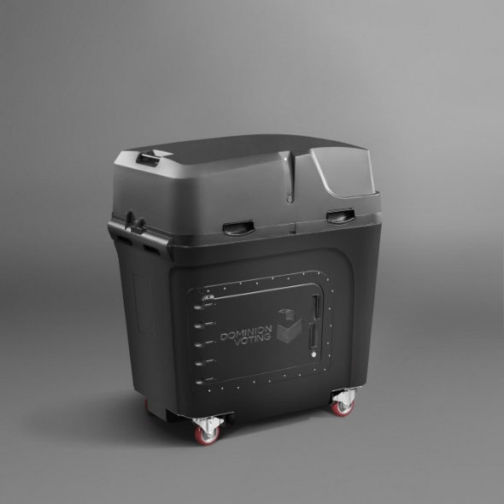
- Operating and/Storage Conditions (Relative Humidity): From 20% - 80% RH non-condensing
- Place the tabulator inside the re-sealable bag into the provided packaging box with foam inserts to provide vibration and impact protection.
- Store the packaged tabulator box under conditions specified.
- Alternatively, leave the tabulator on the Ballot Box but place the Ballot Box dust cover over it to keep it free from environmental elements.
- Store the tabulator (and Ballot Box, if applicable) in a dust-free, clean environment.
- Perform periodic charging of the back-up battery module for 12 hours every 9 months.
- The tabulators should not be stacked on top of one another for storage unless they are in their respective carrying cases or packaging boxes (Suggested Maximum Stack
= 4 Boxes High)

