Section 2 – Election Management System

File 2-1 EMS

2.1 Complete the attached form titled "Election Management System" and include narrative.

Below we provide Attachment I – EMS Form for your review. In addition, the pages following the completed Attachment I includes a narrative of Democracy Suite:

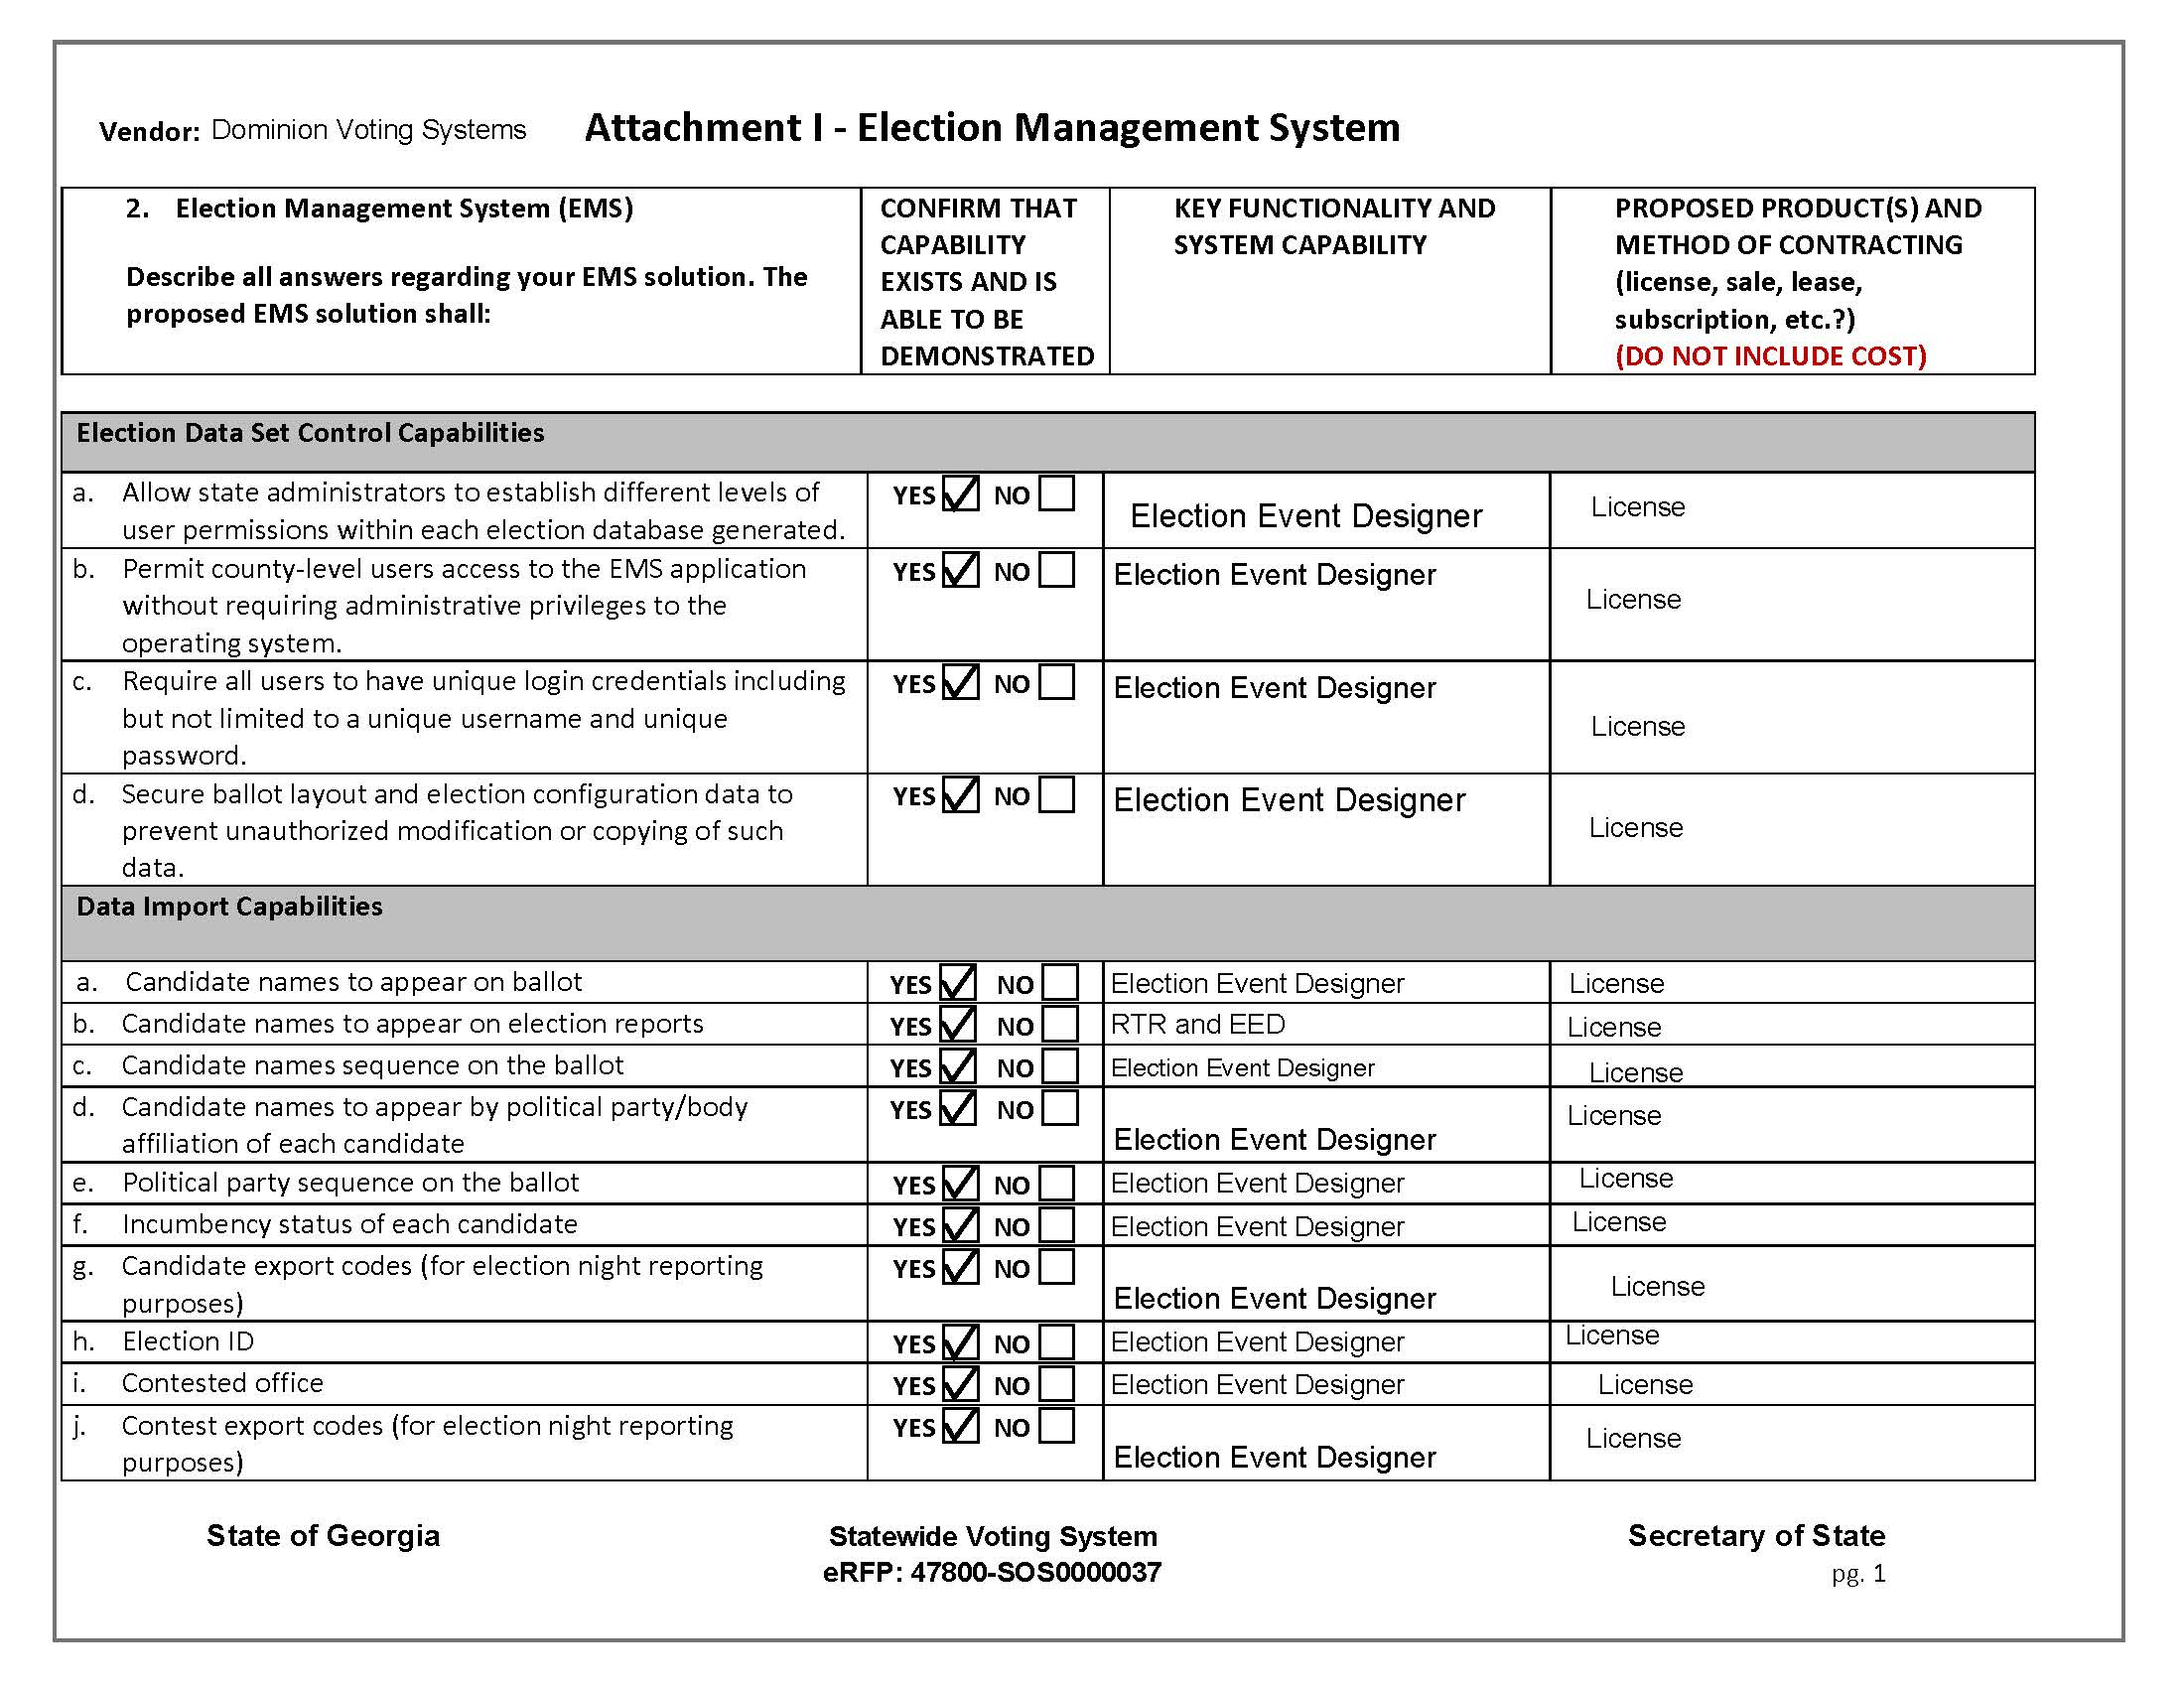
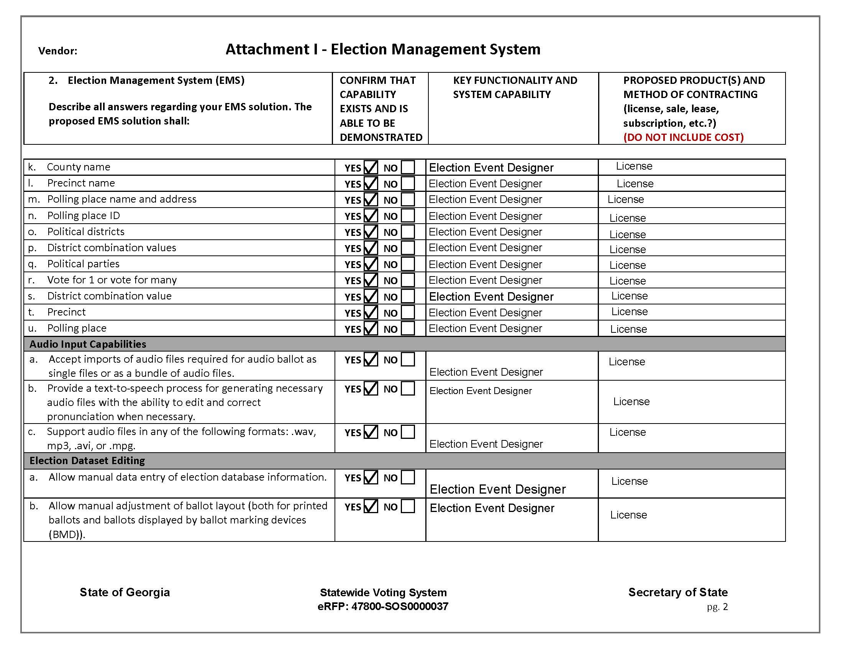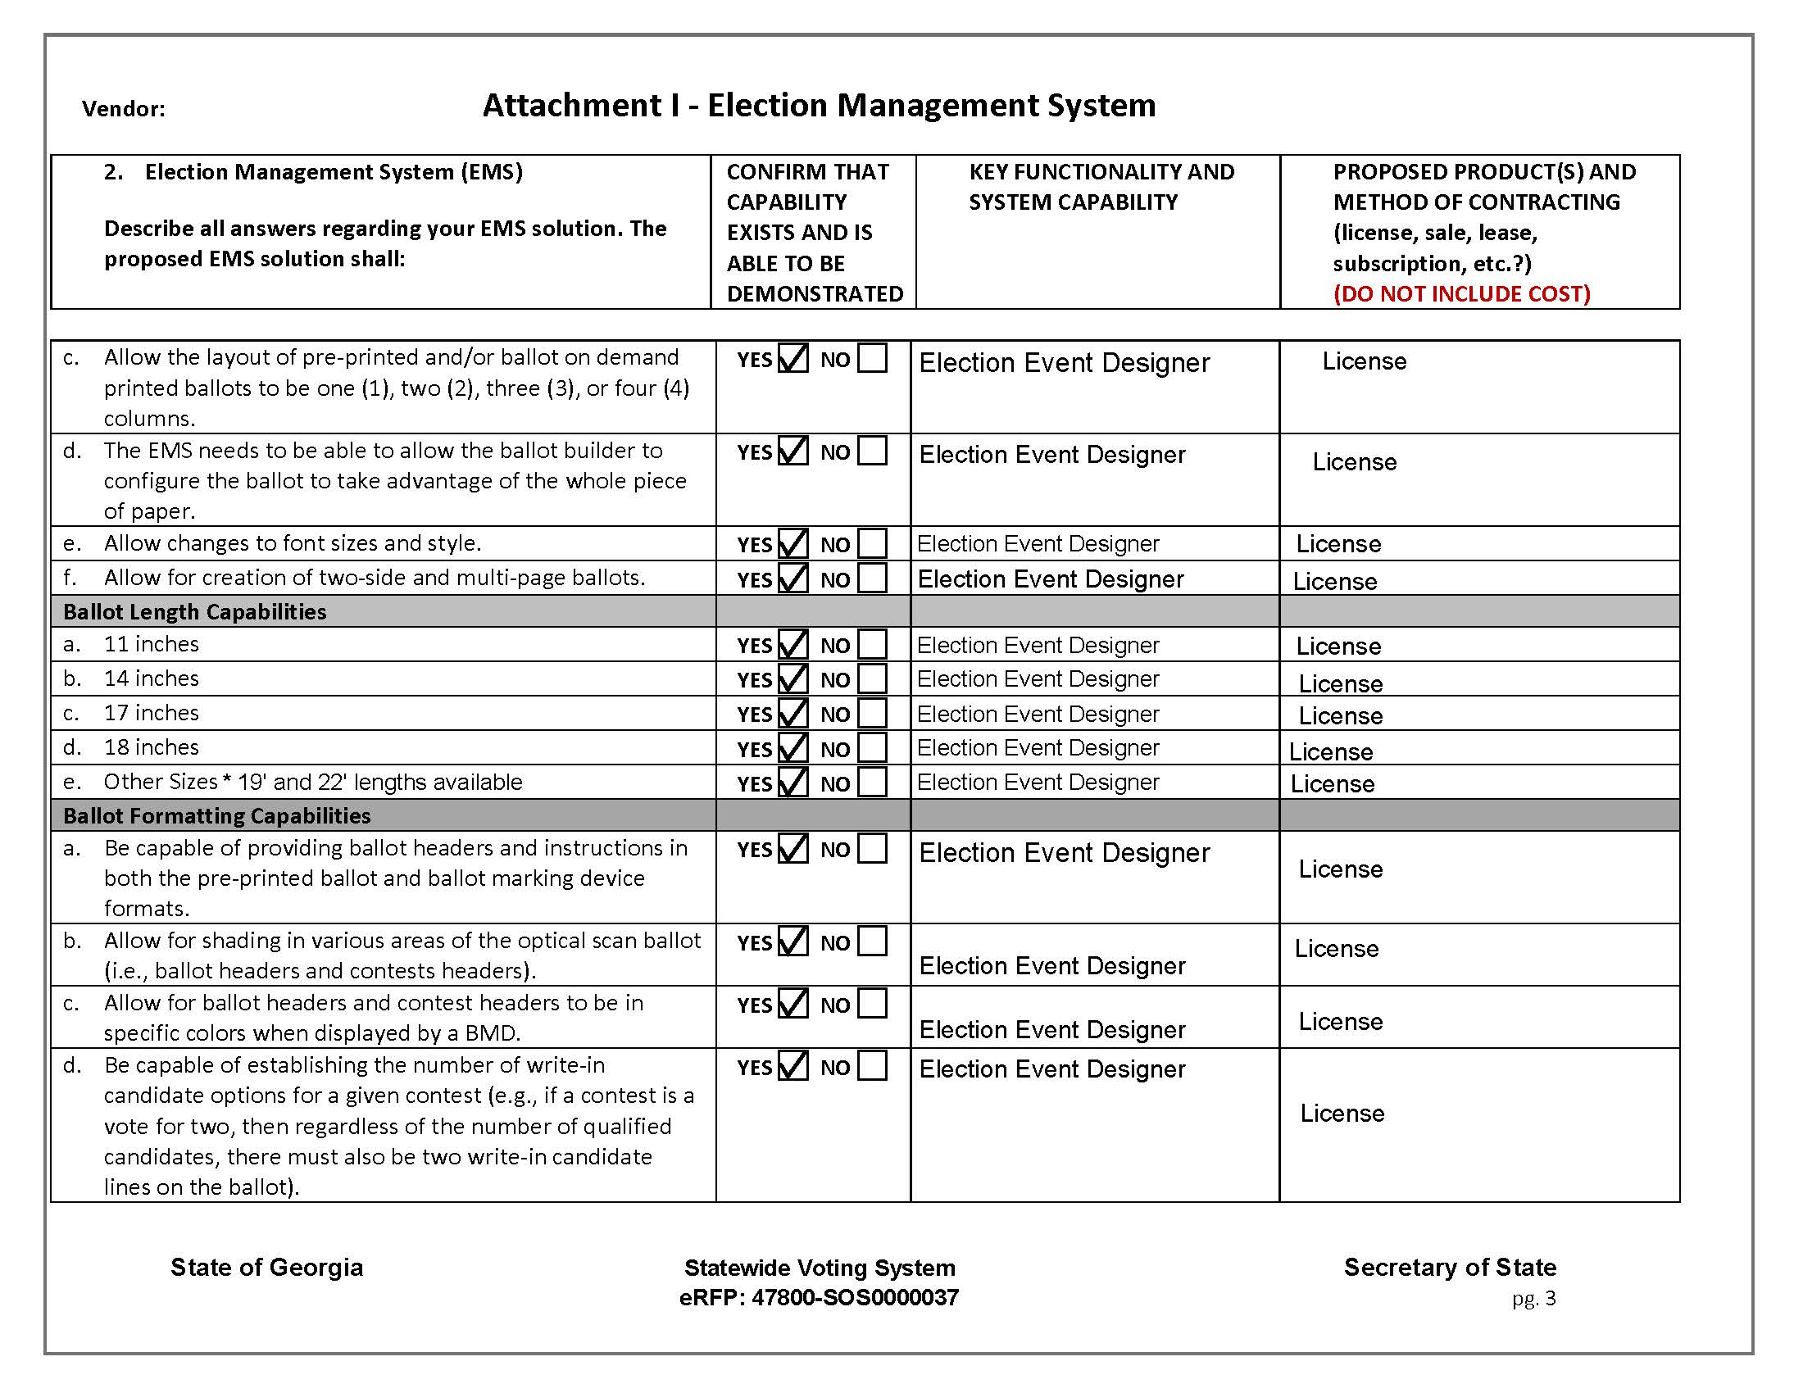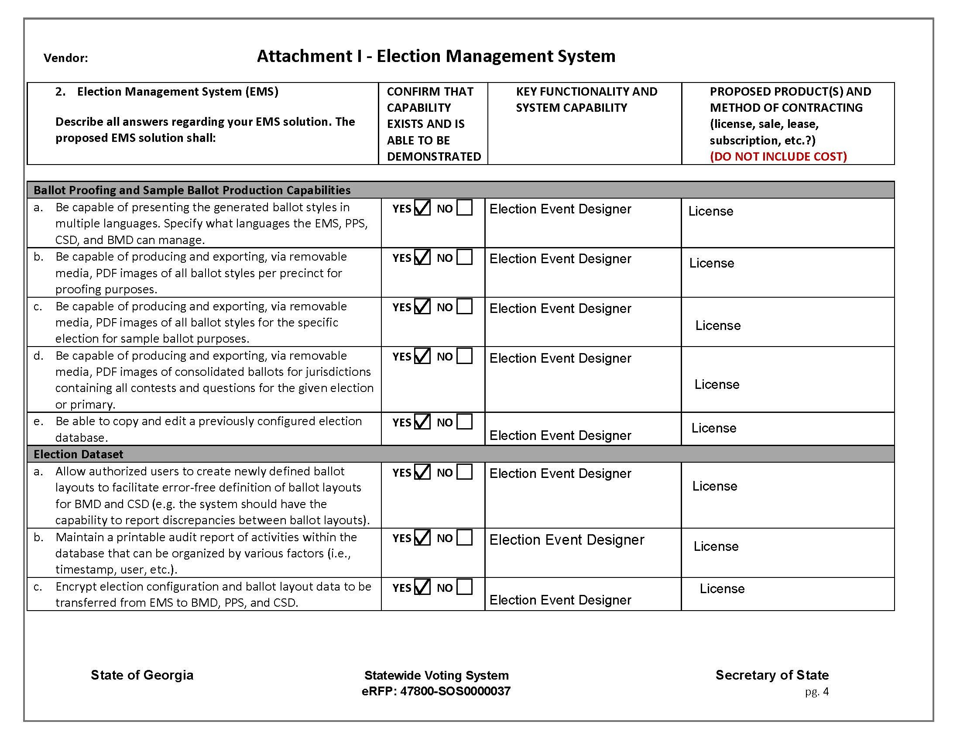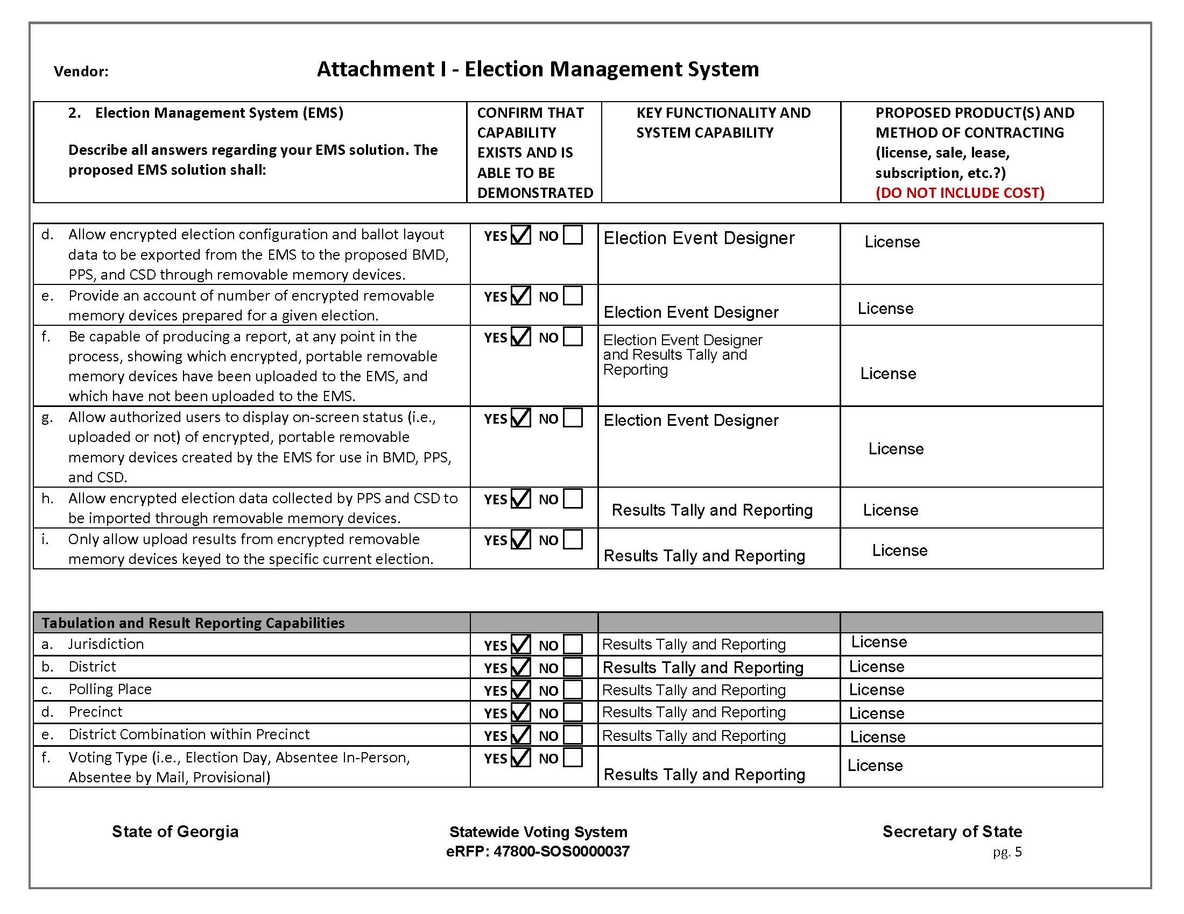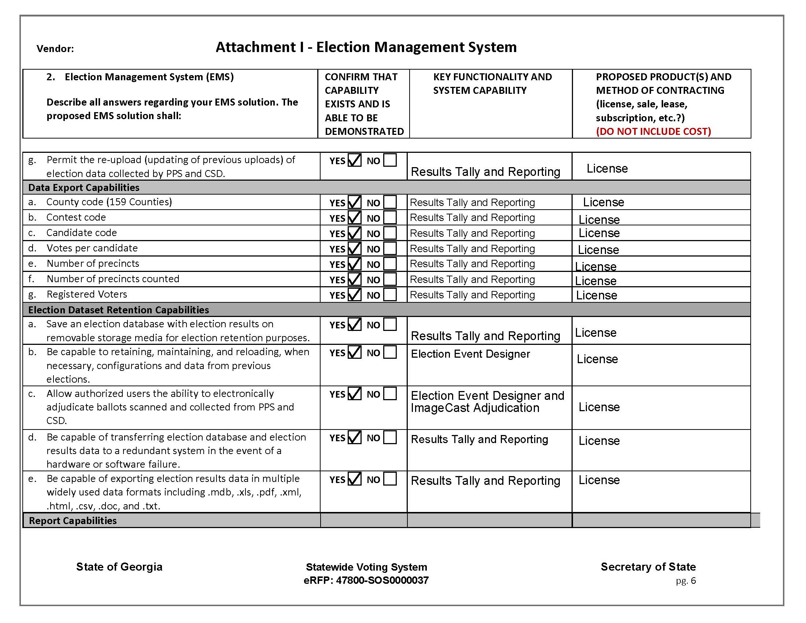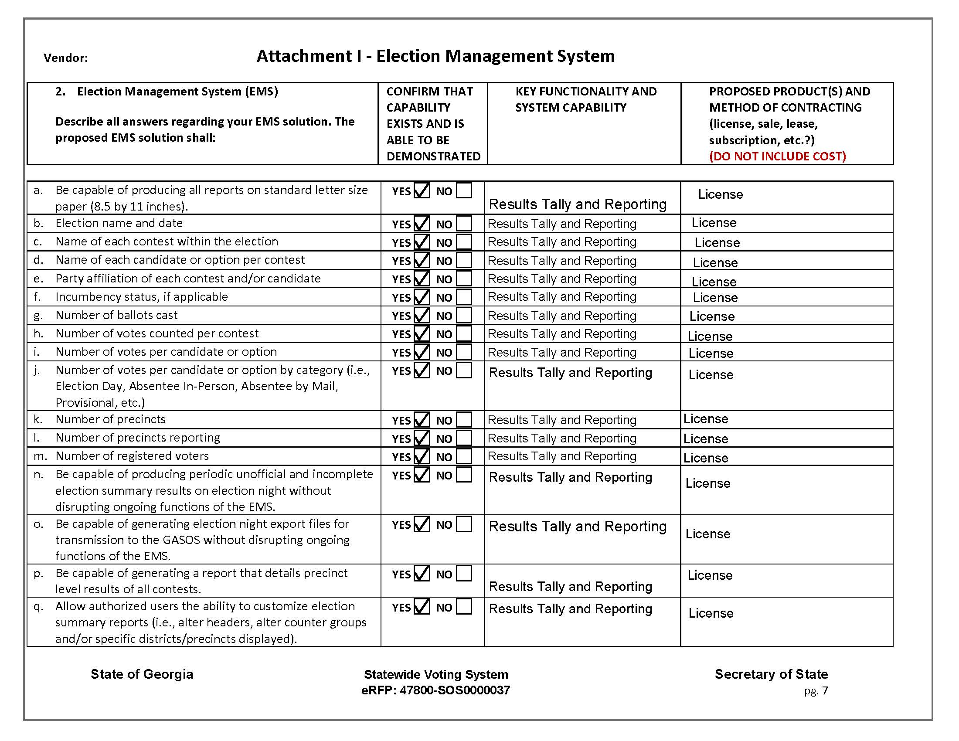

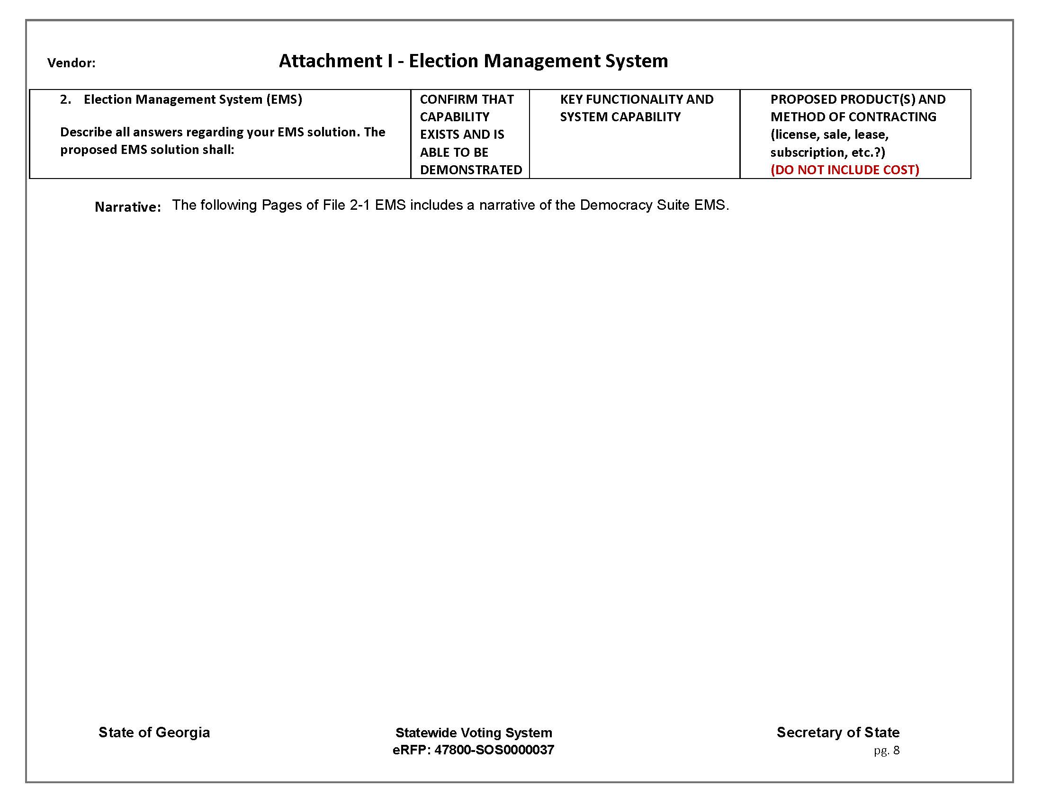

Democracy Suite Narrative

At the heart of our complete voting system solution is Democracy Suite, a robust and tested Election Management System that drives all voting channels out of a single comprehensive database; mail-in ballots, in person voting, accessible voting, and Uniformed Overseas Citizens Absentee Voting Act (UOCAVA)/Remote Accessible Vote by Mail(RAVBM). All pre-election and post-election tasks utilize the same database. From ballot layout to results reporting on Election Night, Democracy Suite is a complete, end-to-end elections solution. Democracy Suite provides a single, powerful and versatile platform for election management.

The Democracy Suite technology platform delivers an improved experience for the voter, long-term sustainability, operational efficiencies, transparency and cost-savings.
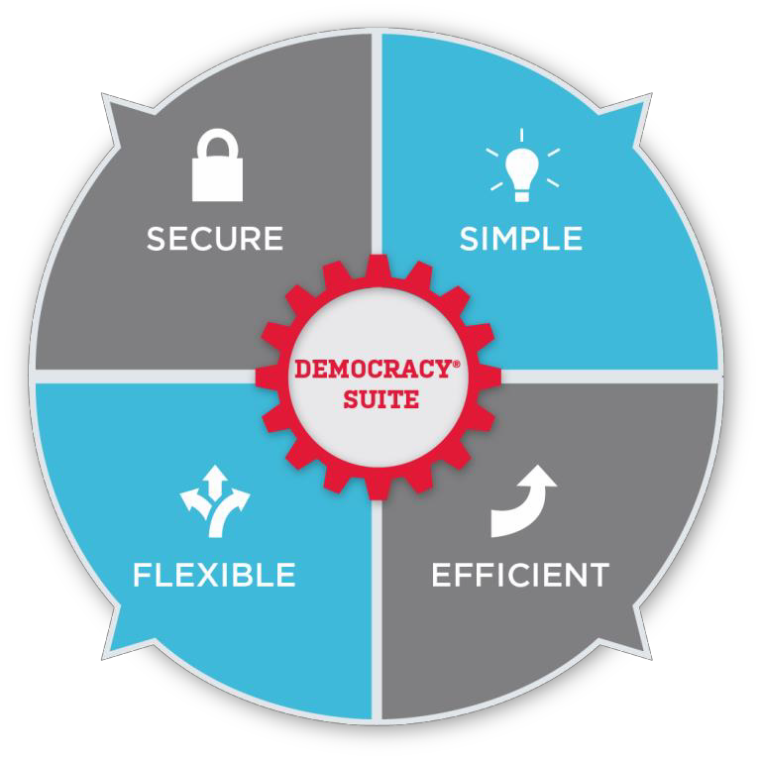
- Designed to meet the latest EAC VVSG requirements with industry leading FIPS 140-2 compliant security protocols
- Complete end-to-end system auditability
- Symmetric and asymmetric encryption for data confidentiality
- All communications channels are encrypted with SSL protocols
- Reduced complexity for election officials, as programming and results consolidation takes place out of a single unified database
- With easy-to-use, intuitive user interfaces across the entire product line, your staff and poll workers are able to confidently carry out the tasks in their workflow
- Capable of handling many types of elections, voting rules (i.e. straight party, open or closed primaries, etc.) and a range of jurisdiction sizes
- Built-in tools to help you simplify and streamline your process, increase productivity, and save you time and money
- A diverse range of EMS modules and voting channel singular devices with flexible configurations to meet jurisdictional needs
- Save and re-use ballot templates, election event definitions, and report templates so you can quickly and easily generate future election projects

Benefits of using the Democracy Suite System

- Democracy suite powers the entire voting system out of a single comprehensive database, with all the tools needed to simplify and streamline the process.
- All voting-channels whether absentee ballots, accessible voting, or precinct-based voting – are supported and powered by Democracy Suite.
- All pre-election and post-election tasks take place out of the same database – from ballot programming to results reporting on Election Night, Democracy Suite is a complete, end-to-end elections solution.
- It is designed to suit the needs and requirements of jurisdictions large and small can be easily scaled to support any size jurisdiction.
- The State will be equipped with Dominion’s Democracy Suite Election Management System, which is comprised of several modules to manage an election project from start to finish. Democracy Suite is composed of two main modules:
  - Through the Election Event Designer (EED) module, the election definitions of the jurisdiction such as districts, races, and candidates can be input or imported. The Election Data Translator utility allows the import of the election definition, further simplifying the election definition process for the County or State Administrator.
  - Through the Results Tally and Reporting (RTR) module, the counties can easily and quickly receive and accumulate election results from their precincts and rapidly report them to the State for accumulation and distribution of State-wide election results. The system allows for the configuration and creation of a wide range of reports that can be easily accessed or customized.
- The system allows for the configuration and creation of a wide range of reports that can be easily accessed or customized.

Election Event Designer

The Election Event Designer module manages all of the information needed to define the election. Definition of an election is a complex task, and the event definition module allows for the easy entry and tracking of districts, precincts, contests, candidate names, voting locations and ImageCast tabulators and ICX BMD devices simultaneously. Election Event Designer allows jurisdictions to choose from a variety of language options for an election project.

Election definition data may be entered manually or imported using the Election Data Translator utility. The Election Data Translator utility allows the import of the election definition from an Excel file, further simplifying the election definition process for the County or State Administrator. Election definition data may be exported or copied from prior election databases to speed up the process of coding subsequent elections.

Election Event Designer uses the State’s geopolitical and election event data to automatically calculate the required ballot styles and generate full-sized press-ready ballots in industry-standard PDF format. EMS lays out contests on the ballot in the most space-efficient manner possible, in order to minimize printing costs. Election Event Designer offers extensive options or ballot styling with full user control – choose fonts, line weights, number of columns, multiple languages, multi-card or double-sided, landscape or portrait style, variety of voting target options, colored headers, etc. A unique ballot ID barcode distinguishes each ballot style. The ballot is 8.5” wide and can vary between 11”-22” in length.

The EMS uses Cepstral, a third-party text-to-audio synthesizer, to automatically generate audio ballots for the ImageCast Precinct and the ImageCast X. Users also have the option to import human-recorded audio using Cepstral’s Swifttalker application. The system outputs audio ballots (PNG images, SPX audio files and XML definition files), definition reports (XML, Excel or HTML files), and election definition files required to program all tabulators and voting devices.

The in-person voting devices are defined and configured in the Election Project and these parameters are passed to the voting machines via the election files on the memory media. Tabulators are automatically configured to know which ballot styles to accept or display to the voter, how the unit should interact with voters and where results files are uploaded. The ImageCast X will store all available ballot styles and will present the correct ballot style to the voter when the voter inserts their activation card and activates the voting session. The poll worker only needs to follow the Election Day procedures established by the State/County and never needs to make a decision regarding the voting device’s settings at the voting locations.

Results Tally and Reporting
The EMS Results Tally and Reporting (EMS RTR) module is used on Election Night upon close of polls to accumulate results from tabulators and generate results reports. The application allows officials to physically transport memory media to a central processing office.

For the EMS RTR module, inputs represent encrypted and signed election result files (proprietary format), log files (plain text) and scanned ballot images with AuditMark, produced by the Precinct and Central tabulators (PNG and TIFF images). Outputs represent a variety of election result reports, as well as auditing information (XML, HTML, CSV, MS Excel and PDF formats).

The program automatically uploads the result files into the results tally module, and consolidated results are verified, tabulated, and published. Once the vote data is uploaded into the result tally module, the flow of results to the public and media can be controlled.

RTR allows election officials to review the results before releasing them, and the system provides a number of reporting methods, including but not limited to Summary and Precinct-level (Statement of Votes Cast) results reports. In addition to the static, pre-defined reports found in most reporting systems, RTR’s Summary and Precinct-level reports use the Microsoft SQL Server Reporting Services engine to offer maximum flexibility to the user. These reports feature a variety of configurable options and filters, including detailed breakdowns of provisional ballots cast, ballots cast during early voting, on Election Day, and by mail. Election administrators may use the default settings or configure the data fields included in the reports depending on the target audience. Reports may be filtered by precinct, district, contest, tabulator, or voting, location, to narrow in on specific results data of interest contained within the election database.

The Democracy Suite Results Tally and Reporting (RTR) module features a one-click results export to a variety of formats and can meet the State’s election night reporting requirements. In addition, the module features numerous export types for compatibility with third-party web-based Election Night Reporting software.

In Democracy Suite 5.5A, the Democracy Suite Results Tally and Reporting module also includes a full export of all Cast Vote Records (CVR) from the system. This export is available in a JSON format to support any risk-limiting audits or post-election analysis on individual vote records. The CVR export includes references to the ballot image data from all tabulator channels as well as providing a full, robust audit solution on a ballot-by-ballot basis.

Core Technology – Ensuring Accurate and Transparent Elections
- The Democracy Suite Election Management System handles all activities related to your election. It produces ballots and tabulator information and is enhanced by Dominion’s core Dual Threshold and AuditMark technologies.
- Dual Threshold technology has a user-defined low and high marginal mark threshold to ensure that each and every voter’s ballot will be read the same every time. If a voter does not properly fill in the oval while marking their ballot and their oval mark falls in the marginal mark zone, the system will inform the voter of the Marginal Mark and the onus of clearly defining their intent is on the voter, not the Election Official.
- The AuditMark auditing system is, however, what makes the Dominion difference and sets us apart from other vendors in the industry. It is the only system that digitally stores an image of every ballot cast along with a record of how the ImageCast tabulator interpreted each vote, ensuring a completely transparent and auditable election.
- Administrators find it a great comfort when reviewing ballot images during recounts and every image is accompanied by this clear, digital, human-readable AuditMark record.
- We take particular pride in this unique feature, because it demonstrates how seriously Dominion takes our policy of being 100% accountable for each and every vote cast.

Dominion Voting Systems has invested in the development of technology that truly sets its products apart from the competition. Dominion’s core technologies focus on ensuring two key aspects of the electoral process – accuracy and transparency.

Dual Threshold Technology (Marginal Marks)
From its early beginnings, Dominion continues to set the standard in digital image acquisition and analysis in the tabulation of digitally scanned ballots. When a hand-marked ballot is scanned by an ImageCast tabulator – at the precinct level or centrally – a complete duplex image is created and then analyzed for tabulation by evaluating the pixel count of a voter mark. The pixel count of each mark is compared with two thresholds (which are defined through the Election Management System by the Election Official) to determine what constitutes a vote.

If a mark falls above the upper threshold, it is determined to be a valid vote. If a mark falls below the lower threshold, it will not be counted as a vote. However, if a mark falls between the two thresholds (known as the “ambiguous zone”), it will be deemed as a marginal mark and the ballot will be returned to the voter for corrective action (please see diagram below).

With this feature, the voter is given the ability to determine his or her intent at the time they cast their ballot, not an inspection or recount board after the fact, when it is too late. The chart below illustrates the Marginal Mark threshold interpretation.

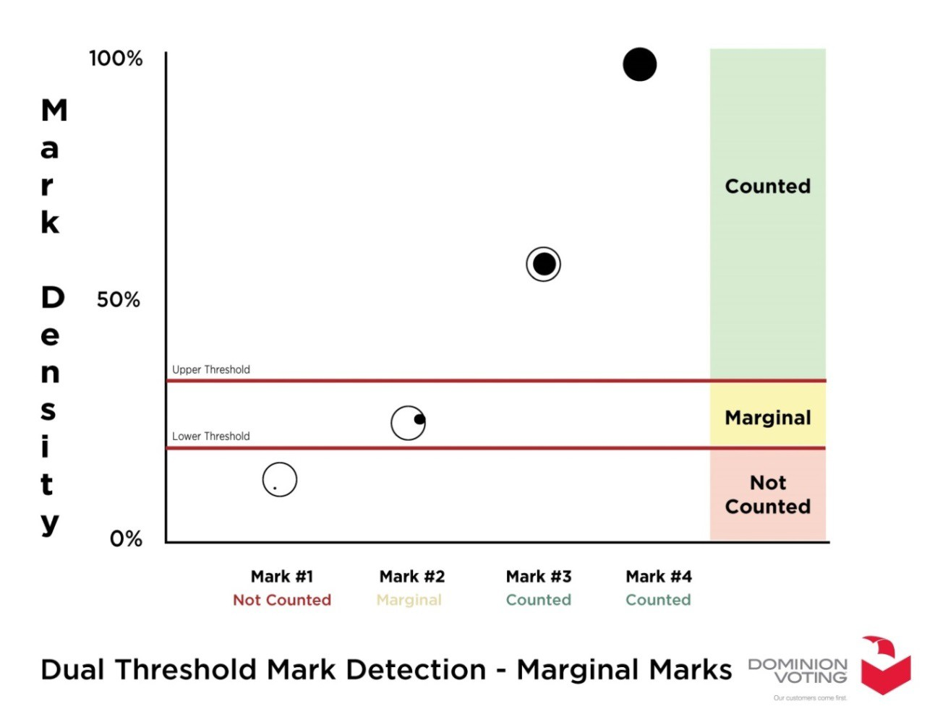

Dominion’s Exclusive Digital Ballot AuditMark
Dominion’s AuditMark technology will allow Georgia counties to provide greater transparency in the electoral process. Every single ballot in the election is imaged and appended with Dominion’s patented AuditMark, a record of how the system interpreted the voter’s intent. The AuditMark is the only technology that proves a clear and fully auditable single vote cast record for every ballot cast.

The AuditMark Advantage

Transparency: Our system is the only one that stores a complete image of every ballot cast, along with the audit trail for that ballot visually affixed to the image.

Accuracy: The audit trail shows how the tabulator interpreted the vote ballot markings of the secure barcode, at the time the ballot was cast. By viewing this image, an election official can easily verify that the tabulator has correctly interpreted the voter’s selections on the ballot.

Trust: Furthermore, by randomly opening a small number of image files and verifying that the audit trail displays the correct results, the election official can quickly develop a high level of confidence that all of the ballots have been interpreted correctly.

In practice, the AuditMark feature can used as:
- A method to test machine integrity before an election
- A method of obtaining confidence that the equipment is functioning properly
- A method to completely audit the entire election
- A method to enhance recounts

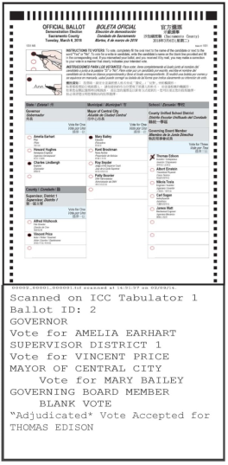
Hand-Marked Ballot Image with Audit Trail
This is a sample ballot image for a centrally-processed ballot. All ballots are imaged and stored for auditing purposes. The image contains:

1. Timing Marks: Fixed marks on the ballot that the scanner reads in order to determine the ballot’s orientation and identify voting targets.

2. Ballot Header: Includes the name of the election and any other text the jurisdiction provides. Can also include the organization’s logo.

3. Instructions: Formatted free text that the jurisdiction can customize.

4. Contest Headings and Choice Fields: These areas support customized items and formatting including images.

5. Voting Targets: Voting targets can be placed on the left or right of the candidate’s name.

6. Columns: Ballots can have one, two, three or four columns.

7. AuditMark: Ballot-level audit trail feature shows how the tabulator interpreted the voter’s marks.

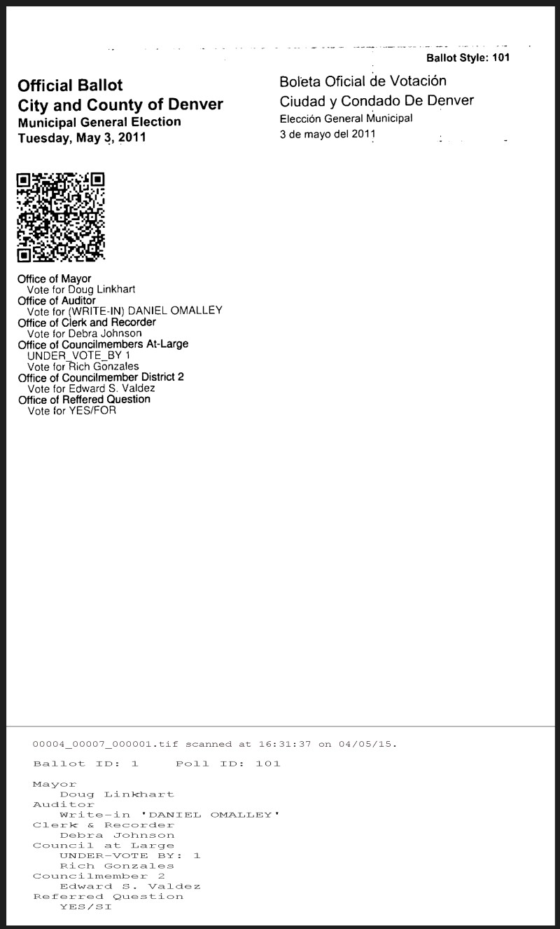
ImageCast X Choice Summary Ballot Image with Audit Trail
This is a sample ballot image for a centrally verifiable choice summary ballot. All ballots are imaged and stored for auditing purposes.

1. Ballot Header: Includes the name of the election and any other text the jurisdiction provides.

2. Secure QR Code: Voter’s choices are digitally signed in the secure barcode image that can only be scanned and decoded by Dominion’s ImageCast tabulators.

3. Ballot Data: Clear image of all text, ballot contest headings, and voter choices.

4. AuditMark: Ballot-level audit trail feature showing how the tabulator decoded the barcode image and counted the voter’s choices. Comparing the AuditMark to the written summary verifies that the system accurately recorded the voter’s selections.

